**A Study on Creating Digital Twin Foliage Representation Through Computer Vision, Aerial Image Analysis and Machine Learning techniques to enhance the Network Planning and Deployment**

Dissertation Proposal

Submitted to National University

National University

in Partial Fulfillment of the

Requirements for the Degree of

DOCTOR OFDATA SCIENCE

by

HASHIM SHAIK

San Diego, California

July 2024

**Table of Contents**

Chapter 1: Introduction 1

Statement of the Problem 3

Purpose of the Study 4

Introduction to Theoretical or Conceptual Framework 5

Introduction to Research Methodology and Design (Nature of the Study) 8

Research Questions 10

Hypotheses 11

Significance of the Study 13

Definitions of Key Terms 14

Summary 17

Chapter 2: Literature Review 20

Key Areas in Building Digital Twin Representation of Foliage 25

Digital Twin Representation of Foliage Theoretical Framework 41

Data Ethics and Legal Frameworks in the Study of Digital Twin Representation of Foliage 47

Summary 52

Chapter 3: Research Methodology 55

Digital Twin Representation of Foliage Research Methodology and Design Process Diagram 56

Research Methodology and Design of Digital Twin Representation of Foliage 58

Population and Sample 89

Materials or Instrumentation 91

Assumptions in the Construction of Digital Twin Representation of Foliage 92

Limitations in the Construction of Digital Twin Representation of Foliage 95

Delimitations in the Construction of Digital Twin Representation of Foliage 97

Ethical Assurances 98

Ethical Considerations using Google aerial imagery 98

Summary 99

References 101

Appendix A Annotated Bibliography 125

Appendix B Topic Description and Supporting Literature 136

Appendix C GitHub Details 138

Appendix D IRB Approval Letter 139

**List of Tables**

**Table 1**  *YOLO-V8 Vs Mask R-CNN* 67

**Table 2** *Key Metrics Considered During Model Evaluation* 74

**Table 3** *Curves Generated as Part of Model Evaluation* 76

**Table 4** *Interpretation of Metrics* 77

**List of Figures**

**Figure 1** *Smart City Digital Twin: Urban Planning and Green Spaces Integration* 2

**Figure 2** *Digital Twin Representation of Foliage - Example* 8

**Figure 3** *Flowchart: Digital Twin Representation of Foliage (AI-Driven Foliage Detection Using Machine Learning and Computer Vision)* 9

**Figure 4** *Obstacles in 5G Millimeter-Wave Deployment* 27

**Figure 5** *Vegetation Loss Simulation Results* 29

**Figure 6** *Illustration of Collection of Data in Lidar and UAV* 30

**Figure 7** *Elements of the Digital Twin Ecosystem* 34

**Figure 8** *Some of the Key Ethical Considerations* 47

**Figure 9** *Research Design Methods for Digital Twin Representation of Foliage* 57

**Figure 10**  *Data Collection Strategy* 59

**Figure 11** *Standardized Image Pixels* 60

**Figure 12**  *Annotations Tools* 61

**Figure 13** *Annotations Using VIA or Roboflow* 62

**Figure 14** *Foliage/Vegetation Extraction from Aerial Images* 63

**Figure 15** *Measuring Unknown Objects from Known Reference Objects (From a Calibrated Image)* 66

**Figure 16** *YOLO-v8 Performance Over the Previous Versions* 69

**Figure 17** *Validation Sample Vs Validation with Inference* 78

**Figure 18** *Vegetation / Foliage Bounding Box Metrics* 79

**Figure 19** *Vegetation / Foliage Area masks metrics* 79

**Figure 20** *Digital Twin Representation of Foliage Success Criteria* 81

**Figure 21** *Selected Region for Construction of Digital Twin Representation of Foliage* 89

**Figure 22** *Glimpse of How Aerial and Street View Images Collected by Google* 91

**Figure 23** *Assumptions, Limitations, and Delimitations in the construction of DTRF* 92

# Chapter 1: Introduction

In today’s rapidly advancing telecommunications landscape, the emergence of millimeter-wave (mmW) networks is a pivotal development aimed at fulfilling the surging demand for greater bandwidth, enhanced throughput, and minimized latency (Abdullah et al., 2020; Hong et al., 2021). This progression is vital for the progression of 5G wireless networks to meet the escalating needs of the mobile industry. However, mmW networks are challenged by issues like signal scattering, atmospheric absorption, and the obstruction caused by foliage and building structures; these are critical to navigating the successful roll-out of 5G networks, ensuring optimal coverage and data speeds (Barb et al., 2022; Bose et al., 2024; N. A. Khan & Schmid, 2024; Pradeep et al., 2021; Y. Zhang et al., 2019).

The process of accurately capturing foliage data, crucial (Lai et al., 2023) for the deployment of these high-frequency networks like mmW, has traditionally relied on costly and time-consuming methods such as Light Detection and Ranging (LiDAR) and unmanned aerial vehicles (UAVs) (Q. Chen et al., 2022; X. Deng et al., 2022; Mazzacca et al., 2022; Rogers et al., 2020). To adapt to the dynamic nature of our surroundings, the need for frequent updates of data renders traditional methods less viable for continuous application (Gaspari et al., 2022). However, the rise of digital twin technology offers a groundbreaking alternative (Attaran & Celik, 2023; Shahat et al., 2021).

Digital twins have become a game-changing strategy with applications spanning urban development and industrial operations, notably in the planning of wireless networks (T. Deng et al., 2021; Gabriele et al., 2023). One of the most compelling uses of digital twin technology is in the detailed modeling of foliage or vegetation. By constructing a virtual representation of the natural environment, focusing on the variety, distribution, and properties of plant life, digital twins afford network planners, environmental experts, and other stakeholders a nuanced understanding of how vegetation influences signal behavior, including path loss and network coverage, in high frequency mmW networks integral to 5G and 6G technology (L. U. Khan et al., 2022; Kuruvatti et al., 2022).

The sample image (Figure 1) depicting a digital twin representation of an urban area has been created for illustration purposes. It includes 3D models of buildings, streets, and foliage, presenting a clean and simplified city landscape that could be used for architectural visualization or city planning simulation. The design conveys a modern and futuristic tone, indicative of advanced urban planning and smart city concepts (T. Deng et al., 2021; Shahat et al., 2021).

**Figure 1***Smart City Digital Twin: Urban Planning and Green Spaces Integration*

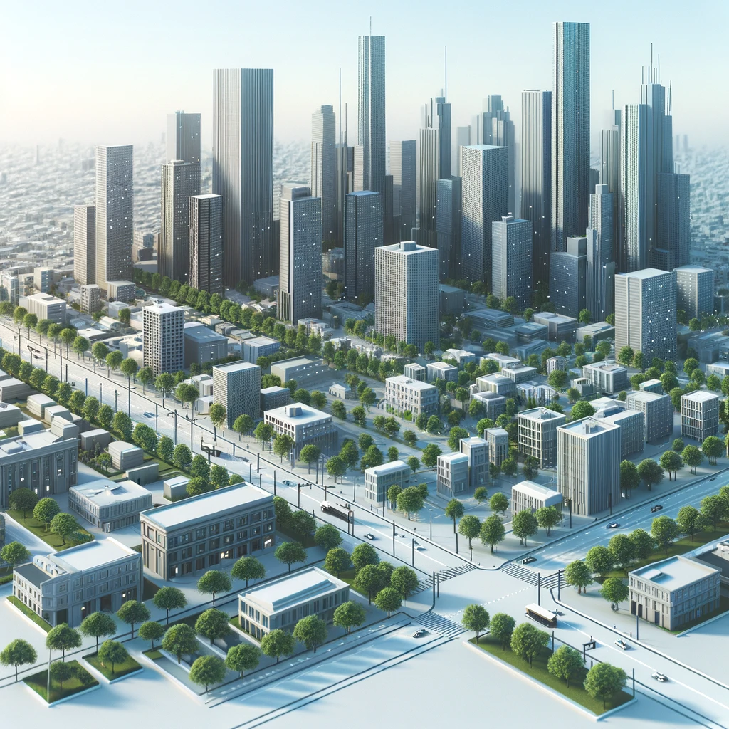

*Note.* This image was generated with the assistance of Artificial Intelligence (AI).

## Statement of the Problem

Connected devices are becoming more common, and users are demanding higher bandwidth, throughput, and lower latency. This led to the development of mmW networks. The mmW band suffers from scattering, atmospheric absorption, canopy (or foliage), and building facades. Implementation of 5G requires mmW band propagation channel optimization (Farooq & Lokam, 2023; Pradeep et al., 2021; Y. Zhang et al., 2019).

Accurate modeling of foliage’s channel propagation is vital for wireless network design, particularly in diverse environments like rural, suburban, and urban settings. The blockage effects of foliage, especially at mmW frequencies, can be severe because of the comparable size of leaves and branches to the transmitted signal wavelength. Overcoming these challenges is crucial to developing reliable channel propagation models that effectively consider foliage’s impact on wireless communication systems (Anzum, 2021; Chikhale et al., 2022; Lai et al., 2023). Network operators must consider all these factors while deploying mmW technologies (5G, 6G) to improve user coverage and throughput.

Currently, foliage data is acquired using costly methods such as UAVs and LiDAR, requiring substantial physical effort (Q. Chen et al., 2022; Hematang et al., 2022; Mazzacca et al., 2022; Shen et al., 2023; Suhaizad et al., 2023). The continuous growth and transformation of foliage necessitates regular data collection to keep information current. The impracticality of repeating these tasks for regular foliage updates becomes clear because of their high cost, labor, and resource intensity. A more cost-effective and efficient approach involves leveraging Google Street View and satellite images in conjunction with state-of-the-art computer vision and machine learning models for object detection (Aikoh et al., 2023; Sun et al., 2023; Y. Zhao et al., 2023), presenting a promising way forward to address the challenges on collecting foliage or vegetation data.

As foliage is one of the main characteristics impacting the higher frequency like mmW network deployment, this study addresses the problem of providing foliage information by creating a digital twin (DT) of an environment with foliage with which network operators planning to deploy networks with higher frequency can use in their network planning to place the nodes at right locations for better coverage and user experience (Gabriele et al., 2023; Nguyen et al., 2021; Qi & Tao, 2018; Thuvander et al., 2022; D. Zhao et al., 2022).

## Purpose of the Study

The ~~purpose of this~~ study aims to develop a sophisticated digital twin that mirrors the physical environment, particularly integrating detailed foliage information (Lai et al., 2023; Pradeep et al., 2021; Y. Zhang et al., 2019). The digital twin will serve as a critical tool for network operators, enabling them to estimate the path loss attributed to foliage within the context of high frequency mmW network planning (Lai et al., 2023). Such estimations are pivotal for optimizing network performance and reliability in environments where vegetation can significantly impact signal propagation (Farooq & Lokam, 2023; Pradeep et al., 2021; Y. Zhang et al., 2019).

In order to accomplish this, a machine learning model based on computer vision will be used, which will be meticulously trained on a large dataset of foliage imagery. This model will employ advanced instance semantic segmentation techniques to identify and categorize foliage or vegetation within images. Through a combination of image segmentation, classification, and object detection methodologies, the study will dissect images into precise regions or objects (J. Chen et al., 2021; He et al., 2018; Sun et al., 2023; Y. Zhao et al., 2023).

This approach enables a pixel-level analysis of each scene, facilitating a deeper understanding of the vegetative elements within the digital twin environment (Jiang et al., 2023; Savelonas et al., 2022). The study will explore the nuanced interactions between vegetation and signal propagation, offering network operators a robust framework for mitigating the adverse effects of foliage on mmW network signals (De Beelde et al., 2023; Pradeep et al., 2021; Y. Zhang et al., 2019). This comprehensive approach representing foliage in a DT aims to bridge the gap between theoretical network planning and the practical challenges posed by natural vegetation, fostering more resilient and efficient communication networks in the face of environmental obstacles.

The study will utilize aerial and street view imagery from broad geographic areas in Philadelphia alongside LiDAR or UAV datasets (Research Natural Areas, 2023; OCM Partners, 2024; Philadelphia Lidar - LAS Files 2022 {2022} - Big Ten Academic Alliance Geoportal, 2022) for validating the model via grid-based assessments and Mean Intersection over Union (MIoU) for segmentation accuracy evaluation (Rezatofighi et al., 2019).

## Introduction to Theoretical or Conceptual Framework

The theoretical framework for employing digital twin technology in enhancing mmW network planning and deployment pivots around the Cross-Industry Standard Process for Data Mining (CRISP-DM) process model (Blume et al., 2020; Hayat Suhendar & Widyani, 2023). This framework is specifically tailored to address the unique challenges posed by foliage in urban and suburban environments, which can significantly impact mmW signal propagation due to its high frequency and susceptibility to attenuation by physical obstacles, such as trees and dense vegetation (Barb et al., 2022; De Beelde et al., 2023; Rogers et al., 2020). The digital twin representation of foliage, built upon the CRISP-DM framework, serves as a foundational tool for simulating and analyzing the interaction between mmW signals and urban foliage, facilitating optimized network infrastructure placement and configuration. This initial phase is crucial for delineating the scope and objectives of the mmW network planning project, with a specific emphasis on understanding how foliage impacts signal integrity and network performance (Lai et al., 2023). The aim is to leverage the digital twin to simulate real-world scenarios, thus enabling network engineers to preemptively identify and mitigate potential signal interference or blockage caused by vegetation. Identifying the specific needs, such as improving telecommunications infrastructure, enhancing urban green spaces, or optimizing environmental conservation efforts, will dictate the direction of the subsequent phases.

The second phase involves an initial data collection and familiarization process. For foliage digital twins, this entails gathering high-resolution aerial and street view imagery (Aikoh et al., 2023), LiDAR data, and any available UAV survey data (Q. Chen et al., 2022). Understanding the types, densities, and heights of foliage within the proposed network area is essential for assessing potential mmW signal attenuation or reflection issues. The following Data collection phase is Data preparation. This phase prepares the data for analysis, which may involve cleaning, selecting subsets, constructing data sets, annotating, and formatting data to suit the modeling needs (Dutta & Zisserman, 2019). Given the complexity of urban environments and the diverse data sources involved, this stage is critical for ensuring that the inputs to the machine learning models are of high quality and appropriately structured for detecting and analyzing foliage (J. Chen et al., 2021; He et al., 2018; Sun et al., 2023; J. Zhang et al., 2021; Y. Zhao et al., 2023). With the data prepared, various modeling techniques are applied to extract patterns and generate the digital twin representation. In the case of foliage, machine learning models such as convolutional neural networks (CNNs) or Mask R-CNN are employed to identify, classify, and analyze foliage from the aerial or street view imagery (J. Chen et al., 2021; He et al., 2018; Sun et al., 2023). This involves training models on annotated datasets, selecting the most effective models, and tuning parameters to optimize accuracy and performance (Rezatofighi et al., 2019).

Before proceeding to full-scale deployment, the models and their representations need to be evaluated against predefined success criteria, such as accuracy, reliability, and usability in practical applications (Rezatofighi et al., 2019). This could involve comparing the digital twin outputs with ground-truth data from LiDAR or UAV surveys and assessing the model's ability to represent foliage in various urban scenarios accurately. The final phase involves integrating the digital twin into the mmW network planning and deployment workflow. This enables planners and engineers to visualize signal propagation in the context of urban foliage, identify optimal equipment placement, and anticipate potential maintenance or signal-boosting requirements. The deployment also includes mechanisms for updating the digital twin with new data, ensuring it remains a relevant and effective tool for mmW network optimization (Rogers et al., 2020). By focusing on the unique challenges of mmW network planning in environments with significant vegetation, the CRISP-DM-based digital twin represents a targeted approach to enhancing network reliability and performance. Through detailed simulation and analysis of foliage interactions with mmW signals, network planners can make informed decisions that optimize coverage and capacity while minimizing interference and attenuation, thereby ensuring robust, high-speed wireless connectivity in urban and suburban settings.

## Introduction to Research Methodology and Design (Nature of the Study)

This section describes the research methodology and design for the study relating to the study problem, purpose, and research questions in constructing a Digital Twin Representation of Foliage. The constructive research design aims to bridge the gap between theoretical computer vision techniques and practical applications in digital twin technology for foliage representation. A constructive research design for the “Digital Twin Representation of Foliage” problem ensures a systematic approach to creating a practical solution that addresses the challenges of accurate foliage representation in digital twin models. Below (Figure 2) is a sample of a Digital twin representation of foliage (Z. Li et al., 2023; S. Song & Qin, 2022; Wilk et al., 2022).

**Figure 2***Digital Twin Representation of Foliage - Example*

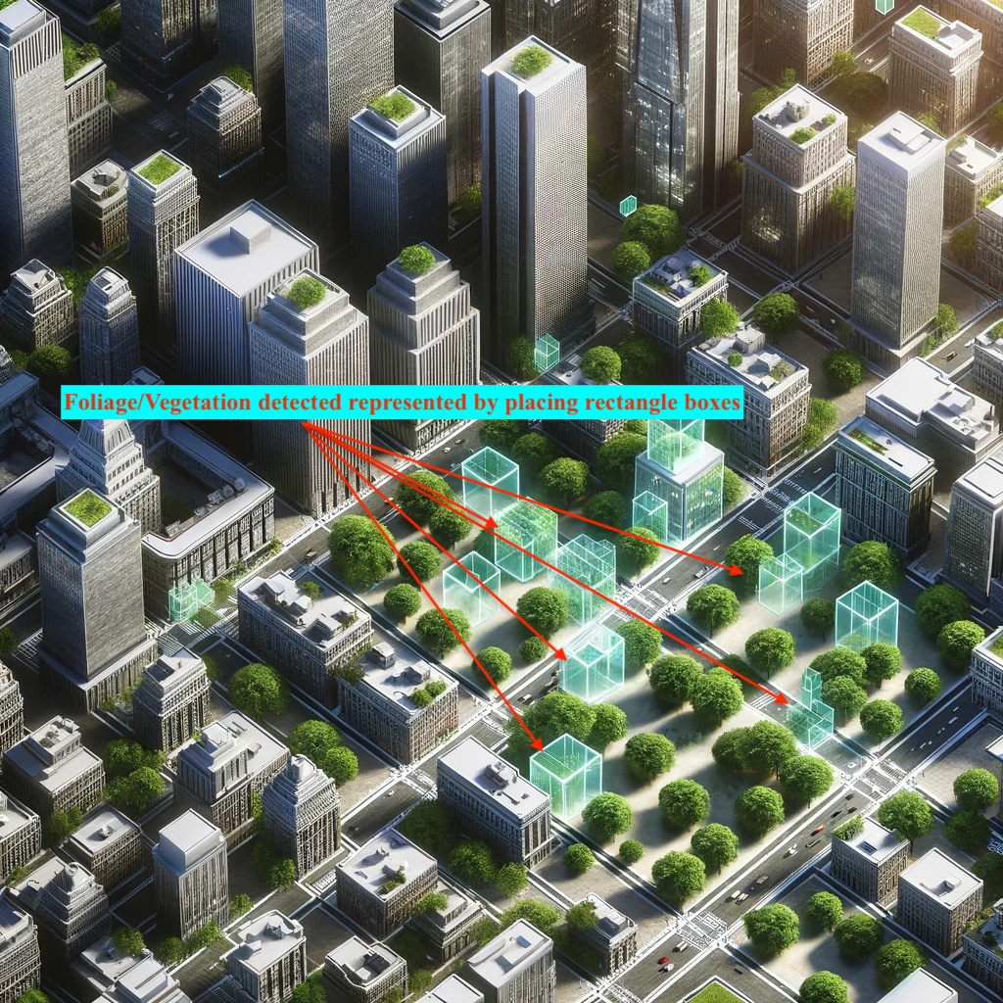

*Note.* This image was generated with the assistance of Artificial Intelligence (AI).

**Figure 3***Flowchart: Digital Twin Representation of Foliage (AI-Driven Foliage Detection Using Machine Learning and Computer Vision)*

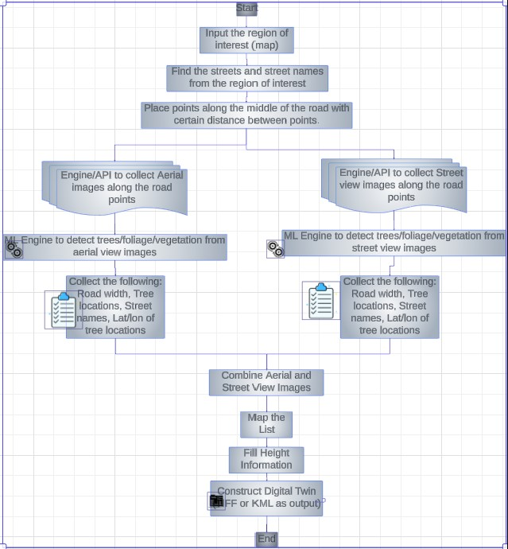

For future implementation

The current approach focuses on constructing a digital twin model to represent foliage in various environments, leveraging cutting-edge computer vision and machine learning techniques. The flowchart in Figure 3 outlines the process for constructing a Digital Twin model of foliage, starting with the region of interest as the initial input.

## Research Questions

The research questions aim to drive innovation and practical applications in the field of digital twin technology for foliage representation, fostering interdisciplinary collaboration and knowledge exchange among researchers, practitioners, and stakeholders. By addressing these research questions and hypotheses, the study aims to evaluate the feasibility, accuracy, and practicality of using digital twin technology for foliage representation, offering valuable insights for future research and practical applications in wireless network planning and environmental monitoring.

### RQ1

What extent can a digital twin representation of foliage, created using machine learning, computer vision, and image analysis techniques achieving an MIoU greater than 60% with LiDAR as the ground truth, effectively capture the spatial distribution and characteristics of foliage in natural environments?

### RQ2

What is the cost difference in obtaining foliage information using the integration of image analysis from street view and aerial view images with computer vision techniques compared to traditional survey methods like LiDAR or UAV?

### RQ3

What is the accuracy and performance of Digital Twin models concerning the area of foliage represented, as measured by Mean Intersection over Union (MIoU), compared to traditional LiDAR and UAV datasets?

### RQ4

How can digital twin models incorporating foliage representation contribute to more effective wireless network optimization in smart city environments by identifying suitable node placements?

## Hypotheses

With the use of computer vision-based machine learning methods and image analysis techniques on images collected through aerial (satellite) and street view images, DT models can be generated that provide information about foliage so that mmW networks can be deployed more intelligently and efficiently with better information about foliage.

### H10

There is no significant difference between the spatial distribution and characteristics of foliage as represented by a digital twin and as measured in actual field observations in natural environments.

### H1a

There is a significant difference between the spatial distribution and characteristics of foliage as represented by a digital twin and as measured in actual field observations in natural environments.

### H20

There is no significant cost difference between obtaining foliage information through the integration of image analysis from street view and aerial view images with computer vision techniques and obtaining the same information through traditional survey methods.

### H2a

The integration of image analysis from street view and aerial view images with computer vision techniques significantly reduces the cost of obtaining foliage information compared to traditional survey methods.

### H30

There is no significant difference in the accuracy and performance of Digital Twin models, as measured by the MIoU for the area of foliage represented, compared to traditional LiDAR and UAV datasets.

### H3a

There is a significant difference in the accuracy and performance of Digital Twin models, as measured by the Mean Intersection over Union (MIoU) for the area of foliage represented, compared to traditional LiDAR and UAV datasets.

### H40

There is no significant difference in the effectiveness of wireless network optimization in smart city environments between digital twin models incorporating foliage representation and traditional methods.

### H4a

The Digital twin models incorporating foliage representation significantly contribute to more effective wireless network optimization in smart city environments by identifying suitable node placements compared to traditional methods.

## Significance of the Study

The significance of this study on the digital twin representation of foliage primarily revolves around its pivotal role in advancing network planning and deployment strategies, especially pertinent to the challenges posed by urban environments on telecommunications infrastructure. This research is critical as it provides a novel approach to understanding and mitigating the impact of urban foliage on signal propagation, a significant concern for the deployment of high-frequency networks such as 5G and beyond (Barb et al., 2022; De Beelde et al., 2023; Lai et al., 2023; Pradeep et al., 2021; Y. Zhang et al., 2019). By creating virtual replicas of urban landscapes that accurately reflect the spatial distribution and physical characteristics of foliage (Attaran & Celik, 2023; T. Deng et al., 2021; L. U. Khan et al., 2022; Kuruvatti et al., 2022; Shahat et al., 2021), network engineers and planners can simulate and analyze how vegetation impacts network performance, leading to more informed decision-making and optimized network designs.

The purpose of this study is to provide a data-driven framework that can be used to improve the accuracy of predicting signal interference caused by foliage and there by identifying the suitable locations for mmW node placements which provides increased network coverage and user data connectivity (Abdullah et al., 2020; Pradeep et al., 2021; Y. Zhang et al., 2019). The research methodically applies machine learning and computer vision to create digital twins that serve as a sandbox for testing various network configurations and their interactions with urban greenery. This approach not only improves the reliability of network services in densely vegetated areas but also assists in identifying ideal locations for network infrastructure, minimizing environmental disruption and costs associated with physical trials (Rogers et al., 2020).

A number of studies highlight the potential for digital twins to contribute to more sustainable urban development practices (Attaran & Celik, 2023; T. Deng et al., 2021; Kuruvatti et al., 2022; Shahat et al., 2021). The interaction between urban green spaces and network infrastructure can help planners design strategies that protect and enhance vegetation while ensuring technological advancement. Keeping this balance is essential for smart cities of the future, since connectivity needs to be harmonious with conservation of the environment and aesthetics in the urban context (Pradeep et al., 2021; Y. Zhang et al., 2019). The research enriches the data science literature by highlighting an innovative application of digital twins, grounded in rigorous data analysis and modeling. It advances the telecommunications field by providing a novel tool for addressing one of the key challenges in network deployment (Bose et al., 2024; Pradeep et al., 2021), offering insights that are directly applicable to the design and optimization of next-generation wireless networks.

## Definitions of Key Terms

Here are definitions of key terms for the current study:

### Cross Industry Standard Process for Data Mining (CRISP-DM)

CRISP-DM provides a structured approach to data mining projects, ensuring that all necessary steps are followed to achieve successful outcomes (Blume et al., 2020; Hayat Suhendar & Widyani, 2023)

### Digital Twin (DT)

A virtual representation of a physical asset that closely mimics its real-world counterpart, including detailed information about its design, materials, components, and behavior, integrating IoT, AI, and real-time data to enable dynamic analysis and predictive modeling (Angin et al., 2020; Attaran & Celik, 2023; Azad et al., 2019).

### Foliage Representation

In the context of the current study, foliage representation focuses on the accurate digital depiction of vegetative elements and their impact on wireless signal. It is a comprehensive characterization and analysis of foliage in the context of radio signal propagation at 28 GHz in vegetated areas of typical residential environments. This representation involves measuring and analyzing the effects of foliage on signal propagation, discriminating between different propagation components such as scattering paths from trees and reflection paths from buildings and ground, calculating power ratios for these components, and developing models like the modified exponential decay (MED) model and the maximum attenuation (MA) model to quantify foliage attenuation and predict path losses through vegetated areas. Seasonal variations in foliage attenuation to understand how environmental changes impact path loss through vegetation (Ko et al., 2020).

### Path loss

Foliage attenuation is a significant factor affecting path loss in vegetated areas at higher frequencies like 28GHz. The reduction in power density of an electromagnetic wave as it propagates through space and interacts with natural obstacles like foliage (Ko et al., 2020).

### Geospatial Data

Data that provides information about the geographic location or spatial characteristics of objects, features, or events is typically represented by latitude and longitude coordinates (Cureton & Hartley, 2023; Rogers et al., 2020; Suhaizad et al., 2023).

### Hypothesis Testing

A statistical process is used to assess the validity of research hypotheses by evaluating whether observed data is consistent with the proposed hypotheses.

### LiDAR (Light Detection and Ranging)

A remote sensing technology that uses laser light to measure distances, providing highly accurate 3D information about the terrain, objects, and surfaces it interacts with (Q. Chen et al., 2022; X. Deng et al., 2022; Mazzacca et al., 2022).

### ~~Machine Learning Model~~

~~A computational system is trained to perform specific tasks or make predictions based on data, often utilizing algorithms that improve their performance over time (Hayat Suhendar & Widyani, 2023; Kapteyn & Willcox, 2020).~~

### Mask RCNN

A type of machine learning model, specifically a convolutional neural network, is used, for instance, in segmentation in computer vision tasks. It segments objects in images by delineating their boundaries (He et al., 2018; Sun et al., 2023; J. Zhang et al., 2021).

### ~~Precision, Recall, F1-Score, and~~ Intersection Over Union (IoU)

Performance metrics are used to evaluate the accuracy and effectiveness of machine learning models. Precision measures the proportion of true positive predictions, recall measures the ability to identify actual positives, the F1-score is a harmonic mean of precision and recall, and IoU measures the overlap between predicted and actual objects in segmentation tasks (Rezatofighi et al., 2019; J. Song et al., 2022).

### ~~Quality Assurance and Validation~~

~~Ensuring data integrity, accuracy, and reliability through systematic checks and validation procedures to confirm that the collected data and results are trustworthy.~~

### ~~Statistical Analysis~~

~~Applying statistical techniques and tests to analyze and interpret data, identify patterns, and draw meaningful conclusions from datasets.~~

### ~~Spatial Analysis~~

~~Examining the spatial distribution, relationships, and patterns of geographic features or data, often using geographic information system (GIS) tools and methods.~~

### UAV (Unmanned Aerial Vehicle)

An aircraft without a human pilot onboard is often equipped with cameras or other data collection and remote sensing sensors (Q. Chen et al., 2022; Hematang et al., 2022; Luo et al., 2023; Suhaizad et al., 2023; D. Zhao et al., 2022).

### ~~Visualization~~

~~Visual aids, such as charts, maps, graphs, or diagrams, can be used to represent and communicate data and analysis results in a comprehensible and informative manner.~~

## Summary

This constructive research design aims to bridge the gap between theoretical computer vision techniques and practical applications in digital twin technology for foliage representation. This multidisciplinary approach, combining remote sensing, computer vision, machine learning, and digital twin technology, offers a comprehensive method for accurately representing foliage in digital models, which is essential for the effective planning and deployment of next-generation wireless networks. The study seeks to offer a cost-effective, scalable, and accurate tool for urban planners and network engineers (Alkhateeb et al., 2023; Fett et al., 2023; Kuruvatti et al., 2022; Lehtola et al., 2022). The approach is grounded in rigorous data analysis, ethical considerations, and a clear acknowledgment of its scope and limitations, setting a foundation for future advancements in digital twin technology and its applications in smart city development and environmental monitoring.

The current research significance of digital twin representation of foliage, utilizing computer vision image analysis methods, compared to traditional approaches like LiDAR and UAV, stems from its capacity to overcome inherent challenges and constraints in conventional methodologies. Traditional techniques such as LiDAR and UAV surveys are often cost-prohibitive (Rogers et al., 2020), labor-intensive, and require extensive human involvement for data collection and processing (X. Deng et al., 2022; H. Li et al., 2021). Moreover, these methods could be more extensive in their coverage, resolution, and ability to maintain up-to-date information. In contrast, the digital twin representation of foliage harnesses advanced computer vision, AI, and machine learning techniques to analyze aerial and street view imagery. This approach offers several advantages, including cost-effectiveness, scalability, and the potential for real-time or near-real-time data updates (Attaran & Celik, 2023; Mylonas et al., 2021).

By automating foliage detection and analysis, digital twin representation enables swift and accurate data collection, facilitating more efficient network planning, urban development, and other applications. The impetus behind developing a DT representation of foliage arises from the escalating demand for precise and current foliage information across diverse sectors, encompassing telecommunications, urban planning, and environmental conservation. Industry reports and white papers underscore the critical role of digital twin technology in optimizing telecommunications infrastructure and enhancing service quality (Alkhateeb et al., 2023; L. U. Khan et al., 2022; Kuruvatti et al., 2022). A number of government initiatives, including ones aimed at sustainable urbanization and environmental stewardship, emphasize the use of digital twins to inform data-driven decision-making (Angin et al., 2020; T. Deng et al., 2021; Mylonas et al., 2021; Shahat et al., 2021).

In summary, traditional methods, like LiDAR and UAVs, will be significantly displaced by digital twins in urban and city planning. The benefits include improved data integration, faster iterations, sustainability, and smart city applications. AI and computer vision are driving the development of digital twins, which can be used to solve the challenges and limitations of conventional methods, offering more efficient, cost-effective, and scalable solutions.

# Chapter 2: Literature Review

The evolution of wireless communication networks towards higher frequencies, particularly mmW bands, presents unique challenges and opportunities in network design and optimization (Kaur et al., 2020). The demand for higher bandwidth, throughput, and lower latency, driven by the proliferation of connected devices, necessitates the development of mmW networks (Abdullah et al., 2020; Hong et al., 2021). These networks, however, are susceptible to various propagation losses, including scattering, atmospheric absorption, and, notably, the blockage effects of foliage and building facades (Barb et al., 2022; Bose et al., 2024; Ko et al., 2020; P. Zhang et al., 2020). Integrating 5G and the expected deployment of 6G technologies amplify the need for precise mmW band propagation channel optimization to ensure reliable and efficient network performance across diverse environments—rural, suburban, and urban (Anzum, 2021; Chikhale et al., 2022; Farooq & Lokam, 2023; Lai et al., 2023; Pradeep et al., 2021; Y. Zhang et al., 2019).

The current study proposes the development of a sophisticated digital twin model incorporating detailed foliage information to accurately reflect the physical environment. The critical need to estimate the path loss underscores this initiative attributed to foliage within high-frequency mmW network planning, a task that becomes pivotal for optimizing network performance and reliability in vegetation-impacted areas (Farooq & Lokam, 2023; Lai et al., 2023; Pradeep et al., 2021; Y. Zhang et al., 2019).

The impact of vegetation on wireless communication systems operating at high frequency microwave signals in the mmW radio bands is significant. The presence of vegetation leads to increased path loss, affecting the received power levels and, consequently, network performance metrics such as packet error rate (PER) and throughput. Through measurements and analysis, the study highlights the significant impact of vegetation on network performance at V-band frequencies, emphasizing the importance of considering vegetation effects in the design and deployment of wireless communication systems in such environments (De Beelde et al., 2023).

Computer vision and image analysis techniques are used to identify vegetation. By processing images captured from drones or satellites, these technologies can analyze various visual features such as color, texture, and shape to differentiate between different types of vegetation and assess their health and distribution. Machine learning algorithms classify vegetation types, detect changes over time, and monitor environmental conditions. By applying computer vision and image analysis to vegetation identification, natural resources, agricultural lands, and ecosystems can be studied and managed without invasive methods (He et al., 2018).

A segmentation ML algorithm (Mask R-CNN, YOLO) for estimating areas occupied by the vegetation in aerial images. By combining transfer learning with a small number of training samples, the proposed approach achieves accurate area calculations, demonstrating superior performance compared to traditional methods (J. Chen et al., 2021).

There are challenges identified in remote sensing image analysis data which include the need for a large amount of training data, difficulty in obtaining label data for remote sensing images, and the complexity of high-resolution images requiring improved segmentation algorithms. The integration of auxiliary data into deep learning algorithms, and the optimization of network architecture for efficient learning from small samples. Additionally, lightweight networks, migration learning, GAN, and other network architectures are suggested as hot research topics for the future (Jiang et al., 2023).

In the context of land cover mapping and hyperspectral imaging, computer vision and image analysis techniques are instrumental in identifying vegetation. With these technologies, different types of vegetation can be detected and classified automatically based on their spectral signatures and spatial characteristics. A computer vision algorithm can be used to analyze remote sensing data to provide researchers with valuable insights into agricultural, land management, and environmental studies. (Savelonas et al., 2022).

Mask R-CNN offers several benefits for extracting disturbed areas from high-resolution satellite imagery. Firstly, it provides a compact and versatile framework for object instance segmentation, allowing for the identification and segmentation of targets within images with high precision. Secondly, by incorporating a Fully Convolutional Network (FCN) branch, Mask R-CNN achieves pixel-level segmentation of target objects, enabling detailed extraction of disturbed areas. Additionally, the model's integration of the channel attention mechanism enhances its ability to detect target objects effectively by preserving crucial channel features and suppressing irrelevant information. Overall, Mask R-CNN improves object recognition and segmentation accuracy, leading to more precise identification and extraction of disturbed areas (Y. Zhao et al., 2023).

An improved Mask R-CNN or YOLO ML algorithm, optimizing the backbone network architecture for instance segmentation, mask estimation of vegetation in aerial imagery, achieves superior performance in accurately identifying and segmenting vegetation from complex backgrounds (Sun et al., 2023).

~~A computer vision model based on machine learning will be used to accomplish this goal by utilizing a large dataset of foliage imagery. Utilizing advanced instance semantic segmentation techniques, the model aims to identify and categorize foliage within images, employing a combination of image segmentation, classification, and object detection methodologies. This approach facilitates a pixel-level analysis of vegetative elements, enhancing the digital twin environment with a nuanced understanding of the interactions between vegetation and signal propagation. Such an endeavor not only aims to mitigate the adverse effects of foliage on mmW network signals but also strives to bridge the theoretical and practical gaps in network planning faced by natural vegetation challenges (J. Chen et al., 2021; De Beelde et al., 2023; He et al., 2018; Jiang et al., 2023; Savelonas et al., 2022; Sun et al., 2023; Y. Zhao et al., 2023).~~

The methodology will include the utilization of aerial and street view imagery complemented by LiDAR or UAV datasets from extensive geographic areas, including Philadelphia (Research Natural Areas, 2023; OCM Partners, 2024; Philadelphia Lidar - LAS Files 2022 {2022} - Big Ten Academic Alliance Geoportal, 2022). These resources will support the model’s validation through grid-based assessments and Mean Intersection over Union (MIoU) metrics for segmentation accuracy evaluation (Rezatofighi et al., 2019). ~~(Research Natural Areas, 2023; OCM Partners, 2024; Philadelphia Lidar - LAS Files 2022 {2022} - Big Ten Academic Alliance Geoportal, 2022; Rezatofighi et al., 2019).~~

Because of the continuous growth and transformation of foliage, conventional methods of acquiring foliage data, such as UAVs (Suhaizad et al., 2023) and LiDAR (Q. Chen et al., 2022), have high operating costs and require substantial physical effort to maintain current information (Hematang et al., 2022). The proposed study aims to circumvent these challenges by leveraging more cost-effective and efficient alternatives, such as Google Street View and satellite images (Aikoh et al., 2023), in conjunction with advanced computer vision and machine learning models for object detection (Shen et al., 2023; Y. Zhao et al., 2023). The machine learning approach enables fast processing of large datasets, accurate vegetation filtering in complex environments (Mazzacca et al., 2022). ~~(Aikoh et al., 2023; Q. Chen et al., 2022; Hematang et al., 2022; Mazzacca et al., 2022; Shen et al., 2023; Suhaizad et al., 2023; Y. Zhao et al., 2023).~~

Ultimately, by creating a DT of an environment replete with foliage, this study seeks to equip network operators with a critical tool for deploying higher-frequency networks, such as those required for 5G and 6G technologies (Gabriele et al., 2023).

DT technology in optimizing and developing 5G networks by creating high-fidelity digital replicas of physical entities. These DTs evolve synchronously with their physical counterparts and can be used for various purposes such as enhancing preventive maintenance programs, predicting network performance, and optimizing decision-making processes in the network (Nguyen et al., 2021). DT technology plays a significant role in replicating physical assets digitally to optimize performance and maintenance (Qi & Tao, 2018).

The representation of foliage or vegetation in DTs as a key aspect of urban development projects. By utilizing automated procedural workflows, developers can create realistic representations of vegetation in Virtual Reality (VR) environments, allowing stakeholders to visualize and interact with green structures in urban settings. By integrating real-time sensor data, physical models, and simulations into DTs, stakeholders can gain valuable insights into network performance, optimize resource allocation, and improve decision-making in urban infrastructure development. The use of Digital Twins in networking planning and deployment allows for more efficient and effective management of resources, leading to sustainable and smart city developments (Thuvander et al., 2022).

DTs are instrumental in enhancing vegetation coverage analysis by creating a virtual representation of the research area, enabling high-accuracy plant identification through Convolutional Neural Network modeling. This technology facilitates the assessment of spatial-temporal characteristics and changes in vegetation coverage, providing valuable insights into the impact of urban expansion on the natural environment. By integrating Digital Twins with multispectral data from various sources like satellite remote sensing, surveys, the study offers a comprehensive understanding of vegetation dynamics and supports informed decision-making for sustainable urban development practices (D. Zhao et al., 2022).

This digital twin representation of foliage tool is intended to facilitate optimal node placement for enhanced coverage and user experience, addressing one of the main challenges, foliage impact in mmW network deployment. ~~(Gabriele et al., 2023; Nguyen et al., 2021; Qi & Tao, 2018; Thuvander et al., 2022; D. Zhao et al., 2022).~~ This literature review delineates the study’s comprehensive approach, positioning it at the forefront of addressing the complex interplay between natural vegetation and advanced wireless communication technologies.

## Key Areas in Building Digital Twin Representation of Foliage

In addressing the development of a digital twin representation of foliage for optimizing mmW network planning and performance, there are several key areas that need to be understood in depth. Each sub-heading listed below will delve into existing research, methodologies, technologies, and findings relevant to the creation and application of a sophisticated digital twin that integrates detailed foliage information for network planning purposes. The literature review provides a comprehensive overview of the state of the art in this domain, highlighting gaps that the current study aims to fill.

### Challenges in mmW Network Planning

The current 4G or LTE networks cannot handle increased demand from the user data throughput, coverage, and connected devices (Kaur et al., 2020). Adopting new frequency bands like mmW for the next generation 5G networks offers several advantages over traditional frequency bands below 6 GHz. These benefits include increased bandwidth for higher data rates, enhanced throughput for faster speeds, reduced latency for real-time communication, improved network performance, capacity expansion for IoT applications, spectrum efficiency, support for innovative use cases, and future-proofing networks for evolving technologies. Leveraging mmW technology enables operators to deliver high-speed, low-latency connectivity, accommodate a large number of devices, and pave the way for advanced services and applications in the wireless communication landscape (Barb et al., 2022; Kaur et al., 2020).

The mmW technology faces several challenges in 5G networks, including high propagation losses, limited range, obstruction sensitivity, fading and reflections, equipment and infrastructure requirements, and regulatory considerations (Abdullah et al., 2020). There are several challenges associated with mmW frequencies, including their susceptibility to atmospheric absorption, scattering, and penetration losses through obstacles like buildings and vegetation (Figure 4) (Chikhale et al., 2022). It is crucial to study foliage or vegetation to better understand path loss in 5G networks and to optimize their deployment. Vegetation plays a crucial role in causing attenuation and signal loss in mmW propagation due to scattering and absorption effects (Barb et al., 2022). By analyzing the impact of foliage on signal propagation, researchers can gain insights into the specific challenges posed by vegetation, such as signal penetration through leaves, branches, and tree structures (Farooq & Lokam, 2023; Najafova, 2022) ~~(Abdullah et al., 2020; Barb et al., 2022; Chikhale et al., 2022; Farooq & Lokam, 2023; Y. Zhang et al., 2019)~~.

Overcoming these challenges requires advanced technologies like beamforming and massive MIMO, as well as thorough propagation studies and network planning to optimize performance and ensure successful deployment of mmW networks in 5G systems (Barb et al., 2022; Bose et al., 2024).

**Figure 4**   
*Obstacles in 5G Millimeter-Wave Deployment*

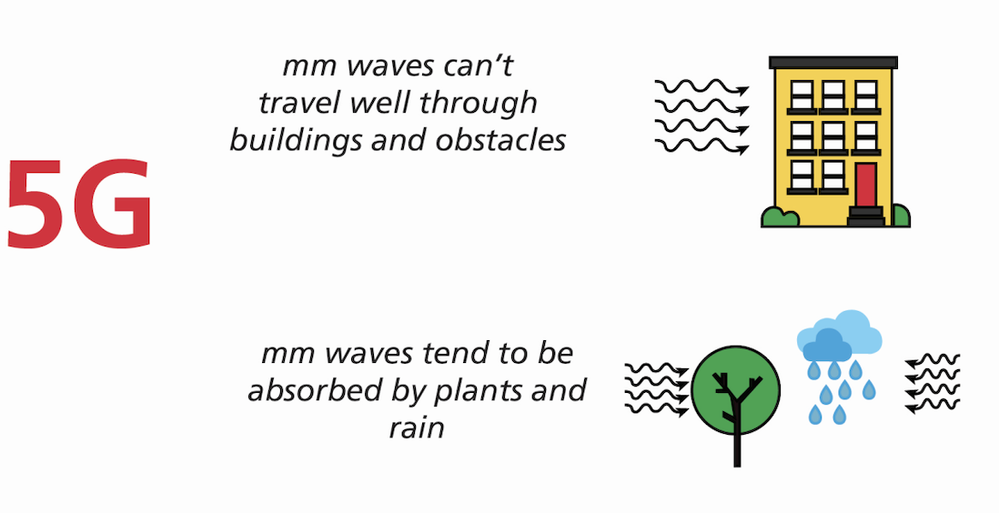

*Note.* (Shah, 2018).

### Role of Foliage in mmW Wireless Network Planning and Deployment

In 5G millimeter-wave (mmWave) networks, foliage or vegetation plays a crucial role by causing signal attenuation through scattering and absorption effects. The presence of leaves, branches, tree trunks, and twigs in foliage environments can obstruct and scatter mmWave signals, leading to path loss and reduced signal quality. Understanding the impact of vegetation on signal propagation is essential for optimizing network planning, predicting coverage, and implementing mitigation strategies to address signal attenuation in foliated areas. Studying foliage characteristics and their effects on path loss enables network operators to enhance the performance and reliability of mmWave networks in outdoor environments with dense vegetation (Barb et al., 2022; Farooq & Lokam, 2023).

Understanding vegetation loss helps in quantifying the path loss experienced by mmW signals in foliated environments, enabling more accurate network planning and optimization strategies. By considering foliage information in propagation models and simulations, network operators can better predict signal coverage, identify areas with high path loss due to vegetation, and implement mitigation techniques to enhance signal quality and reliability in mmW deployments. Therefore, studying foliage characteristics and their effects on path loss is essential for effectively deploying mmW technology in 5G networks and ensuring optimal performance in outdoor environments with dense vegetation (Barb et al., 2022; Farooq & Lokam, 2023).

Foliage depth plays a crucial role in determining the optimal deployment of mmW networks and the coverage area in the presence of foliage obstacles. Vegetation loss rises precisely proportional to the depth of the vegetation, as shown by the graph (Figure 5). The findings suggest that foliage attenuation can pose challenges to mmW or 5G network deployment by limiting signal propagation and coverage range, thereby affecting the overall network performance and user experience. As foliage depth increases, the optimal coverage radius of the mmW network decreases. This decrease in coverage radius is attributed to the increase in losses caused by foliage attenuation (Bose et al., 2024).

The propagation loss due to foliage or vegetation in network planning or deployment is addressed by utilizing foliage loss models, such as the ITU-R model, to quantify the attenuation caused by vegetation based on frequency and foliage depth. By incorporating these models into network planning processes, operators can assess and mitigate the impact of foliage on signal propagation, optimize site selection, adjust antenna height, employ beam steering techniques, and conduct foliage mapping surveys to enhance coverage, reliability, and performance in mmW communication links deployed in vegetated areas (Farooq & Lokam, 2023).

**Figure 5**   
*Vegetation Loss Simulation Results*

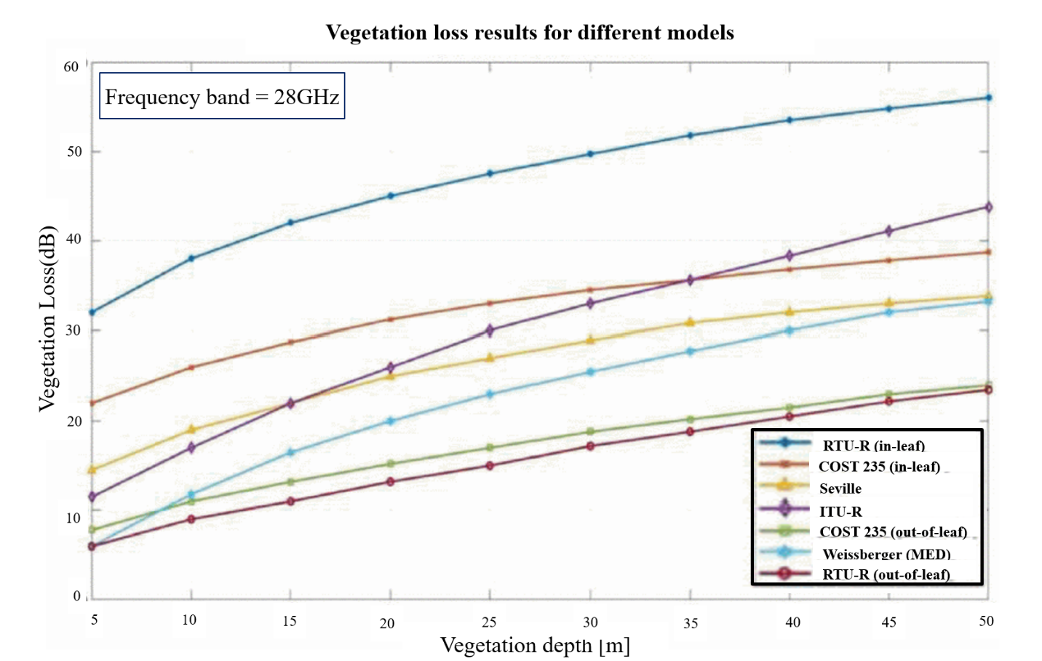

*Note.* (Barb et al., 2022).

### Traditional Datasets from LiDAR and UAV data

LiDAR technology offers a unique advantage in addressing foliage or vegetation challenges compared to photogrammetry with Unoccupied Aerial Systems (UAS). LiDAR can penetrate through vegetation to capture ground data, making it suitable for creating bare earth models or Digital Terrain Models (DTMs). Figure 6 below shows the collection of data using LiDAR and UAV methods. This capability allows LiDAR to effectively map terrain features even in areas with dense foliage or vegetation cover (Diab et al., 2022; Rogers et al., 2020). The benefits of LiDAR in comprehending foliage or vegetation include its sensitivity to vertical vegetation structure variations, enabling effective analysis in natural resources and forest applications. Additionally, LiDAR offers precise spatial information on vegetation shape and components, facilitating detailed foliage characterization and accurate tree species classification (Diab et al., 2022).

**Figure 6**   
*Illustration of Collection of Data in Lidar and UAV*

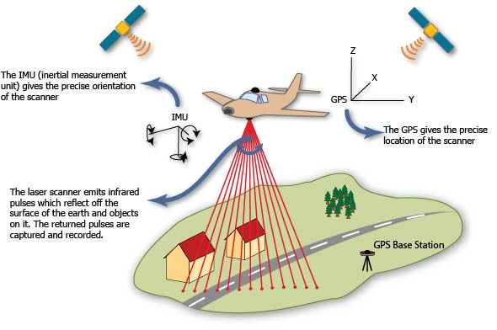

*Note.* (Airborne Laser Scanning, 2013).

However, LiDAR data comes with many challenges. Challenges involve the computational intensity of LiDAR data processing, the complexity of interpreting large LiDAR point cloud datasets in dense vegetation environments, and factors like sensor calibration and data noise affecting data quality and analysis accuracy (Diab et al., 2022). The LiDAR data can be complex and may require specialized knowledge, software tools, and computational resources. LiDAR data processing typically involves several steps, including data cleaning, point cloud classification, feature extraction, and model generation (Rogers et al., 2020).

Given the high volume of point cloud data generated by LiDAR sensors, processing can be computationally intensive and time-consuming. Users need to have a good understanding of LiDAR data structures, processing workflows, and software tools to effectively analyze and interpret the data. The limitations of LiDAR data include the high data requirements, labor-intensive and time-consuming data collection process, and challenges in processing due to factors such as data volume, model complexity, and generalizability (Lu & Jiang, 2024).

As a result of the massive amount of 3D data points, complex geospatial algorithms, and diverse parameter selection involved in tasks like point classification, ground point extraction, and generating final products such as Digital Elevation Models (DEMs) and 3D building models, LiDAR data processing is highly complex (Z. Li et al., 2018; Z. Wang & Menenti, 2021). This complexity is further exacerbated when dealing with large-scale LiDAR data sets that can reach tens of Terabytes in volume, stressing the storage and computational limits of a single computer (Z. Li et al., 2018). The other major significant limitation of LiDAR technology is its cost. Traditional airborne LiDAR systems can be expensive to acquire and operate, making them less accessible for some research projects or applications with budget constraints (Rogers et al., 2020).

Unmanned aerial systems (UAS) offer key benefits for characterizing vegetation complexity, including high spatial and temporal resolution for detailed monitoring, the ability to assess species diversity and map individual species, analyze ecosystem structure for biomass and stand complexity, integrate sensors for 3D information capture, and quantify stand complexity and volume. These advantages make UAS valuable tools for enhancing vegetation monitoring, biodiversity assessment, and ecosystem analysis (Müllerová et al., 2021). This dataset aims to enhance safety by detecting small and flying UAVs, support object detection tasks, facilitate the development of data-driven models for accuracy, ensure universality and robustness by including various objects, and enable benchmarking of advanced detection models. Overall, UAV Data aims to advance research in UAV detection, object detection, and machine learning fields (Zeng et al., 2021).

Like LiDAR, in the case of the UAV system, there are challenges, including regulatory constraints related to UAV operation, the cost of equipment such as specialized sensors, the complexity of data processing and analysis, the need to integrate UAV data with ecological processes, and staying updated on technological advancements. A collaborative approach between plant ecologists and remote sensing professionals will help overcome these challenges and maximize the benefits of UAVs in plant ecology research (Sun et al., 2021).

The integration of UAV-LiDAR and high-resolution optical data enhances the mapping of complex vegetation communities by improving classification accuracy, providing comprehensive data fusion, enabling better species discrimination, increasing spatial resolution, and streamlining data processing workflows. This integration allows for a more detailed and accurate understanding of ecosystem dynamics and species distribution in challenging environments like upland swamps (Banerjee et al., 2019).

### Digital Twins

The concept of digital twins has a rich history that dates to NASA’s Apollo program, where a digital twin of the spacecraft was effectively used during the Apollo-13 mission to simulate and resolve a life-threatening situation (Arnas et al., 2024). This historical event highlighted the power of digital twins in crisis management and problem-solving. Over the years, advancements in sensor technology and computational power have propelled the concept of digital twins forward, enabling their application in various fields beyond aerospace. Today, digital twins play a crucial role in environmental science, medicine, and engineering, revolutionizing how complex systems are understood, monitored, and optimized (Arnas et al., 2024; Kukushkin et al., 2022; J. Song & Le Gall, 2023).

Digital Twins are virtual representations of physical objects or systems that enable seamless data integration between the physical and virtual realms (National Academies of Sciences, Engineering, and Medicine, 2024). Digital Twins find applications in manufacturing, Industry 4.0, production planning, supply chain management, construction, and healthcare (Kukushkin et al., 2022; J. Song & Le Gall, 2023). In manufacturing, they enable predictive maintenance, performance optimization, and customer-centric product design. In healthcare, Digital Twins aid in disease detection, treatment experimentation, and surgical preparation through accurate human body modeling (Attaran & Celik, 2023; T. Deng et al., 2021).

Digital Twins provides companies with the ability to quickly detect and solve physical problems, design and build better products and realize value faster than before. They facilitate real-time monitoring, predictive analytics, automation, and intelligent decision-making, leading to enhanced operational efficiency and innovation. Figure 7 below depicts the digital twin ecosystem.

Digital twins are helping city planning by providing a mirrored digital representation of the city, enabling stakeholders to visualize and plan various aspects effectively. They enhance the visualization and planning of cities by incorporating detailed information on buildings and city elements. Integration of Building Information Modeling (BIM) and Geographic Information System (GIS) applications maximizes the potential of digital twins in city planning. Real-time data updates and efficient 3D model processing reduce the time between data updates and model adjustments, facilitating better decision-making in urban planning processes (Shahat et al., 2021).

**Figure 7**   
*Elements of the Digital Twin Ecosystem*

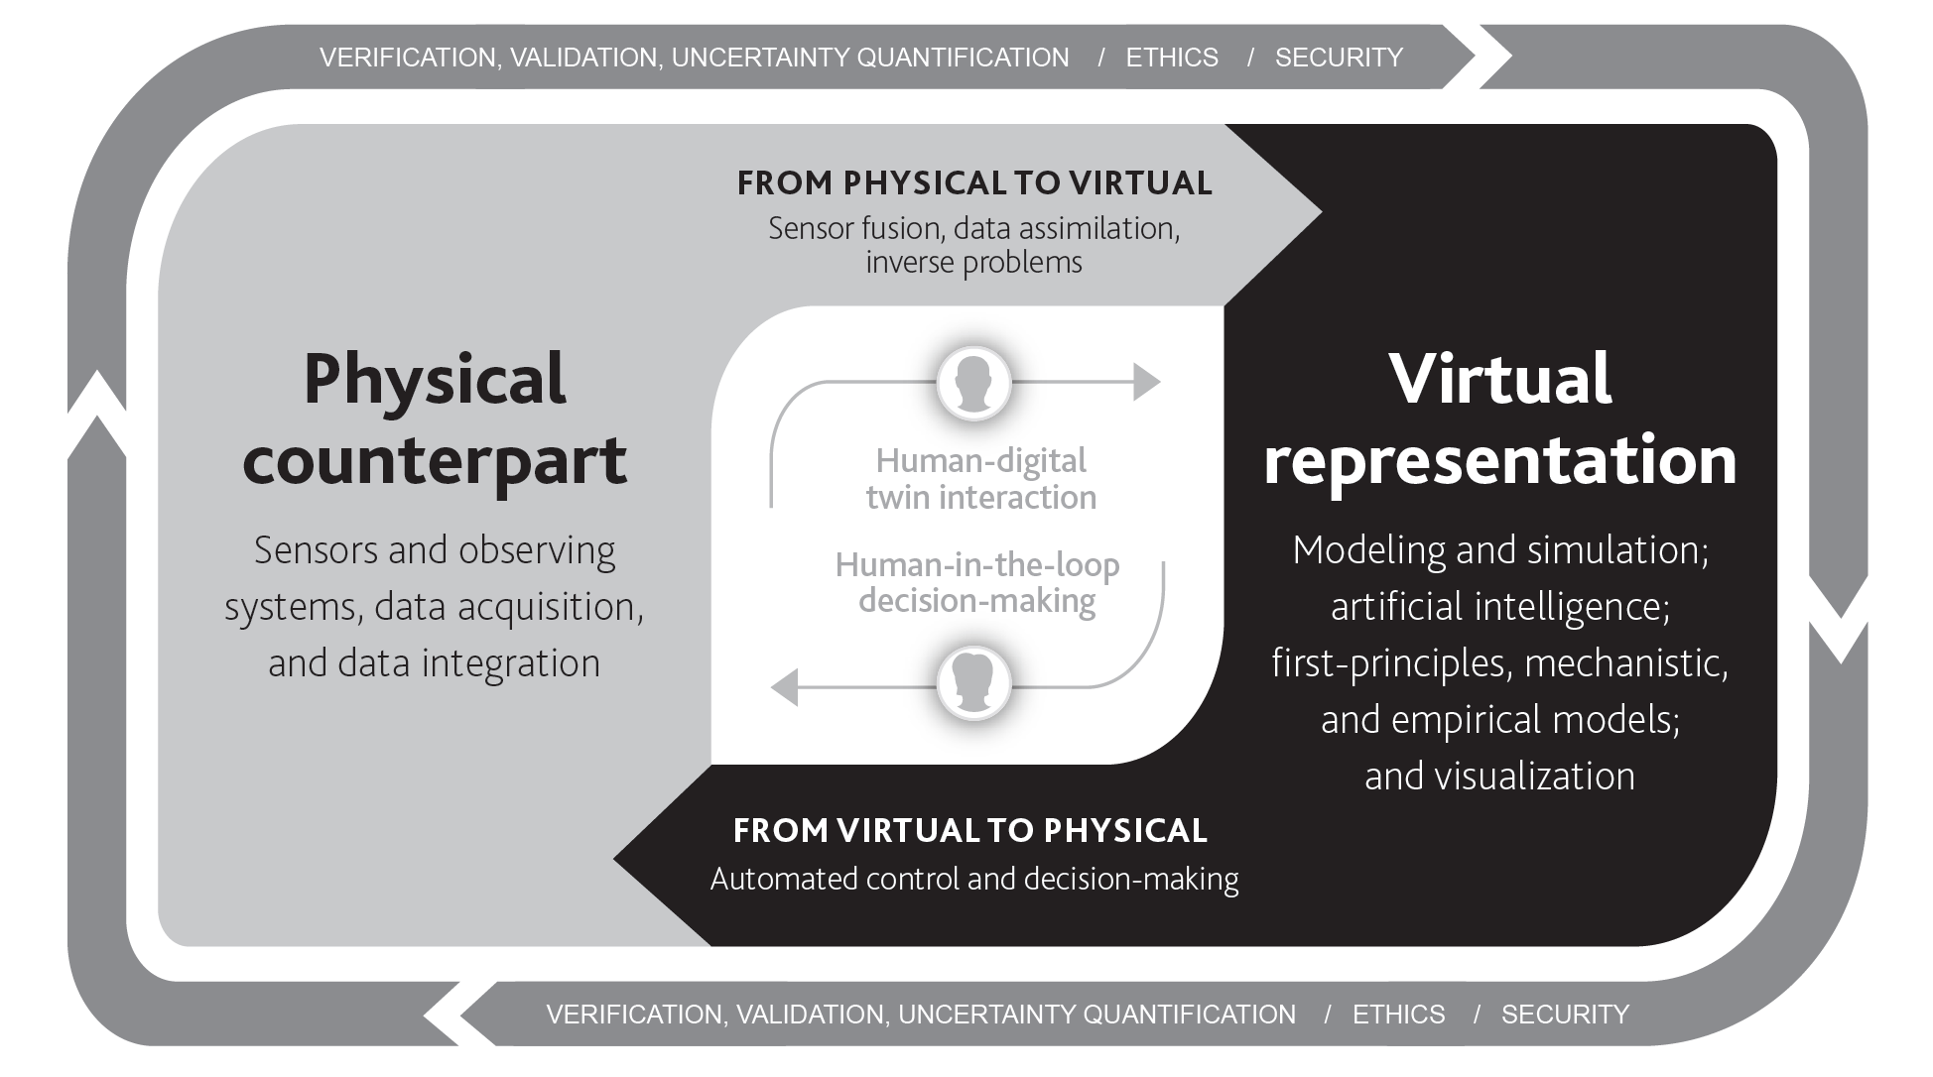

*Note.* (National Academies of Sciences, Engineering, and Medicine, 2024).

In the telecommunication industry, Digital Twins play a crucial role in network planning and deployment. By representing foliage in Digital Twins, telecom companies can simulate the impact of vegetation on signal propagation, enabling more accurate network planning and optimization. This representation helps in identifying potential signal blockages, optimizing antenna placements, and improving network coverage and performance (Attaran & Celik, 2023). They enable operators to visualize network infrastructure, predict performance, and proactively address issues to ensure optimal network operation (T. Deng et al., 2021). By representing foliage in a digital twin, telecommunication companies can simulate the impact of vegetation on network signals. This representation helps in optimizing antenna placement for better coverage, reducing signal interference, improving network performance, and enhancing overall connectivity in urban environments (T. Deng et al., 2021).

Overall, digital twins facilitate network planning by providing a realistic virtual environment for testing and optimizing network configurations, including foliage modeling, to ensure optimal performance in real-world scenarios (Kuruvatti et al., 2022).

### Machine Learning and Computer Vision in Environmental Modeling

Artificial Intelligence (AI) and Machine Learning (ML) technologies have revolutionized many fields, including the study of vegetation and foliage. This transformation has been driven by the exponential growth of computing power and the widespread availability of low-cost memory, which have helped process large datasets that were previously unmanageable (Sarirete et al., 2022). With this computational leap, researchers and technologists have been able to develop AI/ML computer vision image classification algorithms that can identify and classify different types of vegetation with remarkable accuracy using satellite imagery, aerial photographs, and ground-level observations (Raihan, 2023; Sarirete et al., 2022).

AI/ML takes advantage of these technological advancements by employing sophisticated models that learn from vast amounts of data, identifying patterns and features that are often imperceptible to the human eye. By utilizing semantic segmentation and object detection techniques, machine learning models can distinguish various species of trees and other vegetation.

Furthermore, AI/ML models can process and analyze data in real time, providing immediate insights into vegetation conditions and facilitating proactive decision-making. With AI/ML advancements and increased computational power and storage, these applications may become even more sophisticated, offering even more sophisticated tools for monitoring and managing the environment.

Machine learning plays a crucial role in identifying foliage or vegetation by enabling the development of predictive models for semantic segmentation (Sun et al., 2023). These models are trained using features such as geometric characteristics and height-based information to distinguish vegetation from other elements in the dataset. By utilizing machine learning algorithms like Random Forest and semantic segmentation, researchers can accurately filter out vegetation and focus on identifying archaeological structures hidden beneath the foliage. The integration of machine learning enhances the efficiency and accuracy of vegetation filtering (Mazzacca et al., 2022).

By processing images captured from drones or satellites, these computer vision and image analysis techniques can analyze various visual features such as color, texture, and shape to differentiate between different types of vegetation. Machine learning algorithms are employed to classify vegetation types, detect changes over time, and monitor environmental conditions. This application of computer vision and image analysis in vegetation identification offers a non-invasive and efficient way to study and manage ecosystems, agricultural lands, and natural resources (He et al., 2018; Savelonas et al., 2022).

### Data Acquisition Techniques for Digital Twin Development

The limitations of UAVs discussed in the article include regulatory constraints that vary by region, making it challenging to obtain permission for UAV operation; the cost of specialized equipment like hyperspectral cameras and LiDAR systems; the complexity of data processing and analysis; the need to extract more ecologically meaningful parameters from UAV data; and the necessity for plant ecologists to stay updated on technological advancements in UAV technology and remote sensing techniques (Sun et al., 2021).

Traditional airborne LiDAR systems can be expensive to acquire and operate, making them less accessible for projects with budget constraints. The cost of LiDAR data collection, equipment, and processing may pose a financial challenge for some users or research endeavors (Rogers et al., 2020).

LiDAR data collection can be limited by factors such as flight endurance, payload capacity, and operational range, especially when using LiDAR sensors mounted on Unoccupied Aerial Systems (UAS). These limitations may impact the efficiency and coverage of LiDAR data collection missions, particularly in terms of the size of the study area that can be effectively surveyed (Rogers et al., 2020).

Processing LiDAR data can be complex and time-consuming, requiring specialized software, expertise, and computational resources. Analyzing and interpreting LiDAR point cloud data involves data cleaning, classification, feature extraction, and model generation, which can be challenging for users without the necessary skills or resources (Rogers et al., 2020). These limitations underscore the practical challenges associated with utilizing LiDAR data for geospatial applications and emphasize the importance of addressing cost, collection, and processing constraints to effectively leverage the benefits of LiDAR technology in research and analysis (Rogers et al., 2020).

The use of digital twins in the telecommunications sector has become essential for providing a detailed model of physical network components and behaviors. It allows operators to monitor, simulate, and manage their networks efficiently, resulting in heightened efficiency, fewer outages, and better strategic decisions (L. U. Khan et al., 2022). In the field of network design and vegetation analysis for advanced 5G, 6G, and mmW communications, digital twins offer an excellent means of facilitating accurate modeling and simulations. Moreover, they facilitate rapid and cost-effective experimentation and accelerate the deployment of new technologies, making them a crucial component of an effective network planning process (Kuruvatti et al., 2022; Nguyen et al., 2021).

In the context of representing foliage in a digital twin for network planning, the virtual model can incorporate detailed information about the surrounding environment, including trees, buildings, and other obstacles that may impact signal propagation and coverage. By accurately modeling foliage in the digital twin, network planners can simulate how radio waves interact with different types of vegetation and optimize network design to mitigate signal attenuation and interference caused by foliage (L. U. Khan et al., 2022; Kuruvatti et al., 2022).

Furthermore, by leveraging advanced computer vision, image analysis, and machine learning algorithms, digital twins can analyze the impact of foliage on network performance, predict potential coverage gaps or signal blockages, and recommend strategic placement of network elements such as antennas and base stations to optimize signal propagation and ensure reliable connectivity in foliage-rich environments (L. U. Khan et al., 2022).

Overall, integrating foliage representation in digital twins for telecommunications network planning can help operators enhance network coverage, capacity, and quality of service by proactively addressing challenges posed by natural elements like trees and vegetation (Gabriele et al., 2023; L. U. Khan et al., 2022).

The representation of foliage or vegetation in Digital Twins is a key aspect of urban development projects. By utilizing automated procedural workflows, developers can create realistic representations of vegetation in Virtual Reality (VR) environments, allowing stakeholders to visualize and interact with green structures in urban settings. This approach enhances the engagement of citizens in the planning process, especially in areas where new developments are built in nature or forest areas (Thuvander et al., 2022).

Furthermore, Digital Twins is increasingly being used in networking planning and deployment processes. By integrating real-time sensor data, physical models, and simulations into Digital Twins, stakeholders can gain valuable insights into network performance, optimize resource allocation, and improve decision-making in urban infrastructure development. The use of Digital Twins in networking planning and deployment allows for more efficient and effective management of resources, leading to sustainable and smart city developments (Thuvander et al., 2022).

Using low-cost satellite or aerial imagery data sources like Google Imagery, applying computer vision, image analysis, and semantic segmentation machine learning techniques to extract the relevant information related to foliage or vegetation from the imagery, we can build the Digital twin representation of foliage.

### Research Gaps, Current Implementations and Future Directions

As foliage or vegetation is one of the factors impacting the advanced mmW, 5G, and 6G technologies deployment, current methods of identifying foliage for network planning (Barb et al., 2022; Bose et al., 2024; Chikhale et al., 2022; Pradeep et al., 2021; Zhang et al., 2019), such as LiDAR and UAV, are noted for their high cost and labor-intensive nature, which limits the flexibility for frequent updates. These methods also struggle to adapt quickly to changes in foliage due to seasonal variations or environmental shifts, posing significant challenges in maintaining up-to-date data for accurate network planning (Gaspari et al., 2022; Hematang et al., 2022; Rogers et al., 2020; Z. Wang & Menenti, 2021).

There is a promising avenue for future research involving the use of advanced computer vision and image analysis techniques on more accessible and cost-effective data sources like satellite, aerial images, and Google Street View. The development of digital twins that incorporate detailed, regularly updated foliage information can significantly enhance network planning. Such digital twins would allow for more precise assessments of foliage’s impact on signal propagation and path loss, leading to improvements in network coverage and throughput (J. Song & Le Gall, 2023).

The current DTs can be expanded in the future to include various other components that are affecting mmW, 5G, and 6G technologies, like street furniture (stop signs, sign boards, etc.) and building facades.

### Databases Accessed and Other Sources

In the current research study, to ensure a comprehensive and up-to-date review of the literature, the following sources, databases, and search engines are used: 1) NU library, 2) IEEE Xplore, 3) Google Scholar, 4) Science Direct, and 5) Springer Link.

The following sources are used to collect the aerial (satellite) images and street view images:

1. Maps Static API from Google (Google Maps Platform Documentation | Maps Static API | Google for Developers) (Google for Developers Maps Static API, n.d.).
2. Street View Static API from Google (Google Maps Platform Documentation | Street View Static API | Google for Developers) (Google for Developers Street View Static API Overview, n.d.).
3. Google Earth (<https://earth.google.com/web/)>
   1. The following open source, Open Street Map (OSM), Java Open Street Map (JOSM), is used to collect information on streets, roads, and building outlines.
4. Open Street Map (<https://www.openstreetmap.org/>)
5. Java Open Street Map (<https://josm.openstreetmap.de/>)

## Digital Twin Representation of Foliage Theoretical Framework

A digital twin refers to a digital replica of physical entities and processes, integrating IoT, AI, and real-time data to enable dynamic analysis and predictive modeling (Caprari et al., 2022; Huang et al., 2021). In the context of this study, using satellite and street view imagery, AI/ML computer vision, and image analysis techniques, the extracted foliage representation focuses on the accurate digital depiction of vegetative elements and their impact on wireless signal propagation. Using the Digital Twin model, network planners can describe how electromagnetic waves reduce in power density as they propagate through space and interact with natural obstacles (Almasan et al., 2022). The digital twin of an environment, including detailed foliage information, allows for the simulation of path loss due to foliage (Sabri et al., 2015), aiding in the optimization of network planning and performance. Enhanced foliage representation within a digital twin framework directly relates to more accurate estimations of network signal degradation and assists in designing more effective communication infrastructures by identifying suitable network node placement locations.

### Assumptions and Propositions

Integrating detailed and dynamic foliage information into digital twins can significantly enhance the accuracy of simulations reflecting real-world environmental impacts on signal propagation. Leveraging enhanced computational power and advanced machine-learning techniques improves the precision with which digital twins represent and process complex environmental data. This approach is grounded in the assumption that richer environmental data enables more accurate simulations of physical phenomena, particularly in how they affect technologies such as communication signals. Further, studies support the proposition that detailed environmental modeling enhances predictive accuracy in digital twin applications (Correia et al., 2023; Kang & Mo, 2024; Thelen et al., 2022).

### Origin and Development of the Framework

The theoretical framework for the digital twin representation of foliage is a sophisticated blend of environmental science, network engineering, and digital simulation technologies. The origins of this framework can be traced back to the broader concept of digital twins, which first emerged in the early 2000s. Notably, the idea was pioneered by Michael Grieves in 2003 during his tenure at the University of Michigan, initially focusing on manufacturing and aerospace sectors (VanDerHorn & Mahadevan, 2021). In these fields, digital twins served as virtual replicas of physical systems, providing ground for simulations that could predict mechanical wear and tear and process optimization without the risks and costs associated with physical testing.

Historically, digital twins have been associated with NASA's Apollo programs. In the Apollo 13 mission, NASA effectively used a digital twin of the spacecraft to simulate and resolve a life-threatening situation. It highlights the importance of using digital twins to manage crises and solve problems (Arnas et al., 2024). Over the years, this concept expanded into industrial applications, focusing on the predictive maintenance and operation of complex systems. More recently, the adaptation of digital twins in network planning, particularly integrating environmental factors such as foliage, is seen as an evolution in the precise design and deployment of telecommunications networks.

Over the years, the scope of digital twins has broadened significantly beyond its initial industrial confines. This expansion has been driven by technological advancements on the Internet of Things (IoT), artificial intelligence (AI), and big data analytics. These technologies have enabled the creation of more complex and dynamic digital twins capable of real-time data analysis and simulation. As such, the concept has been increasingly applied in fields like environmental science and network planning, marking a significant evolution from its industrial roots.

The intersection of digital twins with environmental science and network engineering reflects an increasingly interdisciplinary approach to technological applications. In environmental science, digital twins are used to model complex ecosystems or urban environments, allowing for detailed simulations of natural processes and human interactions. This capability is particularly valuable for studying the impact of various factors on foliage and vegetation, such as climate change, urban expansion, and ecological conservation efforts.

In the context of network engineering, digital twins facilitate the planning and optimization of telecommunications networks. They help in understanding how natural elements like foliage can affect signal propagation, particularly in the development of advanced communication technologies such as 5G and 6G networks. By simulating different scenarios, network engineers can anticipate potential issues and plan infrastructure, accordingly, enhancing network reliability and performance (Hui et al., 2023).

The convergence of these disciplines within the digital twin framework allows for a more comprehensive analysis and a better understanding of the interactions between technology and the environment. This interdisciplinary approach not only broadens the applicative landscape of digital twins but also enhances their practicality in tackling complex, real-world problems.

As the application of digital twins continues to evolve, they are expected to play a crucial role in sustainable development and smart city initiatives. By integrating environmental data with digital simulation and network planning, digital twins offer a powerful tool for policymakers, scientists, and engineers to make informed decisions that balance technological advancement with environmental conservation and societal needs. This ongoing development underscores the dynamic nature of the digital twin framework, highlighting its potential to adapt and grow in response to new challenges and technological opportunities (Alkhateeb et al., 2023; Hu et al., 2021; L. U. Khan et al., 2022; Nguyen et al., 2021).

### Relevant Studies

Several studies have explored the use of digital twins for urban planning and environmental management (Caprari et al., 2022; Schrotter & Hürzeler, 2020). For instance, the integration of digital twins with urban greenery to assess environmental benefits highlights a similar application, though not specifically targeting telecommunications.

AI technologies enhance the capabilities of digital twins in smart manufacturing by enabling efficient data analysis, improving predictive maintenance, optimizing production processes, enhancing decision-making, and facilitating personalized production. By leveraging AI algorithms, digital twins can analyze data effectively, predict maintenance needs accurately, optimize processes in real time, provide actionable insights for decision-making, and customize production to meet specific customer requirements (Huang et al., 2021).

DTs with foliage facilitate assessing path loss (Ko et al., 2020; P. Zhang et al., 2020) and thereby facilitate network planning, allowing for resource reservation reconfiguration to adapt to dynamic network conditions. Overall, DTs enhance network planning by providing granular insights, adaptability, and intelligence to optimize resource management and improve network performance in advanced networks like mmW/5G/6G (Hui et al., 2023; Zhou et al., 2022).

### Alternative Frameworks

While GIS is potent for spatial analysis and has been used extensively for environmental data integration, it lacks the dynamic and predictive capabilities of digital twins (Chaminé et al., 2021). Traditional simulation models offer detailed analyses but do not support the real-time updating and integration capabilities of digital twins (Angin et al., 2020; Capecchi et al., 2023; Hematang et al., 2022; Rogers et al., 2020; Z. Wang & Menenti, 2021).

The digital twin framework was chosen due to its ability to dynamically integrate and analyze complex datasets, including real-time environmental changes, which is essential for accurate network planning and adaptation in response to environmental changes (Hui et al., 2023).

The ~~Digital Twin~~DT, at its core, replicates the physical network and uses machine learning techniques to process network state descriptions and output relevant metrics. Unlike traditional network modeling tools, DTs take a data-driven approach by training models directly with real network data, enabling real-time operation and accurate representation of complex network environments. This approach allows for more efficient network control and management at shorter timescales, making DTs a more advanced and dynamic solution for modern communication networks (Almasan et al., 2022).

### Framework Relevance to the Study

The digital twin framework guides this study by providing a structured approach to simulate and analyze the impact of foliage on network performance. This directly relates to and supports the development of the problem statement (the impact of foliage on mmW networks), purpose statement (development of a digital twin for network planning), and research questions (What extent can a digital twin representation of foliage capture the characteristics and spatial distribution of foliage in natural settings?).

By utilizing the digital twin framework, this study aims to bridge the gap between theoretical network optimization and practical, real-world applications, ensuring that network deployments are both resilient and efficient against environmental challenges (Almasan et al., 2022; Hui et al., 2023; J. Song & Le Gall, 2023). DTs can leverage the power of data-driven modeling to enhance network performance evaluation and drive innovation in the field of networking (Hui et al., 2023).

## Data Ethics and Legal Frameworks in the Study of Digital Twin Representation of Foliage

In creating digital twins, Google Street View and Aerial imagery are widely used. There are several ethical considerations to be considered. Collection, processing, and dissemination of imagery that may include identifiable features of individuals’ properties are central to these concerns. The ethical use of data raises issues of privacy, autonomy, and control over personal information.

### Data Ethics and Privacy Concerns in the Collection and Use of Google Imagery Data

**Figure 8**   
*Some of the Key Ethical Considerations*

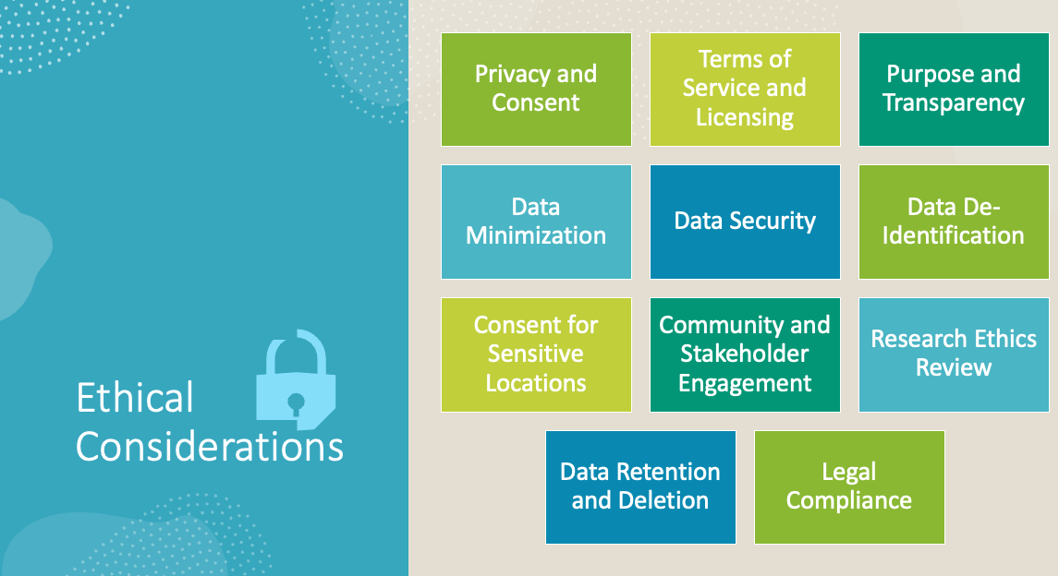

Images captured by Google’s aerial and street view images provide detailed visual information about private residences, businesses, and public places, sometimes including images of identifiable individuals. In order to handle this data ethically, it must take individuals’ privacy rights into account, ensuring that imagery is used in a way that does not violate privacy or misuse it. Some of the key ethical considerations outlined in Figure 8.

Privacy is a priority for Google. In order to protect the privacy of individuals, Street View imagery is blurred to obscure faces and license plates. Consider privacy concerns when using Street View imagery provided by users and adhere to Google’s guidelines (Google-Contributed Street View Imagery Policy, n.d.).

### Transparency and Consent

Transparency in how data is collected, what it is used for, and who has access to it is vital. For imagery used in digital twins, stakeholders should be informed about the data’s scope and purpose. Most Google’s mapping products (such as Google Maps, Google Earth, and Street View) do not require a user request. The use of these products is permitted if you adhere to their Terms of Service and guidelines (Brand Resource Center | Products and Services - Geo Guidelines, n.d.).

Adding annotations to maps (points, lines, labels) will allow you to personalize them. However, it is important not to alter the appearance of Google Maps, Google Earth, or Street View in any significant way. The product interface colors cannot be changed, or attributions cannot be removed (Brand Resource Center | Products and Services - Geo Guidelines, n.d.)

### Data Security

Ensuring the security of data to prevent unauthorized access and use is a crucial ethical obligation. This includes implementing strong data encryption, access controls, and regular audits to safeguard the data throughout its lifecycle. In the current study, only objects of interest (foliage/vegetation) coordinates like latitude and longitude are stored.

### Social Justice Implications

The use of aerial and street view imagery in the context of digital twins necessitates a careful consideration of social justice implications, including:

Equity. It is critical to ensure that the advantages derived from digital twins, such as enhanced urban planning and more effective environmental monitoring, are equitably shared among various socio-economic groups. This involves proactive measures to ensure that no community is left behind or disproportionately benefits from the technology.

Non-discrimination. Measures must be in place to prevent the misuse of data in ways that could discriminate against vulnerable or marginalized groups. For example, data collection and analysis methods should be designed to avoid unintentionally targeting or excluding particular demographics based on factors like location, economic status, race, or ethnicity.

Community Impact. The process of data gathering should include an evaluation of its impact on local communities. This involves not only assessing potential disruptions or negative effects but also actively engaging with community stakeholders. This engagement is crucial for addressing any concerns, securing community support, and ensuring that the project aligns with the interests and needs of those it affects.

### Regulatory Compliance

Complying with local and international laws regarding data privacy, such as General Data Protection Regulation (GDPR) in Europe or Californica Consumer Privacy Act (CCPA) in California, is essential. These regulations provide a framework for addressing many of the ethical concerns related to privacy and data protection.

Ethical Guidelines and Frameworks. EU-U.S. and Swiss-U.S. Data Privacy Frameworks: According to Data Privacy Framework (DPF) (Data Privacy Framework) certification (Data Privacy Framework, n.d.), Google adheres to the EU-U.S. and Swiss-U.S. DPF and the UK Extension to the EU-U.S. DPF, as outlined by the US Department of Commerce regarding the collection, use, and retention of personal information from the EEA, Switzerland, and the UK. According to the DPF Principles, Google LLC (and its wholly owned US subsidiaries, unless explicitly excluded) adheres to them. Any personal information shared by Google with third parties under the Onward Transfer Principle for external processing on our behalf remains Google’s responsibility (Privacy and Terms – Google, n.d.).

Belmont Report. Belmont Report’s principles (respect for persons, beneficence, and justice) provide a moral framework that emphasizes the protection of individuals and the equitable distribution of benefits and burdens (Nagai et al., 2022).

Association for Computing Machinery (ACM). ACM Code of Ethics and IEEE Standards offer guidelines and best practices for professionals handling data, ensuring ethical decision-making that aligns with broader societal values (The Code Affirms an Obligation, n.d.).

### Transfer of Data

As Google maintains servers around the world, information may be processed on servers located outside of your country of residence. There are differences in data protection laws among countries, with some providing more protection than others. The Privacy Policy applies the same protections regardless of where your information is processed (Privacy and Terms – Google, n.d.). Additionally, Google complies with certain legal frameworks related to data transfer (Data Transfer Frameworks – Privacy and Terms – Google, n.d.), such as those described in: a) European Commission adequacy decisions (Data Protection Adequacy, n.d.), b) UK adequacy regulations (A Guide to International Transfers, 2024), and c) Swiss adequacy decisions (Federal Data Protection and Information Commissioner (FDPIC), n.d.).

### Addressing Bias and Ensuring Fairness

The algorithms that process these images should be designed so that biases do not persist or become more pronounced. In order to ensure algorithms, perform equally across a variety of geographic and demographic scenarios, diverse data sets must be used during the training and validation of models (Bromm et al., 2020).

To mitigate bias and ensure fairness, it is critical that the algorithms used to process imagery from platforms such as Google’s aerial and street view are carefully designed to avoid the perpetuation or exacerbation of existing biases. This involves employing algorithms that perform consistently across various geographic and demographic contexts, necessitating the use of diverse datasets during the training and validation phases of model development.

Furthermore, integrating social justice principles with data ethics requires an integrated approach that extends beyond mere legal compliance to consider the wider societal impacts and the rights of individuals. This comprehensive approach ensures that the use of technologies like Google’s aerial and street view imagery not only advances in terms of technical capabilities but also aligns with higher standards of ethical responsibility and social (Fairness: Types of Bias, n.d.; Overview – Google Earth, n.d.; “Responsible AI at Google,” n.d.).

By adopting such rigorous frameworks, researchers and technologists can work toward the development of technologies that are not only innovative but also inclusive and fair, promoting a more equitable distribution of technology’s benefits.

## Summary

The theoretical framework for digital twin representation of foliage, emphasizing the concept of a digital twin as a virtual replica of physical entities and processes that integrates IoT, AI, and real-time data for dynamic analysis and predictive modeling. The study aims to utilize satellite and street view imagery, AI/ML computer vision, and image analysis techniques to extract accurate foliage representations within the digital twin model, enabling a deeper understanding of how vegetation impacts wireless signal propagation (Kukushkin et al., 2022; J. Song & Le Gall, 2023).

Digital twins contribute to more efficient engineering processes by optimizing operations, enabling predictive maintenance, facilitating resource management, supporting design, and testing through virtual prototyping, and enhancing data-driven decision-making. By creating virtual representations of physical assets, engineers can monitor performance, anticipate maintenance needs, analyze resource usage, streamline design processes, and make informed decisions based on real-time insights. This technology helps improve productivity, reliability, and cost-effectiveness in engineering operations (National Academies of Sciences, Engineering, and Medicine, 2024; Shahat et al., 2021).

The research further explores the significance of the study in advancing network planning and deployment strategies, particularly in smart city environments. By creating virtual replicas of urban landscapes that accurately reflect the spatial distribution and physical characteristics of foliage, network engineers and planners can simulate and analyze how vegetation influences network performance, resulting in more informed decision-making and optimized network designs (Barb et al., 2022; Bose et al., 2024; Farooq & Lokam, 2023). Through machine learning and computer vision, digital twins are created to test a variety of network configurations as they interact with urban greenery, ultimately improving network reliability in densely vegetated areas by applying machine learning and computer vision (Raihan, 2023; Sarirete et al., 2022; Sun et al., 2023).

Additionally, the research delves into ethical and legal frameworks for digital twin foliage representation. To ensure compliance with data protection laws, intellectual property rights, and privacy laws, it emphasizes the importance of ethical considerations in data collection, analysis, and utilization within the context of digital twin technology (Data Privacy Framework, n.d.; Data Transfer Frameworks – Privacy and Terms – Google, n.d.; Privacy and Terms – Google, n.d.). Considering these ethical and legal considerations, the study aims to promote responsible and sustainable technology use in developing digital twins of foliage.

With a focus on foliage, the research combines advanced technologies and environmental understanding to create a nuanced digital replica of natural environments. Using digital twin models, network planners, environmental scientists, and stakeholders can better understand how foliage influences wireless signal propagation dynamics. A special emphasis is placed on modern connectivity challenges and the deployment of millimeter-wave (mmW) networks in this study, which will contribute greatly to wireless communication technology advancement (Barb et al., 2022; Farooq & Lokam, 2023).

~~In summary, the literature review provides a comprehensive overview of the theoretical foundations, technological aspects, and ethical considerations essential for constructing a digital twin representation of foliage. By synthesizing existing literature and theoretical frameworks, the study sets the stage for the subsequent research methodology and design, laying the groundwork for the innovative exploration of digital twin technology in the context of foliage representation and wireless signal propagation.~~

In summary, this study provides a comprehensive overview of the theoretical foundations, technical aspects, and ethical considerations behind creating a digital twin of foliage. This study lays the groundwork for further research methodology and design by synthesizing existing literature and theoretical frameworks, laying the basis for innovative explorations of digital twin technology in the context of foliage representation. By creating a digital twin of foliage, it enables the deployment of advanced wireless communication technologies in areas with dense vegetation, improving signal strength and coverage. This breakthrough can revolutionize the way wireless networks operate, leading to more reliable and efficient communication systems.

Checklist:

Briefly restate the key points discussed in the chapter. Review the headings and/or table of contents to ensure all key points are covered.

Highlight areas of convergence, divergence, and gaps in the literature supporting the study's need. This discussion should logically lead to Chapter 3, where the research methodology and design will be discussed.

# Chapter 3: Research Methodology

The proliferation of connected devices has driven a demand for higher bandwidth, higher throughput, and lower latency, leading to the development of millimeter wave (mmW) networks (Barb et al., 2022). To fully exploit the potential of 5G technology, these networks must overcome formidable obstacles, such as scattering and atmospheric absorption, as well as the impact of foliage and building facades (De Beelde et al., 2023; Pradeep et al., 2021; Zhang et al., 2019). Using Google Street View and satellite images (Capecchi et al., 2023) in conjunction with computer vision and machine learning techniques (Mazzacca et al., 2022), this study offers an accessible means of addressing these challenges.

Foliage, which influences the deployment of higher-frequency networks (Zhang et al., 2019), has traditionally been measured using labor-intensive and costly methods (Hematang et al., 2022; Zeng et al., 2021), such as unmanned aerial vehicles and light detection and ranging (Q. Chen et al., 2022; Zeng et al., 2021). Figure 6 illustrates how data is collected through Light Detection and Ranging (LiDAR) and unmanned aerial vehicles (UAV). The need to repeatedly update this data often makes these methods impractical. With technology evolving, a new paradigm is emerging in the form of digital twins (DT) (Angin et al., 2020; Cureton & Hartley, 2023; Zhao et al., 2022).

The study aims to create a DT of an environment incorporating foliage data utilizing open-source and low-cost resources. In addition to optimizing coverage and user experience, this DT holds promise for network operators planning high-frequency network deployments (Bose et al., 2024). Using images from Google Street View and satellites and applying machine learning algorithms, such as segmentation, this study emphasizes the role of foliage in mmW networks.

A digital twin concept developed here could also apply to building facades, traffic signs, road markers, and pedestrian crossings. Through this comprehensive approach, technology is now poised as a key enabler of more efficient, adaptable, and cost-conscious deployment and management of mmW networks.

## Digital Twin Representation of Foliage Research Methodology and Design Process Diagram

Figure 9 describes the entire process of research methodology and design process from the selection of the region for which DT of foliage needs to be built, data collection to creation of a digital twin representation of foliage (DTRF), which can be used by network planners for smart and efficient placement of network nodes for providing better coverage and greater user connectivity (Bose et al., 2024). DTRF can also be used by city planners (Lehtola et al., 2022) for various applications such as city development, greenery monitoring, density of foliage, etc. (Capecchi et al., 2023). Network planners utilize the digital twin representation of foliage to strategically determine the optimal placement of network nodes (Alkhateeb et al., 2023).

By leveraging the DTRF, network planners or operators can ensure better coverage and improved user connectivity, resulting in a more efficient and reliable network infrastructure. The DTRF also provides valuable insights for city planners regarding greenery monitoring, foliage density, and other aspects of urban development (Capecchi et al., 2023; Lehtola et al., 2022). DTRF can be utilized to monitor greenery by providing real-time data on foliage health and condition in a particular region. This information can be used to assess the impact of urban development on green spaces, identify areas in need of conservation efforts, and track changes in vegetation over time.

**Figure 9***Research Design Methods for Digital Twin Representation of Foliage*

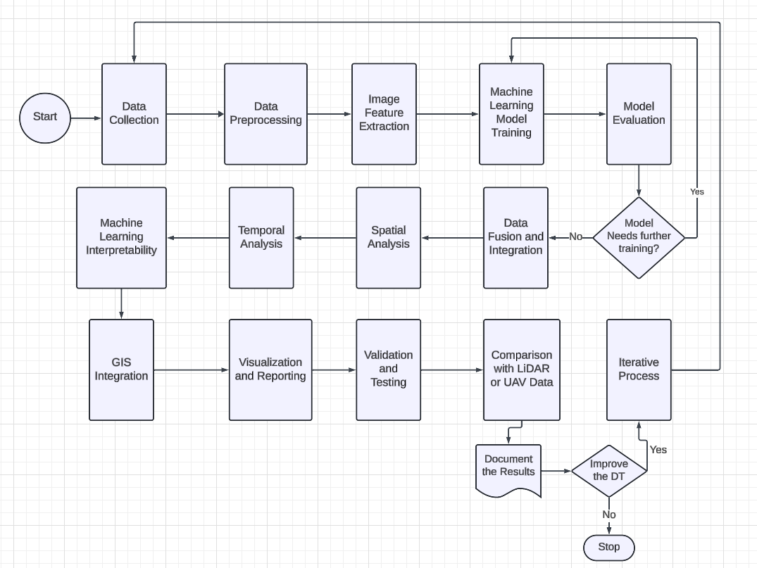

The DTRF also provides valuable insights for city planners regarding greenery monitoring, foliage density, and other aspects of urban development (Mylonas et al., 2021). DTRF can be utilized for monitoring greenery by providing real-time data on foliage health and conditions in a particular region (Gaspari et al., 2022). This information can be used to assess the impact of urban development on green spaces, identify areas in need of conservation efforts, and track changes in vegetation over time. DTRF can help evaluate green infrastructure projects and guide decision-making for sustainable urban planning (Attaran & Celik, 2023).

## Research Methodology and Design of Digital Twin Representation of Foliage

### Data Collection/Acquisition

Aerial and street view imagery are used to gain comprehensive foliage data using platforms like Google Maps APIs (Google for Developers Maps Static API, n.d.; Google for Developers Street View Static API Overview, n.d.), supplemented by LiDAR data for detailed three-dimensional foliage structure insights. The process involves leveraging Google's APIs to collect high-resolution street views and aerial images of the target areas (Figure 10), which serve as the primary data sources for identifying and analyzing foliage (Google for Developers Maps Static API, n.d.; Google for Developers Street View Static API Overview, n.d.). Additionally, LiDAR and UAV datasets of the same areas are obtained for validation purposes, allowing for comparison against the digital twin models created from Google imagery or any third-party vendors aerial imagery. This multi-faceted approach ensures robust and accurate representations of foliage within the digital twin framework.

As outlined in Figure 10, it first ~~it~~ starts identifying region of interest where a polygon is drawn around the region of interest. Secondly, road lanes or street lanes are extracted inside the region of interest along with their names. Thirdly, points are placed along the road or street lanes 30 meters apart. The distance between the points is placed such that when the aerial images are captured at the desired zoom level, for the pixel sizes desired, there will be less overall vegetation or foliage between the images. This will reduce the duplication of vegetation or foliage. Fourth, aerial images of the region at these points should be extracted. Fifth, start annotating the collected images for the instance segmentation computer vision machine learning model.

**Figure 10**   
Data Collection Strategy

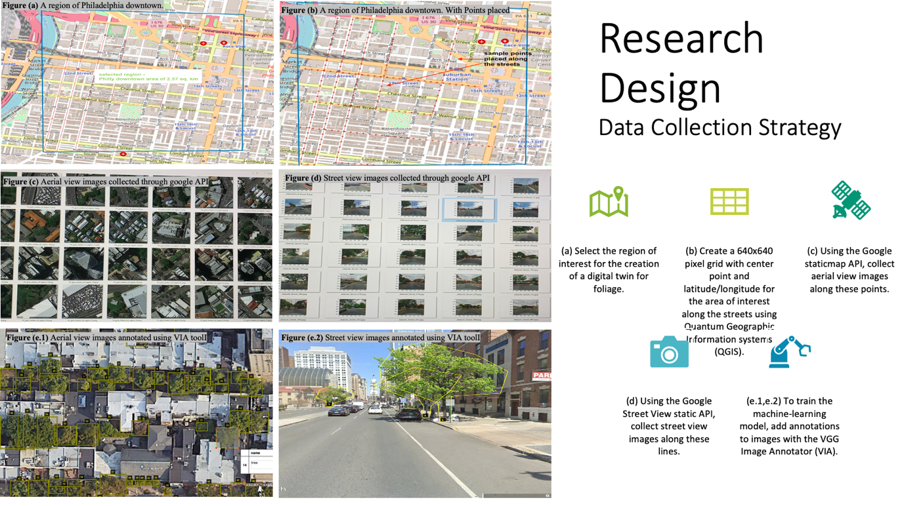

### Data preprocessing

Data preprocessing is crucial in image analysis, especially when dealing with foliage representation. Data preprocessing involves various techniques, such as image normalization (Kumar et al., 2023), noise removal, and image enhancement, to improve the quality of the foliage representation. These techniques help reduce noise, improve contrast, and enhance the overall appearance of the foliage, which in turn leads to more accurate analysis and interpretation of foliage information from aerial images. Here are some of the guidelines followed during Data Preprocessing:

#### Standardized Data.

Standardizing the data during the preprocessing stage is important because it ensures that all the input features have the same scale and distribution, allowing for fair comparisons and preventing certain features from dominating the analysis. Standardized data also helps improve machine learning algorithms' performance by reducing the effects of outliers and making the training process more stable. In current ML training, all the images are resized to a uniform size, for example, 640x640 pixels, to ensure consistency across the dataset. In the current study, the images captured are 288x288 (Figure 11). To avoid duplicate images, the image pixel size is calculated based on the camera zoom level and the distance between the images along the road. In the current study, Google aerial images are collected at zoom level 20, and a distance of 30 meters is maintained between points on the road. Maintain standard channels (e.g., RGB) and consider normalizing pixel values.

**Figure 11***Standardized Image Pixels*

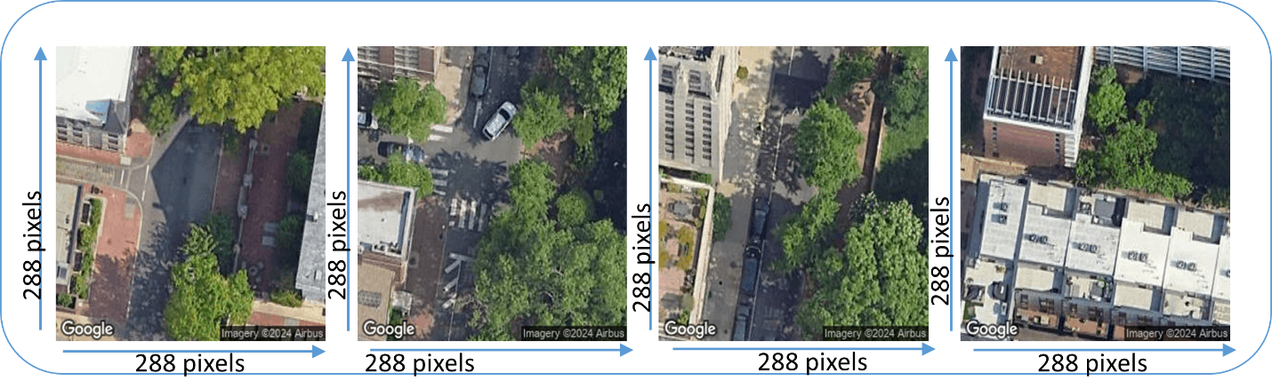

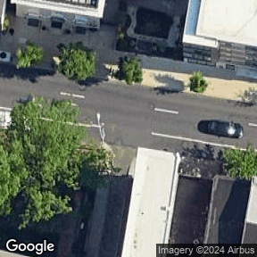

#### Verify foliage representation.

Ensure that the foliage is accurately represented in the images without any misrepresentation. Accurate foliage representation in image analysis is crucial because it directly impacts the reliability and accuracy of the analysis results. Misrepresentation of foliage can lead to incorrect measurements, misclassification of vegetation types, and inaccurate interpretation of vegetation health and condition. Therefore, ensuring accurate foliage representation through data preprocessing techniques is essential for obtaining reliable and meaningful insights from aerial images. Using image segmentation techniques, isolate the foliage from the background. As part of the preparation for training instance ML algorithms like Mask RCNN (Chen et al., 2021; He et al., 2018) or You Only Look Once (YOLO) (Hussain, 2023; Jocher et al., 2023; Wang et al., 2023) instance segmentation, annotation tools like VIA (Dutta & Zisserman, 2019) and Roboflow (“Getting Started with Roboflow,” 2024) are utilized for annotating foliage or vegetation information (Figure 12).

**Figure 12**   
*Annotations Tools*



Annotation tools such as VIA and Roboflow are critical in accurately annotating foliage information in aerial images. These tools use smart polygons to precisely outline and label the foliage, which ensures that the data is properly prepared for the training of machine learning algorithms like Mask RCNN or YoloV8-instance segmentation (YOLO version 8) (Figure 13).

**Figure 13***Annotations Using VIA or Roboflow*

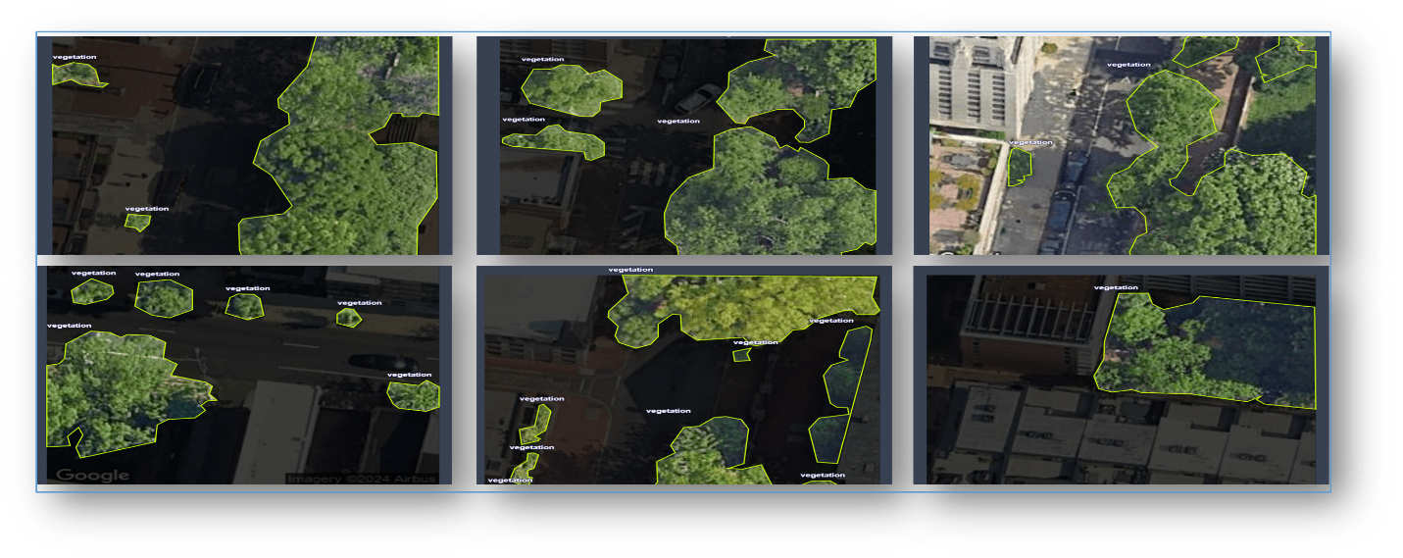

#### Remove duplicates/artifacts.

By eliminating duplicates and artifacts, the annotation tools help to create high-quality datasets that enable more accurate analysis and interpretation of the foliage representation. One technique for removing duplicates and artifacts in the datasets is using image difference. This method involves comparing multiple images of the same foliage representation and identifying discrepancies or anomalies. By subtracting one image from another, the differences can be highlighted, allowing for the removal of duplicates and artifacts (Soares et al., 2024).

Another approach to identifying duplicate objects in subsequent images (in case there is an overlap in images) is to handle the duplicate count of objects in the images through a novel graph-based method that incorporates multiple attributes to improve duplicate removal and counting accuracy. The method involves analyzing attributes such as velocity, direction, state, color, and distance for each detected object. These attributes are combined and used to assign weights to a Ford–Fulkerson graph algorithm, which effectively solves the duplicate removal problem. By utilizing this approach, the study aims to ensure precise counting results by detecting and removing duplicated objects based on their multiple attributes (Soares et al., 2024).

This can help to restore the integrity of the foliage representation and remove any unwanted artifacts. Employ algorithms to detect and remove duplicate images to avoid bias in the dataset (Thyagharajan & Kalaiarasi, 2021). Clean up artifacts, such as random noise or irrelevant objects, which may skew the analysis. In the current research study, to overcome the duplicates or overlap of images, aerial images are taken at a distance of 30 meters between points placed in the region selected, at a zoom level of 20, with an image size of 288x288 pixels.

### Image Feature Extraction

Image Feature Extraction is a process that involves several steps. First, the image needs to be preprocessed by resizing, cropping, and adjusting the color if necessary. Then, techniques such as edge detection, texture analysis, and color histograms can be applied to extract specific features from the image. Finally, these extracted features can be used for object recognition, image classification, or content-based image retrieval tasks. Extract color, texture, and shape from foliage through image processing (Figure 14).

The feature extraction process returns one or more features from an image. Features are typically scalars like area or aspect ratio or short vectors like the coordinates of an object or the parameters of a line. Image feature extraction is a necessary step in extracting foliage information from image data (Corke, 2022).

**Figure 14**   
*Foliage/Vegetation Extraction from Aerial Images*

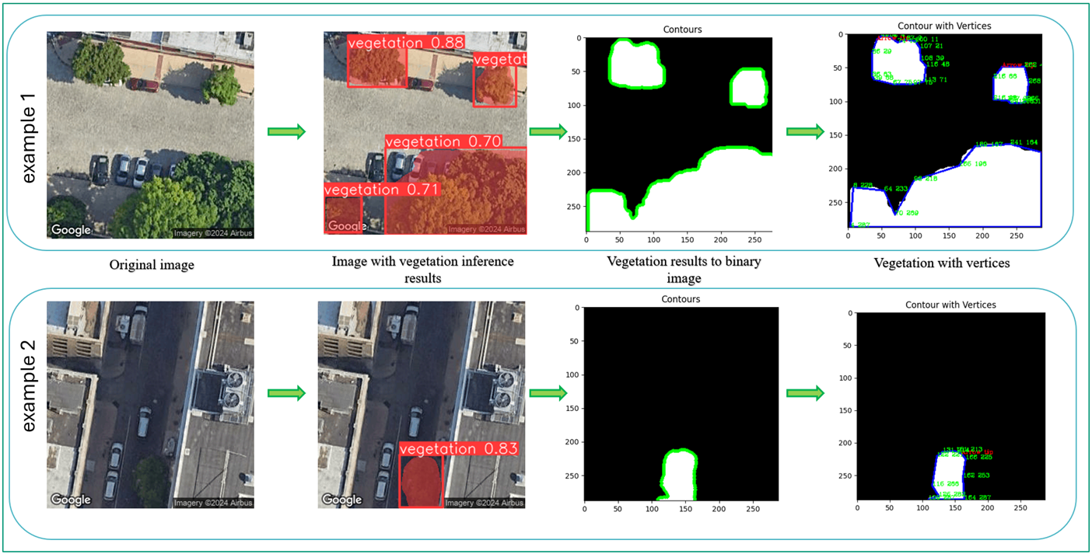

The extracted features from foliage using image processing can be utilized for tasks such as plant species identification, vegetation analysis, and environmental monitoring. These features can provide valuable insights into the foliage's health, growth patterns, and biodiversity, allowing for more informed decision-making in fields like agriculture, forestry, and ecology.

In the current study, the extracted foliage information is mapped to geo coordinates and then used for analyzing the impact of path loss of mmW radio signal, thereby assisting the network operators or planners in selecting the best suitable location for the placement of network nodes for maximum user data connectivity and higher user data rate in the region.

### Image Processing

The segmentation algorithms used for foliage analysis play a crucial role in distinguishing and classifying foliage from other elements captured in images. This involves employing advanced techniques such as edge detection, color analysis, and texture classification to identify vegetation accurately (Mehmood et al., 2022). Further steps include normalization and calibration of the collected images to address variations in lighting, scale, and perspective. This process often utilizes known reference objects within the images, enabling precise calibration for distance and height measurements (Yang et al., 2022). Additionally, image processing techniques are applied to extract salient features relevant to foliage, including tree canopy outlines, heights, and densities, thereby providing a comprehensive understanding of the vegetation in the analyzed area.

Segmentation allows us to obtain the complete area of a class image. While detection algorithms focus on detecting objects, segmentation provides a more precise understanding by delineating objects' exact boundaries. This leads to more accurate localization and understanding of the objects present in the image. However, segmentation typically involves higher time complexity than detection algorithms because it requires additional steps, such as separating annotations and creating the model. These additional steps in the segmentation process include image preprocessing to enhance features, selecting an appropriate segmentation algorithm or model, manually annotating the training data with pixel-level labels, and training the model using these annotated images. While these steps may increase the time complexity, they are necessary to achieve the accurate and fine-grained delineation that segmentation offers. Despite this drawback, segmentation's increased precision can outweigh computational costs in tasks where precise object delineation is crucial (N. Wang et al., 2023).

In the current research methodology, from aerial imagery of the region, foliage objects are extracted and mapped to geo coordinates like latitude and longitude of the contours. To optimize network planning, the contours of the foliage are used to determine the area of the foliage. This information helps in understanding the impact of foliage on the region.

**Figure 15**   
*Measuring Unknown Objects from Known Reference Objects (From a Calibrated Image)*

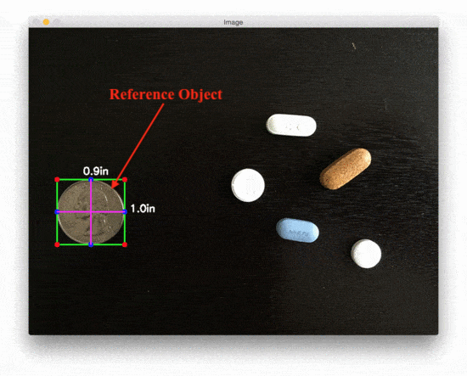

*Note.* Measuring the size of pills in an image by using the USA Quarter coin as a reference object (Yang et al., 2022).

To ensure accurate measurement of surrounding objects during calibration phases, road widths will be essential in future studies or extension of the current study (W. Wang et al., 2018). This approach is grounded in the principle that road widths, which are typically standardized or can be accurately measured, provide a reliable scale against which the sizes of nearby objects can be gauged. By establishing the road width as a constant reference point, we can apply mathematical and imaging algorithms to extrapolate the dimensions of other entities within the image, such as trees (Yang et al., 2022). This process involves analyzing the proportional relationship between the known width of the road and the pixel dimensions of trees in aerial or street view images, thereby enabling the precise calculation of tree heights. This calibration technique is pivotal, as it ensures that our measurements of natural features within the environment are both accurate and consistent, laying a solid foundation for further analysis and the development of digital twin models that reflect the true characteristics of the physical world (Figure 15).

### Machine Learning Model Development

Utilizing machine learning models, particularly deep learning frameworks like YOLOv8 and Mask R-CNN, for instance, segmentation to distinguish individual trees and types of vegetation (J. Zhang et al., 2021).

**Table 1**   
*YOLO-V8 Vs Mask R-CNN*

|  |  |  |
| --- | --- | --- |
|  | **YOLO - V8** | **Mask R-CNN** |
| **Architecture** | YOLOv8 is a one-stage object detection model that is designed for speed and accuracy. It employs a single neural network to predict bounding boxes and class probabilities directly from full images in one evaluation (Sapkota et al., 2023). | Mask R-CNN is a two-stage deep learning model that extends Faster R-CNN by adding a branch to predict object masks in parallel with the existing branch for bounding box detection. It is renowned for its accuracy and efficiency in instance segmentation tasks (Sapkota et al., 2023). |
| **Approach** | YOLOv8 uses a direct approach to object detection without the need for a region proposal step. This leads to faster processing speed and fewer false positives in certain scenarios (Sapkota et al., 2023). | Mask R-CNN follows a two-stage process involving generating region proposals before classifying and segmenting objects. This can sometimes result in the inclusion of non-target areas and may be more sensitive to lighting variations (Sapkota et al., 2023). |
| **Advantages** | Known for speed and efficiency in object and efficiency in object detection tasks. A direct approach without a region proposal step leads to faster processing and fewer false positives. Effective in excluding similar non-target areas (Casas et al., 2024). | Excels in precise instance segmentation tasks, especially in complex scenarios with densely packed or partially obscured objects. High precision in complex segmentation scenarios (Casas et al., 2024). |
| **Performance** | Achieved high precision and recall metrics for single-class and multi-class segmentation tasks. Demonstrated adaptability across different orchard conditions (Sapkota et al., 2023). | Showed slightly lower performance in precision and recall metrics compared to YOLOv8 in the evaluated tasks (Sapkota et al., 2023). |

While YOLOv8 and Mask R-CNN have different approaches and strengths, the choice between them depends on the specific requirements of the instance segmentation task. YOLOv8 may be preferred for its speed and efficiency, while Mask R-CNN could be chosen for its precision in complex segmentation scenarios. Both models can be effective tools for developing precision and automated agricultural solutions, with potential applications extending beyond enhancing crop management and improving crop yield and quality through machine learning (Table 1) (Sapkota et al., 2023).

YOLOv8 is an advanced, state-of-the-art (SOTA) model that expands upon previous YOLO versions, adding performance and flexibility improvements. In comparison with previous versions of YOLO models prior to YOLO v8, YOLOv8 models are found to be superior in terms of speed, accuracy, and segmentation capabilities for detection and segmentation tasks (Casas et al., 2024). This makes it an excellent choice for object detection and tracking, instance segmentation, image classification, and pose estimation tasks. As shown in Figure 16, YOLO v8 has made significant improvements over its predecessors (Jocher et al., 2023).

**Figure 16**   
*YOLO-v8 Performance Over the Previous Versions*



YOLO-v8 has effectively met the demands of automated quality inspection in industrial surface defect detection by offering real-time performance, computational efficiency, architectural enhancements, and precise small-scale defect detection capabilities (Hussain, 2023).

In the current research study, both models serve the purpose of extracting the foliage from aerial images and identifying the region of vegetation/foliage from the detection (N. Wang et al., 2023). Based on the software community support of the models (Jocher et al., 2023), the YOLO-v8 instance segmentation machine learning model is chosen. Once the model is selected, the next step is to prepare the data for the custom model building for vegetation/foliage data. The process begins with the preparation of training data, where images are annotated using tools like VGG Image Annotator (VIA) (Dutta & Zisserman, 2019) or Roboflow (“Getting Started With Roboflow,” 2024) to identify both foliage and non-foliage elements, thereby creating a labeled dataset essential for the training of the model. Following this, an appropriate computer vision model is selected; options include Convolutional Neural Networks (CNNs) and Mask R-CNN, which are particularly adept at detecting and segmenting foliage from the surrounding urban landscape (J. Zhang et al., 2021). The final step involves the validation and testing of the models, using data from LiDAR and UAV as ground truth to confirm the accuracy of the foliage representation generated, ensuring that the machine learning models are effectively distinguishing and accurately representing foliage in the digital twin environment.

### Machine Learning Model Training

#### **Machine Learning Model Training for object detection and classification.**

Instance segment machine learning algorithms are used to detect and classify objects. These algorithms include convolutional neural networks, decision trees, and support vector machines. Each algorithm has its strengths and weaknesses, and selecting the best one for a particular application is important. The region-based convolutional neural network (R-CNN) (Kumar et al., 2023), YOLO (Hussain, 2023; Jocher et al., 2023; Wang et al., 2023), and Single Shot Multi Box Detector (SSD) (F. Yang et al., 2024) are examples of these algorithms. Each algorithm has its strengths and weaknesses, and the choice of which one to use depends on the specific requirements of the task at hand. The Faster R-CNN (Region-based Convolutional Neural Network) is a popular object detection algorithm. It generates region proposals and then classifies those regions to identify objects within an image. This algorithm has been widely adopted due to its accuracy and efficiency in detecting and classifying objects in complex scenes. The recent version of YOLO v8 machine learning algorithms is also popular and widely available for performing tasks like instance segmentation and regional masks, which are used to detect foliage from aerial images.

#### Split dataset.

Splitting the dataset is an essential step in machine learning model training. It involves dividing the sample data into three subsets: the training, validation, and test sets. Data is split into 70% training, 20% validation, and 10% testing. The training set comprises 70% of the data and trains the model. The validation set, accounting for 20% of the data, is used to fine-tune the model and evaluate its performance during training. Finally, the test set, consisting of 10% of the data, is examined to assess the model's performance on unseen data~~. As a result, it can generalize well~~ (Kahloot & Ekler, 2021).

#### **Fine-tune for accuracy.**

Fine-tuning in machine learning refers to adjusting a pre-trained model's parameters on a specific task or dataset. The purpose of fine-tuning is to enhance the model's performance by adapting it to the unique characteristics of the target task or dataset (Kumar et al., 2023). The model can better generalize and make more accurate predictions on the problem by fine-tuning. The validation set is used to fine-tune the model by adjusting hyperparameters and optimizing the model's performance. For example, suppose the model is overfitting to the training data. In that case, the validation set can be used to identify the best regularization techniques or determine the model's optimal learning rate. In addition to accuracy, other common evaluation metrics to assess the performance of object detection and classification models include precision, recall, and F1 score (Kahloot & Ekler, 2021). Precision measures the proportion of correctly detected objects among all the objects predicted by the model. Recall measures the proportion of correctly detected objects among all the ground truth objects. The F1 score is the harmonic mean of precision and recall, providing a balanced measure of the model's performance. These metrics give a more comprehensive understanding of the model's effectiveness in detecting and classifying objects (Jocher et al., 2023).

### Model Evaluation

Yolo v8 instance segmentation model evaluation on custom foliage/vegetation data. During the evaluation process, one of the main challenges faced was accurately labeling the foliage/vegetation data. Accurately labeling foliage/vegetation data can be particularly challenging due to plant species' complex and diverse nature. Variations in leaf shape, size, color, and texture make creating a comprehensive and accurate labeling system difficult. Additionally, overlapping leaves and occlusions further complicate accurately identifying and labeling foliage/vegetation in the dataset. Since foliage can have intricate shapes and varying colors, it ~~was~~is difficult to precisely segment and annotate every instance. Inaccurate labeling of the foliage/vegetation data can significantly impact the evaluation results of the Yolo v8 instance segmentation model. It may lead to incorrect detection and segmentation of foliage, resulting in lower accuracy and precision metrics. This highlights the importance of ensuring precise and reliable labeling for accurate model evaluation.

The presence of overlapping leaves and occlusions further complicated the evaluation, making it necessary to carefully analyze and verify the results. The foliage/vegetation data is labeled using various methods to solve the challenge of accurately labeling them. These included manual annotation by human experts who carefully identified and marked the foliage and vegetation areas in the images (Dutta & Zisserman, 2019; “Getting Started With Roboflow,” 2024).

Advanced image processing algorithms assisted in the automated labeling, ensuring a comprehensive and precise evaluation of the Yolo v8 instance segmentation model on the custom foliage/vegetation data. Use unseen testing datasets for unbiased model evaluation. Utilizing advanced image processing algorithms in the labeling process offers several benefits. Firstly, it helps to streamline and automate the labeling process, saving time and effort compared to manual annotation. Secondly, these algorithms can assist in overcoming the challenges posed by variations in leaf shape, size, color, and texture, ensuring more accurate and consistent labeling. Lastly, a comprehensive and precise evaluation of the Yolo v8 instance segmentation model on the custom foliage/vegetation data can be achieved by combining manual annotation with automated algorithms.

Model Fit and Diagnostics. Assess the model with accuracy, precision, recall, F1, Intersection over union (IoU), and Receiver operating characteristic curve (ROC) curves. Each evaluation metric mentioned plays a crucial role in assessing the performance of the Yolo v8 instance segmentation model on the custom foliage/vegetation data. Accuracy measures the overall correctness of the model's predictions, while precision and recall provide insights into the model's ability to correctly identify and label foliage/vegetation instances. Here are a few metrics that are not only important for YOLOv8 but are applicable to other object detection models as well (Table 2) (Jocher et al., 2023).

**Table 2***Key Metrics Considered During Model Evaluation*

|  |  |
| --- | --- |
| Intersection over Union (IoU) | An IoU measure quantifies the overlap between a predicted and ground truth bounding box. To evaluate the accuracy of object localization, it plays an important role. |
| Average Precision (AP) | An area under the precision-recall curve encapsulates the precision and recall performance of a model. |
| Mean Average Precision (mAP) | The mAP concept extends the concept of AP by calculating average AP values for multiple object classes. This is useful for evaluating the performance of the model in multi-class object detection scenarios. |
| mAP50 | The mean average precision is calculated at an intersection over union (IoU) threshold of 0.50. This indicator measures the accuracy of the model-based only on easy detection. |
| mAP50-95 | The mean average precision is calculated at different thresholds of IoU, ranging from 0.50 to 0.95. Shows the model's performance at different levels of detection difficulty. |
| Precision (P) | Precision measures how well a model prevents false positives among all positive predictions. The accuracy of the detected objects, expressed as the proportion of correct detections. |
| Recall (R) | An indicator of the model's capability to detect all instances of a class is the recall, which measures the proportion of true positives among all actual positives. A model's ability to recognize all instances of objects in an image. |
| F1 Score (F1) | Considering both false positives and false negatives, the F1 Score is a balanced measure of a model's performance. |

F1 score combines precision and recall, offering a balanced evaluation metric. IoU (Intersection over Union) measures the overlap between predicted and ground truth labels, ensuring accurate segmentation. ROC curves help analyze the model's performance across different classification thresholds, comprehensively assessing its effectiveness (Figure 17). By utilizing these evaluation metrics, we can thoroughly understand the model's performance on the foliage/vegetation dataset.

~~Let's look~~Here are the box and segmentation mask graphs of each trained model before moving on to inference. The first step is to run inferences on the validation images and to evaluate the performance of the YOLOv8 custom model based on vegetation data (Figure 17).

Metrics to evaluate vary depending on the application. The following metrics are used in the current study: mAP50, mAP50-95, Precision (P), Recall (R), and F1 Score (F1). For each of the vegetation/foliage objects that are being detected in the aerial images, the following two metrics are collected. a) Box (P, R, mAP50, mAP50-95), b) Mask (P, R, mAP50, mAP50-95). This metric provides insights into the model's performance in detecting objects.

Visual Outputs. Furthermore, visual outputs can be produced during model evaluation to provide a better understanding of its performance than just numerical metrics. Listed below are the visual outputs:

**Table 3**  
*Curves Generated as Part of Model Evaluation*

|  |  |
| --- | --- |
| F1 Score Curve | In this graph, the F1 score is represented across various thresholds. An understanding of this curve can provide insight into the model's false positive/false negative balance over different thresholds. |
| Precision-Recall Curve | In addition to illustrating precision and recall trade-offs at different thresholds, this curve is directly applicable to any classification problem. Whenever there is an imbalance between classes, it is especially important. |
| Precision Curve | This graph displays precision values at various thresholds. It helps to understand how precision changes as the threshold is increased or decreased. |
| Recall Curve | The graph illustrates how recall values change with different thresholds. |
| Confusion Matrix | The confusion matrix displays the counts of true positives, true negatives, false positives, and false negatives for each class of outcomes. |
| Normalized Confusion Matrix | A normalized confusion matrix is displayed in this visualization. Instead of raw counts, it represents the data in proportions. Comparing performance across classes is easier with this format. |

Interpretation of Results. Analyzing metrics is crucial for effective decision-making as it provides valuable insights into the trained model's performance and, thereby, decision-making or any adjustment required to further train or evaluate the model. It is helpful to understand why lower scores are commonly observed and to make informed adjustments based on what is being observed to reach better outcomes. Some of the reasons for lower metrics scores are listed in the table below.

**Table 4**   
*Interpretation of Metrics*

|  |  |
| --- | --- |
| Low mAP | Indicates the model may need general refinements. |
| Low IoU | The model might be struggling to pinpoint objects accurately. Different bounding box methods could help. |
| Low Precision | The model may be detecting too many non-existent objects. Adjusting confidence thresholds might reduce this. |
| Low Recall | The model could be missing real objects. Improving feature extraction or using more data might help. |
| Imbalanced F1 Score | There is a disparity between precision and recall. |
| Class-specific AP | Low scores here can highlight classes the model struggles with. |

The following is an example of an image (top row) depicting ground truth labels for different batches. Provides a clear picture of the vegetation with labels and their respective locations as per the dataset. Contrasting the label images, the bottom row visuals in the image display the predictions made by the custom-trained YOLOv8 model for the respective batches. ~~You can~~ One can easily determine how well the model detects and classifies objects visually by comparing these two rows in the images.

**Figure 17**   
*Validation Sample Vs Validation with Inference*

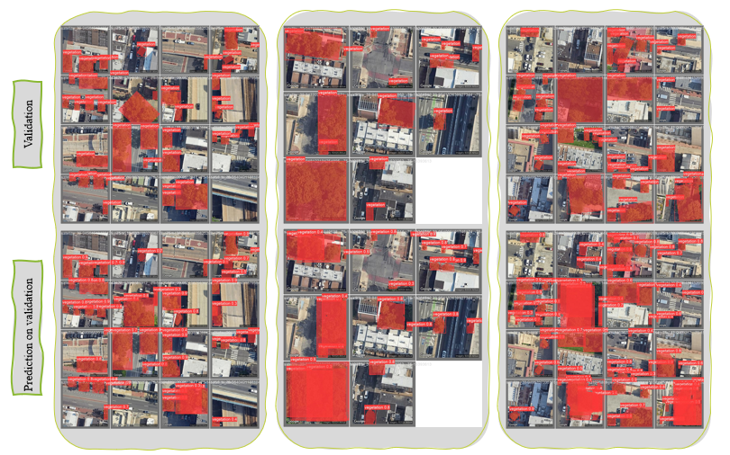

The following images detail the F1 curve, Precision curve, Recall curve, Precision recall curve, confusion matrix of the Bounding box (Figure 18), and mask (Figure 19) of detected foliage/vegetation from the aerial image on validation data.

**Figure 18**   
*Vegetation / Foliage Bounding Box Metrics*

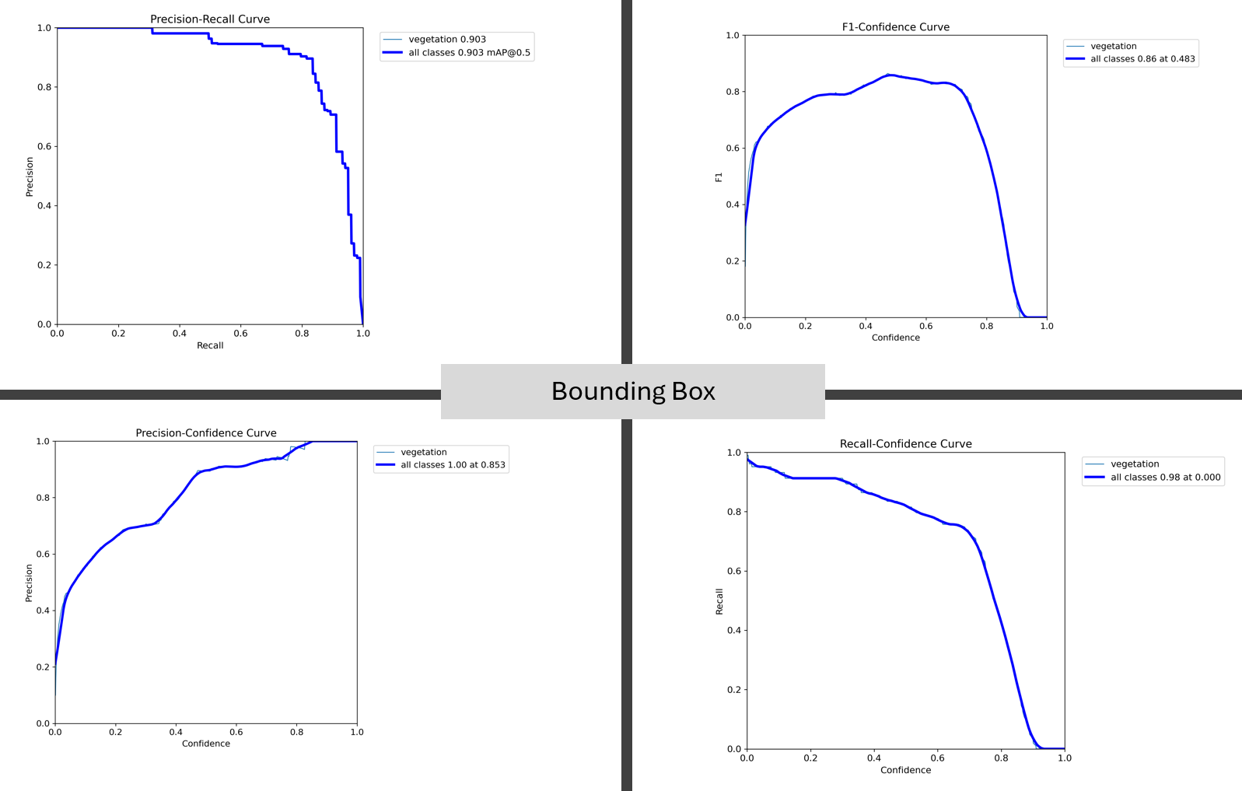

**Figure 19**   
*Vegetation / Foliage Area masks metrics*

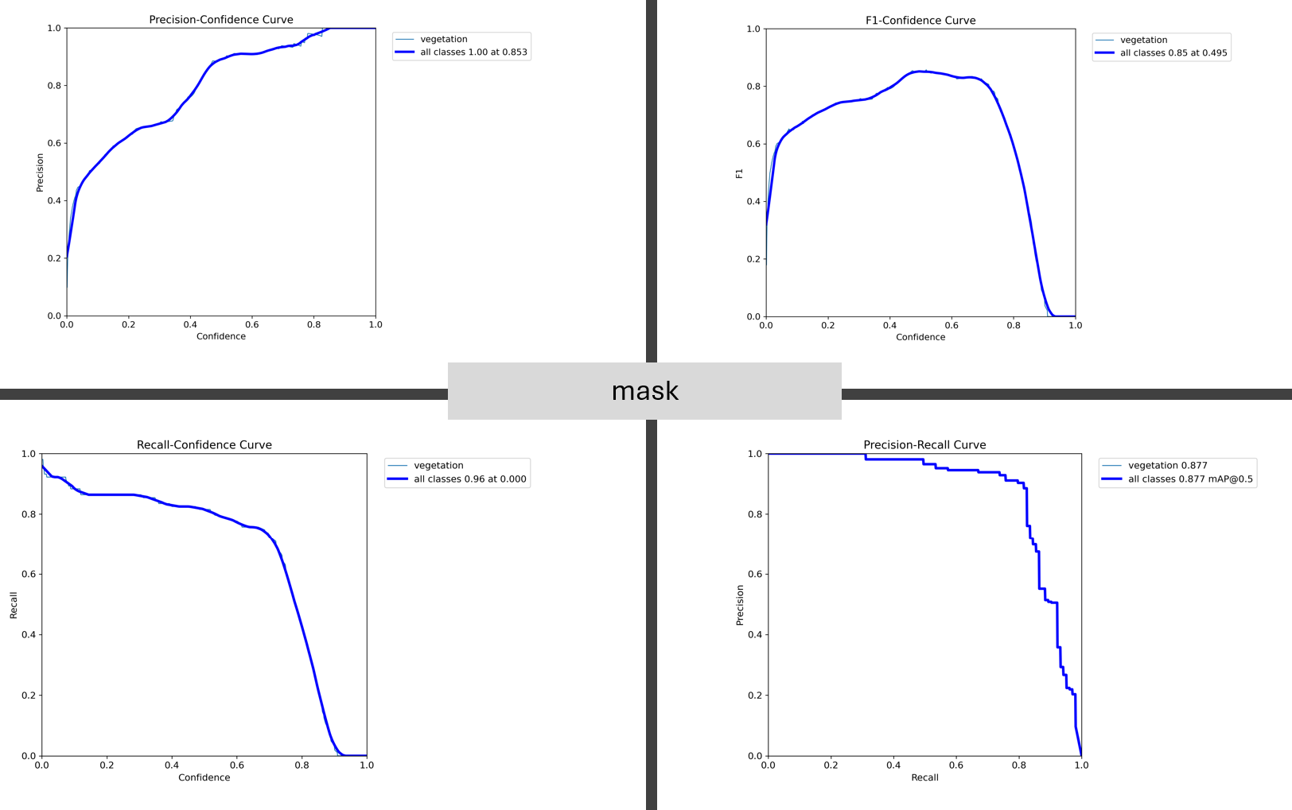

### Digital Twin Construction

The integration of processed imagery and machine learning outputs is pivotal in crafting digital twins that prioritize precise depictions of foliage's spatial distribution and physical attributes (Cureton & Hartley, 2023; Somanath et al., 2023). This process entails merging the processed data from aerial imagery with the outputs of machine learning models to construct a holistic digital twin model that encompasses intricate foliage representation. Additionally, the refinement of the model is essential, involving iterative adjustments based on feedback garnered from validation procedures. This refinement phase includes fine-tuning machine learning models to enhance accuracy and detail in the representation of foliage within the digital twin environment (Z. Li et al., 2023; S. Song & Qin, 2022; Wilk et al., 2022).

### Validation and Benchmarking

The comparison between digital twin models and LiDAR/UAV data for accuracy assessment involves several key steps. Firstly, LiDAR and UAV data are utilized as ground truth benchmarks to evaluate the fidelity of digital twin models in representing foliage. This benchmarking process serves as a crucial means of assessing the accuracy of the digital twin representations.

Quantitative comparison is facilitated through the application of accuracy metrics such as Mean Intersection over Union (MIoU) and Root Mean Square Error (RMSE) (Q. Chen et al., 2022; Hematang et al., 2022; J. Zhang et al., 2021; Rezatofighi et al., 2019; Rogers et al., 2020). These metrics provide objective measures for evaluating the performance of digital twin models in capturing foliage characteristics accurately. Specifically, the accuracy of foliage detection by machine learning models is scrutinized to ensure it meets predefined criteria. Performance metrics like Precision, Recall, F1-score, and Intersection over Union (IoU) are employed to assess the success criteria (Rezatofighi et al., 2019), with the IoU method being particularly instrumental in evaluating model inference results for foliage identification (J. Chen et al., 2021; Sun et al., 2023; J. Zhang et al., 2021; Y. Zhao et al., 2023).

**Figure 20**Digital Twin Representation of Foliage Success Criteria

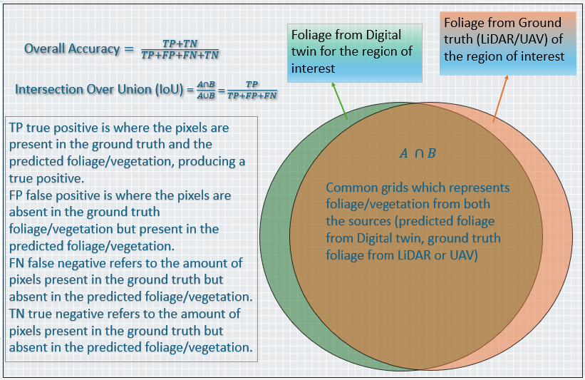

Furthermore, the comparison between LiDAR/UAV datasets and measured foliage is conducted to validate the accuracy of the digital twin models. This validation process involves dividing the region of interest into regular grids and determining the presence of foliage for each grid in both the digital twin and LiDAR/UAV datasets. Venn diagrams are then utilized to visualize the intersection of foliage data, with an intersection percentage exceeding 80%, indicating accurate foliage measurement by the digital twin. Moreover, an analysis of influencing factors is undertaken to identify and scrutinize elements that may affect the accuracy of digital twins. Factors such as image resolution, processing algorithms, and diversity in model training data are examined to gain insights into their impact on the accuracy of digital twin representations (Figure 20).

### Data Fusion and Integration

#### Data Fusion and Integration of Inferred Foliage/Vegetation From Aerial Images.

 Inferring foliage/vegetation from aerial images is challenging due to varying lighting conditions, occlusions caused by buildings or other objects, and the complexity of differentiating between several vegetation types. Existing methods for inferring foliage/vegetation from aerial images include machine learning algorithms that analyze color, texture, and shape features. These algorithms classify pixels or regions as vegetation (Wang et al., 2023). Additionally, the scale and resolution of the aerial images can impact the accuracy of the inference process, as small details may be difficult to detect. Data fusion and integration play a crucial role in vegetation analysis, allowing for a comprehensive and holistic understanding of vegetation cover. Researchers can obtain a more accurate and detailed picture of vegetation distribution, health, and dynamics by combining data from multiple sources, such as aerial images, satellite imagery, and ground surveys (Ghamisi et al., 2019). This comprehensive approach enables informed decision-making in various fields, such as environmental monitoring, agriculture, and urban planning, and helps create a complete digital twin of the environment (Ghamisi et al., 2019).

#### Merge Aerial/Street View Images for a Complete Digital Twin.

 Integrating different perspectives for a comprehensive understanding of the environment. Data fusion in vegetation analysis provides a more comprehensive and accurate understanding of vegetation cover by combining data from multiple sources. Researchers can obtain a detailed picture of vegetation distribution, health, and dynamics by integrating aerial images, satellite imagery, and ground surveys. However, relying solely on aerial images for vegetation analysis has its limitations. Aerial images may not capture fine-scale details, such as small plants or individual leaves, which are important for understanding vegetation dynamics. Moreover, aerial images may struggle to differentiate between different types of vegetation, especially those with similar color or texture. Therefore, integrating aerial images with other data sources, such as street view images or ground surveys, can provide a more comprehensive and accurate vegetation analysis (Ghamisi et al., 2019). Using aerial images and information about the GIS locations of aerial images, the current study infers vegetation/foliage GIS information. Street view images will be integrated in a future study.

### Spatial Analysis

Spatial Analysis of Foliage/Vegetation Data in the Digital Twin Representation of Foliage. One methodology for conducting spatial analysis on foliage data in the digital twin representation is to utilize geographic information systems (GIS). Geospatial analysis is crucial in foliage mapping as it enables us to understand vegetation's spatial patterns and distribution across an area. By conducting geospatial analysis and clustering, we can identify areas with high foliage density, detect anomalies or areas of concern, and gain valuable insights into the overall health and condition of the vegetation in the digital twin representation. This information can be used for effective land management, environmental planning, and decision-making processes. Using clustering algorithms for mapping foliage distribution allows for identifying spatial patterns and hotspots of vegetation, which can provide valuable insights for urban planning, ecological studies, and resource management. These algorithms can help identify areas with high or low foliage density, facilitating targeted interventions and decision-making processes. Using GIS for spatial analysis in the digital twin representation of foliage offers several advantages (Najafova, 2022). Firstly, GIS allows for the integration of various data sources, such as satellite imagery and LiDAR data, providing a comprehensive view of foliage distribution. Secondly, GIS enables the visualization of spatial patterns and relationships, aiding in identifying trends and anomalies in the vegetation data. Lastly, GIS provides powerful analytical tools, such as spatial clustering and interpolation, which can be applied to the foliage data for in-depth analysis and decision-making.

However, there are some limitations and challenges when using GIS for spatial analysis of foliage data. One challenge is the need for accurate and up-to-date data, as foliage patterns can change rapidly. Additionally, the complexity of analyzing large datasets and the potential for spatial data errors can pose challenges in accurately representing and analyzing foliage patterns in the digital twin representation. By overlaying the foliage data onto a digital map, various spatial analysis techniques such as proximity analysis, density analysis, and cluster analysis can be applied to gain insights into the distribution and patterns of vegetation within the digital twin environment.

### Temporal Analysis

Determine how foliage changes over time to improve planning and proactively monitor changes so that necessary changes can be made in network planning and urban planning. Foliage data are collected at defined intervals, such as once a year, for temporal analysis of foliage changes over time (Najafova, 2022). Data is run through the ML model in the current study. Analyze the data for significant changes or correlations between foliage, buildings, and street furniture. Finally, conclusions and insights from the analysis will be drawn to better understand the foliage dynamics of the area. Analyzing changes in foliage over time can provide valuable insights into foliage changes and environmental changes. It can help identify growth patterns and detect obstructed areas caused by foliage. This information is crucial for effective digital twin management and improving network and city planning efforts.

### Machine Learning Interpretability

Make Yolo V8 instance segmentation trained model decisions custom vegetation data interpretable via feature visualization, saliency maps. In addition to feature visualization and saliency maps, another method for making model decisions interpretable could be the use of gradient-based attribution methods, such as Gradient-weighted Class Activation Mapping (Grad-CAM) (Quach et al., 2023), which highlight the regions of an image that contribute the most to the model's decision-making process. This can provide further insights into how the model interprets custom vegetation data. In the current study, Yolo V8 instance segmentation custom model inference results, regions, or masks of vegetation segmentation have been taken and converted to binary images. Extract the contours of the segmented vegetation from the binary image. The contours of the vegetation segments have been saved for further processing.

### Validation and Testing

To validate and test the inference results of the vegetation data using custom-trained YOLO v8 instance segmentation machine learning, the process involves comparing the predicted bounding boxes and segmentation masks with ground truth annotations. This helps to assess the accuracy of the model in detecting and segmenting vegetation objects and provides insights into any potential areas of improvement or fine-tuning required.

### GIS Integration

#### GIS Integration of Foliage/Vegetation Data Extracted from Aerial/Street View Images.

  GIS integration of foliage/vegetation data extracted from aerial/street view images can enhance analysis and decision-making in various ways (Najafova, 2022). For GIS integration, it is critical to use high-quality image capture and processing techniques to maximize accuracy and reliability. This can include using high-resolution aerial or street view images, employing advanced image analysis algorithms, and implementing quality control measures to validate the accuracy of the extracted foliage/vegetation data. In the future, GIS integration of foliage/vegetation data extracted from aerial/street view images could lead to more accurate and detailed mapping of green spaces in urban areas. This could enable cities to better understand and manage their green infrastructure, leading to improved urban planning, environmental conservation, and overall quality of life for residents. For example, it can help identify areas with high tree density that may require pruning or maintenance, assess the impact of vegetation on infrastructure such as power lines or buildings, and support urban planning by identifying suitable locations for new parks or green spaces.

#### Combine Foliage Data with GIS for Advanced Spatial Analyses.

  Integrating GIS with foliage data allows for advanced spatial analyses, such as identifying patterns and trends in vegetation distribution, assessing the health and density of green spaces, and monitoring changes over time (Najafova, 2022). This information can be invaluable for urban planners, environmental scientists, and policymakers in making informed decisions regarding land use, conservation efforts, and the overall management of urban ecosystems. Advanced image analysis algorithms can improve the accuracy and efficiency of foliage/vegetation data extraction from aerial/street view images for GIS integration. These algorithms can automatically detect and classify several types of foliage, such as trees, shrubs, and grass, providing more detailed and precise information for spatial analyses. By leveraging these algorithms, planners and decision-makers can gain deeper insights into the distribution, density, and health of vegetation in urban areas, enabling them to make informed decisions regarding green infrastructure management, urban planning, and environmental conservation.

### Visualization and Reporting

#### Visualization and Reporting of Foliage/Vegetation Data Represented in a Digital Twin.

  Use maps, charts, and graphs to communicate findings to stakeholders. Summarize key insights in reports for decision-makers and researchers. One effective way to summarize the findings for researchers is to provide a concise executive summary. This highlights the main conclusions and implications of the foliage/vegetation data. In the current study, a DT representation of foliage or vegetation provides a visual representation of the selected environment, which can help researchers quickly grasp the key patterns and trends in the data. Finally, including detailed tables or appendices with the raw data can allow researchers to delve deeper into the findings if needed. In the reports, it is important to include key insights such as trends in foliage/vegetation growth or decline, spatial distribution patterns, species diversity, and the impact of environmental factors on vegetation health. These insights can help decision-makers and researchers better understand the current state of vegetation and make informed decisions regarding land management and conservation efforts. In the current study, the vegetation data is analyzed for better planning of advanced network node placement to overcome the blockage caused by the vegetation and, thereby, provide efficient network coverage and user data connectivity.

### Comparison of Digital Twin Foliage Representation with Lidar or UAV Data

Compare digital twin foliage measurements with LiDAR/UAV datasets. Partition the study area into grids for detailed comparisons. Visualize data intersections using Venn diagrams for clarity. Using LiDAR or UAV data for comparison provides several advantages. Firstly, LiDAR technology allows for highly accurate and detailed 3D measurements of foliage, capturing even the smallest details. Secondly, UAVs can capture data from various angles and heights, providing a comprehensive view of the study area. Lastly, both LiDAR and UAV data can be collected quickly and efficiently, allowing for frequent updates and monitoring of changes in foliage over time.

### Iterative Process

Revisit steps to refine digital twin quality as insights evolve. Digital twin quality plays a crucial role in decision-making as it ensures that the insights derived from the digital twin are accurate and reliable. By continuously refining the digital twin through an iterative process, organizations can make informed decisions based on real-time data and simulations, leading to improved operational efficiency and better outcomes. The iterative process of refining digital twin quality involves several steps. First, data needs to be collected and analyzed from sensors and other sources to update the digital twin model. ~~Then, can run~~ After that, simulations can be run and compared to actual data to identify any discrepancies or errors. Based on these insights, adjustments can be made to the digital twin model. The process is repeated until the desired level of accuracy and reliability is achieved.

## Population and Sample

The study concentrates on urban regions with diverse vegetation coverage, encompassing densely populated cities and suburban areas to capture a broad spectrum of foliage types and urban configurations. Sample locations are chosen based on the accessibility of high-quality satellite and street view imagery, as well as LiDAR data.

During the selection process, every precaution is taken to eliminate biases. To ensure that the study sample includes a variety of vegetation densities and types, the study focuses on cities and suburban areas renowned for their substantial foliage diversity. Diverse vegetation types are essential to the study's objectives since it permits a more comprehensive understanding of how different foliage types are distributed across urban landscapes. By including areas with high, medium, and low vegetation coverage, the study can account for the full range of urban foliage scenarios.

These selected sites within cities renowned for their substantial foliage diversity guarantee the inclusion of various vegetation densities and types in the study's analysis (OCM Partners, 2024; Philadelphia Lidar - LAS Files 2022 {2022} - Big Ten Academic Alliance Geoportal, 2022).

The study also takes into consideration the differences in urban configurations at the selected locations. Through the inclusion of a variety of urban layouts, the study ensures that its findings are applicable to a wide range of urban environments. As a result of this approach, a digital twin can be created that can be used for a variety of applications, such as urban planning, environmental monitoring, and resource management.

**Figure 21**   
*Selected Region for Construction of Digital Twin Representation of Foliage*

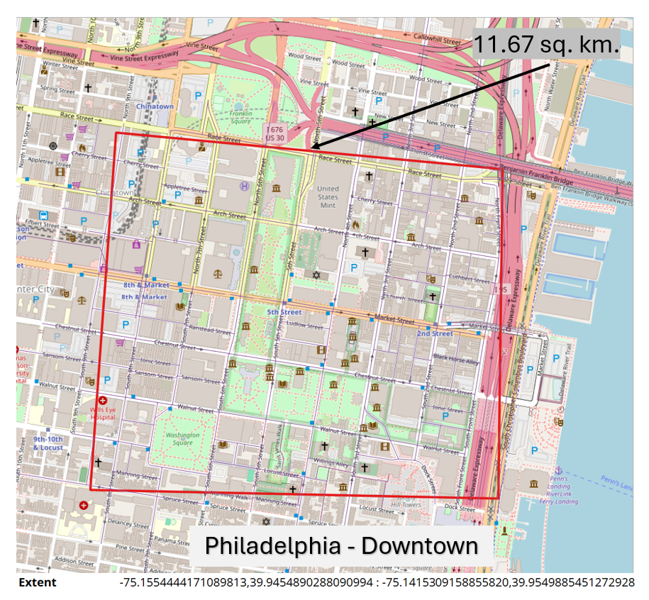

Again, the approach here is to define a framework and methodology that can be used to build digital twins with foliage. There are going to be new vegetation types and environments at different geographical locations, hence the model has been designed to learn from the current selection of the region and identify the vegetation/foliage in building digital twin of foliage.

The study is based on satellite imagery taken over downtown Philadelphia. Research areas include 11.67 square kilometers with latitude and longitude shown in Figure 21 (-75.1554444171089813, 39.9454890288090994, -75.1415309158855820, 39.9549885451272928). A subset of the selected region is considered for the sample.

## Materials or Instrumentation

Figure 22 shows how the Google collects the images using the google car.

**Figure 22***Glimpse of How Aerial and Street View Images Collected by Google*

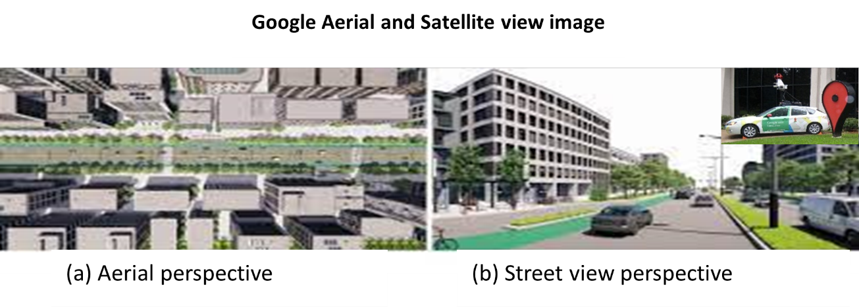

Imagery Sources:

High-resolution Google Street View and aerial images (Google for Developers Maps Static API, n.d.; Google for Developers Street View Static API Overview, n.d.).

Data Collection APIs:

Google Maps API is used to collect street views and aerial imagery (Google for Developers Maps Static API, n.d.; Google for Developers Street View Static API Overview, n.d.).

Validation Data:

LiDAR and UAV datasets for benchmarking and validation purposes (OCM Partners, 2024; Philadelphia Lidar - LAS Files 2022 {2022} - Big Ten Academic Alliance Geoportal, 2022).

Machine Learning Tools:

Software libraries and Neural Network models are used to develop instance segmentation models and image processing (e.g., TensorFlow, PyTorch with Mask R-CNN, YOLO v8).

GIS Software:

For spatial analysis and comparison with traditional data sources. (e.g., Quantum Geographic Information System (QGIS) (QGIS Development Team, 2021), Google Earth engine for data analysis and mapping).

## Assumptions in the Construction of Digital Twin Representation of Foliage

**Figure 23**   
*Assumptions, Limitations, and Delimitations in the construction of DTRF*

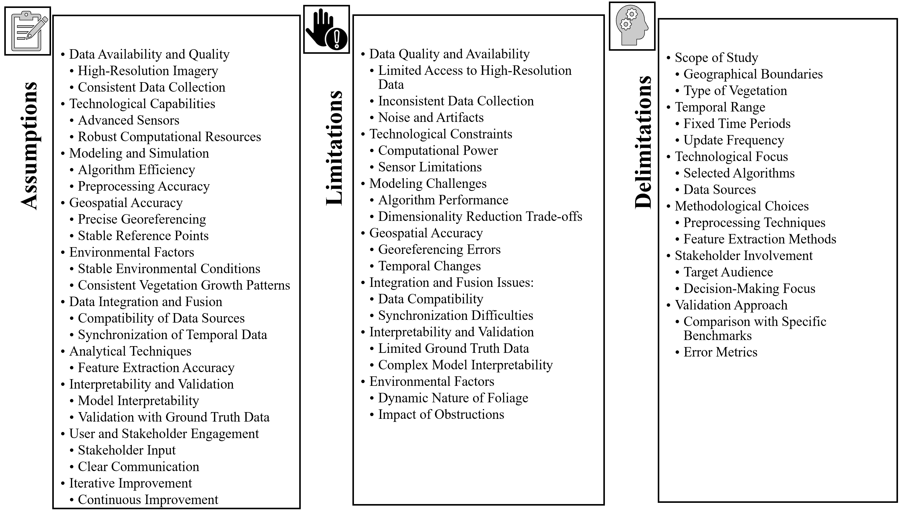

The accuracy, feasibility, and practicality of a digital twin representation of foliage depend on several assumptions, limitations, and delimitations. The accuracy, feasibility, and practicality of a digital twin representation of foliage depend on several assumptions, limitations, and delimitations (Figure 23).

The below assumptions guide the development process and help in setting realistic expectations:

### Data Availability and Quality

Assumes access to high-resolution aerial or satellite images that clearly distinguish individual foliage or vegetation. Ensures that data is collected consistently over time and space, ensuring uniformity in datasets. The imagery is assumed to have accurate geospatial metadata (latitude, longitude, altitude, etc.) for precise georeferencing.

### Technological Capabilities

Nevertheless, processing large datasets can pose several challenges. Obtaining and maintaining high-performance computing systems, which can be expensive, is one of the major challenges. Furthermore, processing large datasets can also strain the system's storage capacity and bandwidth, resulting in bottlenecks and slower processing times. Assumes access to sufficient computational resources, including high-performance computing systems, for processing large datasets and running complex algorithms.

### Modeling and Simulation

Assumes that the machine learning algorithms used (e.g., Mask R-CNN, YOLO) are capable of efficiently processing and analyzing large volumes of image data to identify and segment foliage accurately. Assumes that preprocessing steps are effective in enhancing image quality and reducing noise (e.g., artifact removal, standardization).

### Geospatial Accuracy

Accurate foliage mapping is crucial for analyzing vegetation growth, monitoring changes over time, and understanding ecosystem dynamics. It enables researchers to accurately measure canopy cover, leaf area index, and biomass. These parameters are essential for studying plant health, biodiversity, and climate change’s impacts on vegetation. Additionally, precise foliage mapping allows for effective land management and decision-making in areas such as advanced network planning, agriculture, forestry, and urban planning. Assumes that the geospatial transformation from image coordinates to real-world coordinates is highly reliable, allowing for precise foliage mapping. Assumes the presence of stable reference points in the imagery for accurate alignment and comparison over time.

### Environmental Factors

Assumes stable environmental conditions during data capture, minimizing the impact of temporary changes (e.g., weather variations, seasonal variations) on the foliage representation. Assumes that vegetation growth patterns are consistent and predictable to some extent, allowing for accurate modeling over time.

### Data Integration and Fusion

Assumes that data from different sources (aerial images, street views) can be effectively integrated and harmonized to create a comprehensive digital twin. Assumes that temporal data from various sources are synchronized, allowing for accurate temporal analysis of foliage changes.

### Interpretability and Validation

Assumes that the machine learning models are interpretable, providing insights into how decisions are made and which features are most influential. Assumes the availability of ground truth LiDAR or UAV data for validating the accuracy and reliability of the digital twin.

### Iterative Improvement

Assumes an iterative process where the digital twin is continually refined and improved based on new data, feedback, and advancements in technology. Assumes the availability of ground truth LiDAR or UAV data to validate the accuracy and reliability of the digital twin.

## Limitations in the Construction of Digital Twin Representation of Foliage

Availability and resolution of satellite/street view imagery might vary across different locations. LiDAR and UAV data as benchmarks are assumed to be error-free, which may not always be the case. In the current study, DTRF is built based on the aerial imagery identified vegetation/foliage with a height of the tree set to 12 meters.

Not all regions may have high-resolution aerial or satellite imagery available, which can limit the detail and accuracy of the foliage representation. Variations in data collection methods, times, and conditions can introduce inconsistencies that affect the accuracy and comparability of the digital twin. Images may contain noise and artifacts that are difficult to fully eliminate during preprocessing, potentially affecting the quality of the digital twin. Constructing and maintaining a digital twin requires significant computational resources, which may not be readily available to all organizations or projects. The capabilities of sensors (e.g., resolution, range) can limit the detail and accuracy of the data collected, particularly in densely vegetated or obstructed areas. Machine learning models, such as Mask R-CNN or YOLO, keep training for the new areas as the foliage or vegetation changes across and may not always perform optimally, especially in complex or diverse environments where foliage characteristics vary widely. Transforming image coordinates to real-world coordinates can introduce errors, especially if reference points are not stable or accurately identified. Environmental changes over time (e.g., seasonal variations and weather events) can complicate the accurate tracking and representation of foliage. Integrating data from various sources (e.g., aerial images, LiDAR, street views) can be challenging due to differences in resolution, scale, and formats. Ensuring temporal synchronization of data from different sources is complex and can lead to inaccuracies if not properly managed. The availability of ground truth data for validating the digital twin can be limited, affecting the ability to accurately assess model performance. The dynamic nature of vegetation, influenced by factors such as growth cycles, weather, and human activities, can make it difficult to maintain an accurate and up-to-date digital twin. Buildings, infrastructure, and other obstructions can interfere with data collection, affecting the completeness and accuracy of the foliage representation.

## Delimitations in the Construction of Digital Twin Representation of Foliage

The study focuses on urban and suburban areas, excluding rural or undeveloped regions due to their different foliage characteristics and coverage. Emphasis on high-frequency wireless networks, particularly mmW networks, due to their sensitivity to foliage.

The study ~~may be~~ is limited to specific regions or areas, focusing on those with available high-quality imagery and relevant data. The digital twin may focus on specific types of foliage or vegetation, excluding others that are less relevant to the study's objectives.

The analysis may be conducted over fixed time periods, such as specific seasons or years, to control seasonal variations and other temporal factors. The frequency of updates to the digital twin may be limited by available resources, focusing on periodic rather than real-time updates. The study may focus on specific machine learning algorithms (e.g., Mask R-CNN, YOLO) and image processing techniques, excluding others that may also be applicable. The digital twin may rely on specific data sources (e.g., aerial imagery and satellite images) while excluding other potentially useful sources like ground-based photos or additional sensor types. The study may employ specific preprocessing techniques (e.g., noise removal, standardization) and not explore alternatives that might also be effective. The validation of the digital twin may be based on comparisons with specific benchmarks (e.g., LiDAR data, UAV data, ground surveys) while excluding others. The study may focus on certain error metrics (e.g., accuracy, precision, recall) to evaluate model performance, possibly overlooking other relevant metrics.

By clearly defining these limitations and delimitations, the construction and evaluation of a digital twin representation of foliage can be better understood and refined on a regular basis within the context of its intended use, available resources, and the specific goals of the study.

## Ethical Assurances

Adherence to data privacy laws and regulations, especially in the use of satellite and street view imagery. Ensuring transparency in methodology and findings, with a commitment to non-biased, objective analysis.

## Ethical Considerations using Google aerial imagery

All ethical considerations have been taken care of throughout the entire study and data collection and analysis process. As far as our ethical considerations go, we are not involving any humans in this study. All the images used in the study were sourced from Google APIs, and no human subjects have been involved. To protect privacy, respect copyright, and ensure responsible data usage when collecting images from sources like Google Street View and Google Aerial View, it is crucial to adhere to ethical considerations (Figure 8).

Google has developed a policy for both street view and aerial view imagery collected through Google APIs to ensure a positive experience for users. There are specific criteria for determining whether Street View imagery should be featured on Google Maps, as well as a method for dealing with inappropriate content. The policies are regularly reviewed by Google and updated to reflect recent changes. Furthermore, Google has defined policies concerning the storage of collected information. Here are some policies: (a) Pre-fetching, caching, or storage of content for Google Street View and Aerial View imagery (Policies for Aerial View, n.d.; Policies for Street View Static API, n.d.). (b) Overall Google Maps Platform Terms of Service (Google Maps Platform Terms of Service | Google Cloud, n.d.).

~~Here is the list of some of the policies:~~

* ~~Pre-fetching, caching, or storage of content for Google Street View and Aerial View imagery (Policies for Aerial View, n.d.; Policies for Street View Static API, n.d.).~~
* ~~Overall Google Maps Platform Terms of Service (Google Maps Platform Terms of Service | Google Cloud, n.d.)~~

Google has taken several measures to ensure that individual privacy is protected when Street View imagery is incorporated into Google Maps. To ensure that identifiable information remains obscured within the Google Street View images contributed by the company, Google has pioneered advanced technology for blurring faces and license plates within the images. Google also provides a platform to report any problem with their reporting imagery content using the tool “Report a problem.” In case the content still requires additional blurring or wishes to have the content of the entire home, vehicle, or person blurred, you can easily request this by using the “Report a problem” tool on Google site (Use Street View, n.d.).

## Summary

The creation of a digital twin for foliage, as outlined in this research design and data analysis plan, presents a detailed and systematic approach to capturing, analyzing, and representing the intricate world of vegetation within a defined environment. The structured methodology, from region selection to data analysis, offers a framework for constructing a comprehensive digital twin that holds immense value for a wide array of applications, including network planning, ecological research, and urban development. Key components of the research design, such as the careful selection of the Region of Interest (ROI) and the establishment of a grid using Quantum Geographic Information Systems (QGIS), form the groundwork for thorough data collection. The integration of aerial and Street View images ensures a multi-perspective representation of foliage, enabling the digital twin to encapsulate both aerial and ground-level characteristics. The annotation process, facilitated by the VGG Image Annotator (VIA) or Roboflow, contributes to the creation of a robust training dataset for developing computer vision, image analysis, instance segmentation machine learning models based on Mask R-CNN or YOLO v8, thereby enabling accurate foliage detection. The data analysis plan presents a step-by-step strategy for extracting valuable insights from the collected data. From data preprocessing and image feature extraction to machine learning model training and spatial analysis, each phase is meticulously designed to enhance the quality and comprehensiveness of the digital twin (Figure DTRF process diagram). The strategy allows for iterative improvements, model validation, and the integration of geospatial information systems (GIS) to further enrich the digital twin’s capabilities.

# References

Abdullah, Q., Abdullah, N., Balfaqih, M., Shah, N. S. M., Anuar, S., Almohammedi, A. A., Salh, A., Farah, N., & Shepelev, V. (2020). Maximizing system throughput in wireless powered sub-6 ghz and millimeter-wave 5G heterogeneous networks. *Telkomnika*, 18(3), 1185–1194. https://doi.org/10.12928/TELKOMNIKA.v18i3.15049

Aikoh, T., Homma, R., & Abe, Y. (2023). Comparing conventional manual measurement of the green view index with modern automatic methods using Google Street View and semantic segmentation. *Urban Forestry & Urban Greening*, 80, 127845. https://doi.org/10.1016/j.ufug.2023.127845

*Airborne laser scanning*. (2013, January 18). Geospatial Modeling & Visualization | A Method Store for Advanced Survey and Modeling Technologies. https://gmv.cast.uark.edu/scanning-2/airborne-laser-scanning/

Alkhateeb, A., Jiang, S., & Charan, G. (2023). Real-time digital twins: Vision and research directions for 6G and beyond. *IEEE Communications Magazine*, 61(11), 128–134. https://doi.org/10.1109/MCOM.001.2200866

Almasan, P., Ferriol-Galmes, M., Paillisse, J., Suarez-Varela, J., Perino, D., Lopez, D., Perales, A. A. P., Harvey, P., Ciavaglia, L., Wong, L., Ram, V., Xiao, S., Shi, X., Cheng, X., Cabellos-Aparicio, A., & Barlet-Ros, P. (2022). Network Digital Twin: Context, Enabling Technologies, and Opportunities. *IEEE Communications Magazine*, 60(11), 22–27. https://doi.org/10.1109/MCOM.001.2200012

Angin, P., Anisi, M. H., Göksel, F., Gürsoy, C., & Büyükgülcü, A. (2020). AgriLoRa: a digital twin framework for smart agriculture. *Journal of Wireless Mobile Networks, Ubiquitous Computing, and Dependable Applications (JoWUA)*, 11(4), 77–96. https://doi.org/10.22667/JOWUA.2020.12.31.077

Anzum, R. (2021). Factors that affect LoRa Propagation in Foliage Medium. *Procedia Computer Science*, 194, 149–155. https://doi.org/10.1016/j.procs.2021.10.068

Arnas, Yudan, W., & Eny, K. (2024). Unveiling Innovations Across Multidisciplinary Horizons. *International Journal of Technology*, 15(2), 240–246. https://doi.org/10.14716/ijtech.v15i2.6933

Attaran, M., & Celik, B. G. (2023). Digital Twin: Benefits, use cases, challenges, and opportunities. *Decision Analytics Journal*, 6, 100165. https://doi.org/10.1016/j.dajour.2023.100165

Azad, M. M., Carla, C. M., & Scott, D. L. (2019). Leveraging Digital Twin Technology in Model-Based Systems Engineering. *Systems*, 7(1), 7. https://doi.org/10.3390/systems7010007

Banerjee, B. P., Raval, S., Cullen, P. J., & Kumar Singh, S. (2019). *Mapping of complex vegetation communities and species using UAV-LIDAR metrics and high-resolution optical data*. IGARSS 2019 - 2019 IEEE International Geoscience and Remote Sensing Symposium. https://doi.org/10.1109/IGARSS.2019.8899160

Barb, G., Danuti, F., Ouamri, M. A., & Otesteanu, M. (2022, November). *Analysis of vegetation and penetration losses in 5G mmwave communication systems*. 2022 International Symposium on Electronics and Telecommunications (ISETC) Electronics and Telecommunications (ISETC), 2022 International Symposium on. :1-5 Nov, 2022. https://doi.org/10.1109/ISETC56213.2022.10009963

Barricelli, B. R., Casiraghi, E., & Fogli, D. (2019). A Survey on Digital Twin: Definitions, Characteristics, Applications, and Design Implications. *IEEE Access*, 7, 167653–167671. https://doi.org/10.1109/ACCESS.2019.2953499

Blume, C., Blume, S., Thiede, S., & Herrmann, C. (2020). Data-Driven Digital Twins for Technical Building Services Operation in Factories: A Cooling Tower Case Study. *Journal of Manufacturing Materials Processing*, 4(4), 97. https://doi.org/10.3390/jmmp4040097

Bose, T., Chatur, N., Mukherjee, M., Verma, S., & Adhya, A. (2024). Traffic-Aware Optimal Multi-Beam Resource Allocation in 5G Networks Impaired by Rain and Foliage. *IEEE Communications Letters*, 1. https://doi.org/10.1109/LCOMM.2024.3357174

*Brand resource center | Products and services - Geo guidelines*. (n.d.). Google - About Google, Our Culture & Company News. https://about.google/brand-resource-center/products-and-services/geo-guidelines/#general-guidelines

Bromm, K. N., Lang, I.-M., Twardzik, E. E., Antonakos, C. L., Dubowitz, T., & Colabianchi, N. (2020). Virtual audits of the urban streetscape: comparing the inter-rater reliability of GigaPan® to Google Street View. *Int J Health Geogr*, 19(1), 31. https://doi.org/10.1186/s12942-020-00226-0

Capecchi, I., Borghini, T., & Bernetti, I. (2023). Automated urban tree survey using remote sensing data, Google Street View images, and plant species recognition apps. *European Journal of Remote Sensing*, 56(1), 2162441. https://doi.org/10.1080/22797254.2022.2162441

Caprari, G., Castelli, G., Montuori, M., Camardelli, M., & Malvezzi, R. (2022). Digital Twin for Urban Planning in the Green Deal Era: A State of the Art and Future Perspectives. *Sustainability*, 14(10). https://doi.org/10.3390/su14106263

Casas, E., Ramos, L., Romero, C., & Rivas-Echeverría, F. (2024). A comparative study of YOLOv5 and YOLOv8 for corrosion segmentation tasks in metal surfaces. *Array*, 22, 100351. https://doi.org/10.1016/j.array.2024.100351

Chaminé, H. I., Pereira, A. J. S. C., Teodoro, A. C., & Teixeira, J. (2021). Remote sensing and GIS applications in earth and environmental systems sciences. *SN Applied Sciences*, 3(12), 870. https://doi.org/10.1007/s42452-021-04855-3

Chen, J., Wang, G., Luo, L., Gong, W., & Cheng, Z. (2021). Building Area Estimation in Drone Aerial Images Based on Mask R-CNN. *IEEE Geoscience and Remote Sensing Letters*, 18(5), 891–894. https://doi.org/10.1109/LGRS.2020.2988326

Chen, Q., Gao, T., Zhu, J., Wu, F., Li, X., Lu, D., & Yu, F. (2022). Individual Tree Segmentation and Tree Height Estimation Using Leaf-Off and Leaf-On UAV-LiDAR Data in Dense Deciduous Forests. *Remote Sensing*, 14(12), 2787. https://doi.org/10.3390/rs14122787

Chikhale, D., Munde, M., & Deosarkar, S. (2022). Atmospheric effects and behavior of electromagnetic signals in the millimeter wave range wireless communication. *International Journal of Microwave & Optical Technology*, 17(2), 115–125.

Clancy, R., O’Sullivan, D., & Bruton, K. (2023). Data-driven quality improvement approach to reducing waste in manufacturing. *The TQM Journal*, 35(1), 72. https://doi.org/10.1108/TQM-02-2021-0061

*The code affirms an obligation of computing professionals to use their skills for the benefit of society.* (n.d.). Association for Computing Machinery. https://www.acm.org/code-of-ethics

Corke, P. (2022). Image feature extraction. In P. Corke (Ed.), *Robotic vision.* (Vol. 142, pp. 157–202). Springer, Cham. https://doi.org/10.1007/978-3-030-79175-9_5

Correia, J. B., Abel, M., & Becker, K. (2023). Data management in digital twins: a systematic literature review. *Knowl Inf Syst*, 65(8), 3165–3196. https://doi.org/10.1007/s10115-023-01870-1

Cureton, P., & Hartley, E. (2023). City Information Models (CIMs) as precursors for Urban Digital Twins (UDTs): A case study of Lancaster. *Frontiers in Built Environment*, 9. https://doi.org/10.3389/fbuil.2023.1048510

*Data Privacy Framework*. (n.d.). https://www.dataprivacyframework.gov/

*Data protection adequacy for non-EU countries*. (n.d.). European Commission. https://commission.europa.eu/law/law-topic/data-protection/international-dimension-data-protection/adequacy-decisions_en

*Data transfer frameworks – Privacy and terms – Google*. (n.d.). Privacy and Terms – Google. https://policies.google.com/privacy/frameworks?hl=en

De Beelde, B., Plets, D., & Joseph, W. (2023). Characterization of Vegetation Loss and Impact on Network Performance at V-Band Frequencies. *IEEE Antennas and Wireless Propagation Letters*, 22(3), 596–600. https://doi.org/10.1109/LAWP.2022.3219556

Deng, T., Zhang, K., & Shen, Z.-J., (Max). (2021). A systematic review of a digital twin city: A new pattern of urban governance toward smart cities. *Journal of Management Science and Engineering*, 6(2), 125–134. https://doi.org/10.1016/j.jmse.2021.03.003

Deng, X., Tang, G., & Wang, Q. (2022). A novel fast classification filtering algorithm for LiDAR point clouds based on small grid density clustering. *Geodesy and Geodynamics*, 13(1), 38–49. https://doi.org/10.1016/j.geog.2021.10.002

Diab, A., Kashef, R., & Shaker, A. (2022). Deep Learning for LiDAR Point Cloud Classification in Remote Sensing. *Sensors*, 22(20), 7868. https://doi.org/10.3390/s22207868

Dutta, A., & Zisserman, A. (2019). *The VIA Annotation Software for Images, Audio, and Video*. https://doi.org/10.1145/3343031.3350535

*Fairness: Types of bias*. (n.d.). Google for Developers. https://developers.google.com/machine-learning/crash-course/fairness/types-of-bias

Fang, L., Zhang, H., Zhou, J., & Wang, X. (2020). Image classification with an RGB-channel nonsubsampled contourlet transform and a convolutional neural network. *Neurocomputing*, *396*, 266–277. https://doi.org/10.1016/j.neucom.2018.10.094

Farooq, U., & Lokam, A. (2023). Performance analysis of mmWave/sub-terahertz communication link for 5G and B5G mobile networks. *Frequenz*, 77(11/12), 599–606. https://doi.org/10.1515/freq-2023-0024

Federal Data Protection and Information Commissioner (FDPIC). (n.d.). *Cross-border transfer of personal data*. https://www.edoeb.admin.ch/edoeb/en/home/datenschutz/arbeit_wirtschaft/datenuebermittlung_ausland.html

Fett, M., Wilking, F., Goetz, S., Kirchner, E., & Wartzack, S. (2023). A Literature Review on the Development and Creation of Digital Twins, Cyber-Physical Systems, and Product-Service Systems. *Sensors (Basel, Switzerland)*, 23(24). https://doi.org/10.3390/s23249786

Gabriele, M., Cazzani, A., Zerbi, C. M., & Brumana, R. (2023). DIGITAL TWIN TO MONITOR, UNDERSTAND AND PRESERVE THE COMPLEXITY OF MULTI-SCALE NATURAL, AGRICULTURAL, DESIGNED LANDSCAPES AND ARCHITECTURE: BIODIVERSITY CONSERVATION, TRANSFORMATION AND DECLINE AT VILLA ARCONATI SITE AT CASTELLAZZO OF BOLLATE (MI). *International Archives of Photogrammetry, Remote Sensing & Spatial Information Sciences*, 48(M/2), 613–620. https://doi.org/10.5194/isprs-archives-XLVIII-M-2-2023-613-2023

Gaspari, F., Ioli, F., Barbieri, F., Belcore, E., & Pinto, L. (2022). INTEGRATION OF UAV-LIDAR AND UAV-PHOTOGRAMMETRY FOR INFRASTRUCTURE MONITORING AND BRIDGE ASSESSMENT. *International Archives of the Photogrammetry, Remote Sensing & Spatial Information Sciences*, (B2), 995–1002. https://doi.org/10.5194/isprs-archives-XLIII-B2-2022-995-2022

Getting started with Roboflow. (2024, April 15). *Roboflow Blog*. https://blog.roboflow.com/getting-started-with-roboflow/

Ghamisi, P., Rasti, B., Yokoya, N., Wang, Q., Hofle, B., Bruzzone, L., Bovolo, F., Chi, M., Anders, K., Gloaguen, R., Atkinson, P. M., & Benediktsson, J. A. (2019). Multisource and Multitemporal Data Fusion in Remote Sensing: A Comprehensive Review of the State of the Art. *IEEE Geoscience and Remote Sensing Magazine*, *7*(1), 6–39. https://doi.org/10.1109/MGRS.2018.2890023

*Google for developers Maps Static API*. (n.d.). Google for Developers. https://developers.google.com/maps/documentation/maps-static/start

*Google for developers Street View Static API overview*. (n.d.). Google for Developers. https://developers.google.com/maps/documentation/streetview/overview

*Google maps platform terms of service | Google cloud*. (n.d.). Google Cloud. https://cloud.google.com/maps-platform/terms/

*Google-contributed Street View imagery policy*. (n.d.). Google Maps Street View. https://www.google.com/streetview/policy/

*A guide to international transfers*. (2024, March 24). https://ico.org.uk/for-organisations/uk-gdpr-guidance-and-resources/international-transfers/international-transfers-a-guide/#adequacy

Hayat Suhendar, M. T., & Widyani, Y. (2023, September 7–8). *Machine Learning Application Development Guidelines Using CRISP-DM and Scrum Concept* [Conference session]. 2023 IEEE International Conference on Data and Software Engineering (ICoDSE), Toba, Indonesia, Indonesia. https://doi.org/10.1109/ICoDSE59534.2023.10291438

He, K., Gkioxari, G., Dollár, P., & Girshick, R. (2018). Mask R-CNN. *arXiv.org*. https://doi.org/10.48550/arXiv.1703.06870

Hematang, F., Murdjoko, A., Hendri, H., & Tokede, M. (2022). Application of Unmanned Aerial Vehicle (UAV) For Estimation of Tree Height in Heterogeneous Forest. *Biosaintifika: Journal of Biology & Biology Education*, 14(2), 168–179. https://doi.org/10.15294/biosaintifika.v14i2.35637

Hong, W., Jiang, Z. H., Yu, C., Hou, D., Wang, H., Guo, C., Hu, Y., Kuai, L., Yu, Y., Jiang, Z., Chen, Z., Chen, J., Yu, Z., Zhai, J., Zhang, N., Tian, L., Wu, F., Yang, G., Hao, Z., & Zhou, J. Y. (2021). The Role of Millimeter-Wave Technologies in 5G/6G Wireless Communications. *IEEE Journal of Microwaves*, 1(1), 101–122. https://doi.org/10.1109/JMW.2020.3035541

Hu, W., Fang, J., Zhang, T., Liu, Z., & Tan, J. (2023). A new quantitative digital twin maturity model for high-end equipment. *Journal of Manufacturing Systems*, 66, 248–259. https://doi.org/10.1016/j.jmsy.2022.12.012

Hu, W., Zhang, T., Deng, X., Liu, Z., & Tan, J. (2021). Digital twin: a state-of-the-art review of its enabling technologies, applications and challenges. *Journal of Intelligent Manufacturing and Special Equipment*, 2(1), 1–34. https://doi.org/10.1108/JIMSE-12-2020-010

Huang, Z., Shen, Y., Li, J., Fey, M., & Brecher, C. (2021). A Survey on AI-Driven Digital Twins in Industry 4.0: Smart Manufacturing and Advanced Robotics. *Sensors*, 21(19), 6340. https://doi.org/10.3390/s21196340

Hui, L., Wang, M., Zhang, L., Lu, L., & Cui, Y. (2023). Digital Twin for Networking: A Data-Driven Performance Modeling Perspective. *IEEE Network*, 37(3), 202–209. https://doi.org/10.1109/MNET.119.2200080

Hussain, M. (2023). YOLO-v1 to YOLO-v8, the Rise of YOLO and Its Complementary Nature toward Digital Manufacturing and Industrial Defect Detection. *Machines*, 11(7), 677. https://doi.org/10.3390/machines11070677

Jahnke, N., & Otto, B. (2023). Data Catalogs in the Enterprise: Applications and Integration. *Datenbank Spektrum*, 23(2), 89–96. https://doi.org/10.1007/s13222-023-00445-2

Jiang, B., An, X., Xu, S., & Chen, Z. (2023). Intelligent Image Semantic Segmentation: A Review Through Deep Learning Techniques for Remote Sensing Image Analysis. *Journal of the Indian Society of Remote Sensing*, 51(9), 1865–1878. https://doi.org/10.1007/s12524-022-01496-w

Jocher, G., Chaurasia, A., & Qui, J. (2023). *Ultralytics YOLO* (Version 8.0.0) [Computer software]. https://github.com/ultralytics/ultralytics

Kahloot, K. M., & Ekler, P. (2021). Algorithmic Splitting: A Method for Dataset Preparation. *IEEE Access*, *9*, 125229–125237. https://doi.org/10.1109/ACCESS.2021.3110745

Kang, T. W., & Mo, Y. (2024). A comprehensive digital twin framework for building environment monitoring with emphasis on real-time data connectivity and predictability. *Developments in the Built Environment*, 17, 100309. https://doi.org/10.1016/j.dibe.2023.100309

Kapteyn, M. G., & Willcox, K. E. (2020). From physics-based models to predictive digital twins via interpretable machine learning. *arXiv preprint arXiv:2004.11356*. https://doi.org/10.48550/arXiv.2004.11356

Kaur, K., Kumar, S., & Baliyan, A. (2020). 5G: a new era of wireless communication. *International Journal of Information Technology*, 12(2), 619–624. https://doi.org/10.1007/s41870-018-0197-x

Khan, L. U., saad, W., Niyato, D., Han, Z., & Hong, C. S. (2022). Digital-Twin-Enabled 6G: Vision, Architectural Trends, and Future Directions. *IEEE Communications Magazine*, 60(1), 74–80. https://doi.org/10.1109/MCOM.001.21143

Khan, N. A., & Schmid, S. (2024). AI-RAN in 6G Networks: State-of-the-Art and Challenges. *IEEE Open Journal of the Communications Society*, 5, 294–311. https://doi.org/10.1109/OJCOMS.2023.3343069

Ko, J., Hur, S., Noh, Y., Whang, K., Park, J., Park, D., & Cho, D. (2020). Measurements and Analysis of Radio Propagation at 28 GHz in Vegetated Areas of Typical Residential Environments. *IEEE Transactions on Antennas and Propagation IEEE Trans. Antennas Propagat. Antennas and Propagation, IEEE Transactions on.*, 68(5), 4149–4154. https://doi.org/10.1109/TAP.2020.2968801

Kukushkin, K., Ryabov, Y., & Borovkov, A. (2022). Digital Twins: A Systematic Literature Review Based on Data Analysis and Topic Modeling. *Data*, 7(12), 173. https://doi.org/10.3390/data7120173

Kumar, T. M. K., Aluvala, S., Mandal, P., Saranya, K., & . (2023). *Improving Accuracy in Object Detection Using Region-Based Convolutional Neural Network*. https://doi.org/10.1109/EASCT59475.2023.10392806

Kuruvatti, N. P., Habibi, M. A., Partani, S., Han, B., Fellan, A., & Schotten, H. D. (2022). Empowering 6G communication systems with digital twin technology: A comprehensive survey. *IEEE Access*, 10, 112158–112186. https://doi.org/10.1109/ACCESS.2022.3215493

Lai, C., Senic, D., Gentile, C., Senic, J., & Golmie, N. (2023). Raytracing Digital Foliage at Millimeter-Wave: A Case Study on Calibration Against 60-GHz Channel Measurements on Summer and Winter Trees. *IEEE Access*, 11, 145931–145943. https://doi.org/10.1109/ACCESS.2023.3345248

Lehtola, V. V., Koeva, M., Elberink, S. O., Raposo, P., Virtanen, J.-P., Vahdatikhaki, F., & Borsci, S. (2022). Digital twin of a city: Review of technology serving city needs. *International Journal of Applied Earth Observation and Geoinformation*, 114, 102915. https://doi.org/10.1016/j.jag.2022.102915

Li, H., Ye, C., Guo, Z., Wang, L., Wei, R., & Li, J. (2021). A Fast Progressive TIN Densification Filtering Algorithm for Airborne LiDAR Data Using Adjacent Surface Information. *IEEE Journal of Selected Topics in Applied Earth Observations and Remote Sensing*, 14, 12492–12503. https://doi.org/10.1109/JSTARS.2021.3131586

Li, Z., Hodgson, M. E., & Li, W. (2018). A general-purpose framework for parallel processing of large-scale LiDAR data. *International Journal of Digital Earth*, 11(1), 26–47. https://doi.org/10.1080/17538947.2016.1269842

Li, Z., Wu, B., Li, Y., & Chen, Z. (2023). Fusion of aerial, MMS and backpack images and point clouds for optimized 3D mapping in urban areas. *ISPRS Journal of Photogrammetry & Remote Sensing*, 202, 463–478. https://doi.org/10.1016/j.isprsjprs.2023.07.010

Lu, D., & Jiang, X. (2024). A brief overview and perspective of using airborne Lidar data for forest biomass estimation. *International Journal of Image and Data Fusion*, 15(1), 1–24. https://doi.org/10.1080/19479832.2024.2309615

Luo, S., Liang, Y., Luo, Z., Liang, G., Wang, C., & Wu, X. (2023). Vision-Guided Object Recognition and 6D Pose Estimation System Based on Deep Neural Network for Unmanned Aerial Vehicles towards Intelligent Logistics. *Applied Sciences*, 13(1). https://doi.org/10.3390/app13010115

Mazzacca, G., Grilli, E., Cirigliano, G. P., Remondino, F., & Campana, S. (2022). Seeing among foliage with lidar and machine learning: Towards a transferable archaeological pipeline. *The International Archives of the Photogrammetry, Remote Sensing and Spatial Information Sciences*, XLVI-2-W1-2022, 365–372. https://doi.org/10.5194/isprs-archives-XLVI-2-W1-2022-365-2022

Mehmood, M., Shahzad, A., Zafar, B., Shabbir, A., & Ali, N. (2022). Remote Sensing Image Classification: A Comprehensive Review and Applications. *Mathematical Problems in Engineering*, *2022*(1), 5880959. https://doi.org/10.1155/2022/5880959

Müllerová, J., Gago, X., Bucas, M., Company, Jaume, Estrany, J., Fortesa, J., Manfreda, S., Adrien, M., Mokros, M., Paulus, G., Tiskus, E., Tsiafouli, M., & Kent, R. (2021). Characterizing vegetation complexity with unmanned aerial systems (UAS) -A framework and synthesis. *Ecological Indicators*, 131, 108156. https://doi.org/10.1016/j.ecolind.2021.108156

*MWC23 – Intelligent 5G mmWave network planning*. (2023, February 27). Wireless Technology & Innovation | Mobile Technology | Qualcomm. https://www.qualcomm.com/videos/mwc23-intelligent-5g-mmwave-network-planning

Mylonas, G., Kalogeras, A., Kalogeras, G., Anagnostopoulos, C., Alexakos, C., & Muñoz, L. (2021). Digital twins from smart manufacturing to smart cities: A survey. *IEEE Access*, 9, 143222–143249. https://doi.org/10.1109/ACCESS.2021.3120843

Nagai, H., Nakazawa, E., & Akabayashi, A. (2022). *The creation of the Belmont Report and its effect on ethical principles: a historical study*. https://doi.org/10.1007/s40592-022-00165-5

Najafova, N. Z. (2022). TEMPORAL AND SPATIAL ANALYSIS OF VEGETATION ON THE SOIL SURFACE WITH NDVI ANALYSIS. *Advances in Biology & Earth Sciences*, *7*(3), 224–228.

National Academies of Sciences, Engineering, and Medicine. (2023). *Foundational research gaps and future directions for digital twins*. The National Academies Press. https://doi.org/10.17226/26894

National Academies of Sciences, Engineering, and Medicine. (2024). *Foundational Research Gaps and Future Directions for Digital Twins.* https://doi.org/10.17226/26894

Nguyen, H. X., Trestian, R., To, D., & Tatipamula, M. (2021). Digital Twin for 5G and beyond. *IEEE Communications Magazine*, 59(2), 10–15. https://doi.org/10.1109/MCOM.001.2000343

*Northern Research Station | Research Natural Areas. U.S. Department of Agriculture, Forest Service, Northern Research Station.* (2023, September 22). ArcGIS StoryMaps. https://storymaps.arcgis.com/stories/5b1cfad1e7bd49058b2e570ecdc3b50a

*OCM Partners, 2024: 2022 City of Philadelphia Lidar DEM: Philadelphia, PA*. (2024, January 10). Welcome to NOAA | NOAA Fisheries. https://www.fisheries.noaa.gov/inport/item/70174

Okamoto, R., Ide, R., & Oguma, H. (2024). Automatically drawing vegetation classification maps using digital time-lapse cameras in alpine ecosystems. *Remote Sensing in Ecology and Conservation*, 10(2), 188–202. https://doi.org/10.1002/rse2.364

*Overview – Google Earth*. (n.d.). Google Earth. https://www.google.com/intl/en_us/earth/

*Philadelphia LiDAR - LAS files 2022 {2022} - Big Ten academic alliance Geoportal*. (2022). Big Ten Academic Alliance Geoportal. https://geo.btaa.org/catalog/pasda-7154

*Policies for aerial view API*. (n.d.). Google for Developers. https://developers.google.com/maps/documentation/aerial-view/policies

*Policies for street view static API*. (n.d.). Google for Developers. https://developers.google.com/maps/documentation/streetview/policies

Pradeep, T., Shukla, N. K., Animesh, T., & Shiv, P. (2021). *Investigating the Effect of Rain, Foliage, Atmospheric Gases, and Diffraction on Millimeter (mm) Wave Propagation for 5G Cellular Networks*. https://doi.org/10.1007/978-981-16-3346-1_42

*Privacy policy – Privacy and terms – Google*. (n.d.). Privacy and Terms – Google. https://policies.google.com/privacy?hl=en-US?hl=en#infosharing

QGIS Development Team. (2021). *QGIS Geographic Information System* [Computer software]. QGIS Association. http://www.qgis.org

Qi, Q., & Tao, F. (2018). Digital Twin and Big Data Towards Smart Manufacturing and Industry 4.0: 360 Degree Comparison. *IEEE Access*, 6, 3593. https://doi.org/10.1109/ACCESS.2018.2793265

Quach, L.-D., Quoc, K. N., Quynh, A. N., Thai-Nghe, N., & Nguyen, T. G. (2023). Explainable deep learning models with gradient-weighted class activation mapping for smart agriculture. *IEEE Access*, *11*(August), 83752–83762.

Raihan, A. (2023). Artificial intelligence and machine learning applications in forest management and biodiversity conservation. *Natural Resources Conservation and Research*, 6(2), 3825. https://doi.org/10.24294/nrcr.v6i2.3825

Responsible AI at Google research: Perception fairness. (n.d.). https://blog.research.google/2023/08/responsible-ai-at-google-research.html

Rezatofighi, H., Tsoi, N., Gwak, J., Sadeghian, A., Reid, I., & Savarese, S. (2019). *Generalized Intersection over Union: A Metric and A Loss for Bounding Box Regression*. http://arxiv.org/abs/1902.09630

Rogers, S. R., Manning, I., & Livingstone, W. (2020). Comparing the Spatial Accuracy of Digital Surface Models from Four Unoccupied Aerial Systems: Photogrammetry Versus LiDAR. *Remote Sens.*, 12(17). https://doi.org/10.3390/rs12172806

Sabri, N., Aljunid, S. A., Salim, M. S., Fouad, S., & Kamaruddin, R. (2015). Wireless Sensor Network Wave Propagation in Vegetation. In F. L. Gaol, K. Shrivastava, & J. Akhtar (Eds.), *Recent Trends in Physics of Material Science and Technology.* (pp. 283–298). Springer Series in Materials Science. https://doi.org/10.1007/978-981-287-128-2_18

Sapkota, R., Ahmed, D., & Karkee, M. (2023). *Comparing YOLOv8 and Mask RCNN for object segmentation in complex orchard environments*. https://doi.org/10.32388/ZB9SB0

Saravanan, S. K., Muthusenthil, B., & Gurusubramani, S. (2022). *A review of digital twin leveraging technology, concepts, tools, and industrial applications*. 2022 1st International Conference on Computational Science and Technology (ICCST) Computational Science and Technology (ICCST). https://doi.org/10.1109/ICCST55948.2022.10040359

Sarirete, A., Balfagih, Z., Brahimi, T., Lytras, M. D., & Visvizi, A. (2022). Artificial intelligence and machine learning research: towards digital transformation at a global scale. *Journal of Ambient Intelligence and Humanized Computing*, 13(7), 3319–3321. https://doi.org/10.1007/s12652-021-03168-y

Savelonas, M. A., Veinidis, C. N., & Bartsokas, T. K. (2022). Computer Vision and Pattern Recognition for the Analysis of 2D/3D Remote Sensing Data in Geoscience: A Survey. *Remote Sensing*, 14(23), 6017. https://doi.org/10.3390/rs14236017

Schrotter, G., & Hürzeler, C. (2020). The Digital Twin of the City of Zurich for Urban Planning. *PFG – Journal of Photogrammetry, Remote Sensing and Geoinformation Science, Preprints*, 88(1), 99–112. https://doi.org/10.1007/s41064-020-00092-2

Shah, R. (2018, November 9). *Psst, says 5G... Wanna see what my new antenna tech challenge looks like?* Semiconductor Engineering. https://semiengineering.com/psst-says-5g-wanna-see-what-my-new-antenna-tech-challenge-looks-like/

Shahat, E., Hyun, C. T., & Yeom, C. (2021). City Digital Twin Potentials: A Review and Research Agenda. *Sustainability*, 13(6). https://doi.org/10.3390/su13063386

Sharma, A., Kosasih, E., Zhang, J., Brintrup, A., & Calinescu, A. (2022). Digital Twins: State of the art theory and practice, challenges, and open research questions. *Journal of Industrial Information Integration*, 30. https://doi.org/10.1016/j.jii.2022.100383

Shen, Y., Huang, R., Hua, B., Pan, Y., Mei, Y., & Dong, M. (2023). Automatic Tree Height Measurement Based on Three-Dimensional Reconstruction Using Smartphone. *Sensors 2023*, 23(16), 7248. https://doi.org/10.3390/s23167248

Soares, V. H. A., Ponti, M. A., & Campello, R. J. G. B. (2024). Multi-attribute, graph-based approach for duplicate cattle removal and counting in large pasture areas from multiple aerial images. *Computers and Electronics in Agriculture*, 220. https://doi.org/10.1016/j.compag.2024.108828

Somanath, S., Naserentin, V., Eleftheriou, O., Sjölie, D., Wästberg, B. S., & Logg, A. (2023, May 3). *On procedural urban digital twin generation and visualization of large scale data*. From Oaister®, Provided by the OCLC Cooperative. http://arxiv.org/abs/2305.02242

Song, J., & Le Gall, F. (2023). Digital twin standards, open source, and best practices. In N. Crespi, A. T. Drobot, & R. Minerva (Eds.), *The Digital Twin* (pp. 497–530). Springer Link. https://doi.org/10.1007/978-3-031-21343-4_18

Song, J., Zhao, Y., Song, W., Zhou, H., Zhu, D., Huang, Q., Fan, Y., & Lu, C. (2022). Fisheye Image Detection of Trees Using Improved YOLOX for Tree Height Estimation. *Sensors*, 22, 3636. https://doi.org/10.3390/s22103636

Song, S., & Qin, R. (2022). A NOVEL INTRINSIC IMAGE DECOMPOSITION METHOD TO RECOVER ALBEDO FOR AERIAL IMAGES IN PHOTOGRAMMETRY PROCESSING. *ISPRS Annals of the Photogrammetry, Remote Sensing and Spatial Information Sciences*, V-2-2022, 23–30. https://doi.org/10.5194/isprs-annals-V-2-2022-23-2022

Suhaizad, L. S., Khalid, N., & Abu Sari, M. Y. (2023). Tree Height and Crown Extraction From UAV-Based Multispectral Imagery. *International Journal of Geoinformatics*, 19(5), 61–68. https://doi.org/10.52939/ijg.v19i5.2661

Sun, Z., Wang, X., Wang, Z., Yang, L., Xie, Y., & Huang, Y. (2021). UAVs as remote sensing platforms in plant ecology: review of applications and challenges. *J Plant Ecol*, 14(6), 1003–1023. https://doi.org/10.1093/jpe/rtab089

Sun, Z., Xue, B., Zhang, M., & Schindler, J. (2023). *An Improved Mask R-CNN for Instance Segmentation of Tree Crowns in Aerial Imagery*. 2023 38th International Conference on Image and Vision Computing New Zealand (IVCNZ), Image and Vision Computing New Zealand (IVCNZ). https://doi.org/10.1109/IVCNZ61134.2023.10343827

Thelen, A., Zhang, X., Fink, O., Lu, Y., Ghosh, S., Youn, B. D., Todd, M. D., Mahadevan, S., Hu, C., & Hu, Z. (2022). A comprehensive review of digital twin — part 1: modeling and twinning enabling technologies. *Struct Multidisc Optim*, 65(12), 354. https://doi.org/10.1007/s00158-022-03425-4

Thuvander, L., Somanath, S., & Hollberg, A. (2022). PROCEDURAL DIGITAL TWIN GENERATION FOR CO-CREATING IN VR FOCUSING ON VEGETATION. *International Archives of Photogrammetry, Remote Sensing & Spatial Information Sciences*, 48(4/W5), 189–196. https://doi.org/10.5194/isprs-archives-XLVIII-4-W5-2022-189-2022

Thyagharajan, K. K., & Kalaiarasi, G. (2021). A Review on Near-Duplicate Detection of Images using Computer Vision Techniques. *Arch Computat Methods Eng*, *28*(3), 897–916. https://doi.org/10.1007/s11831-020-09400-w

Tran, B.-H., Aussenac-Gilles, N., Comparot, C., & Trojahn, C. (2022). Semantic Integration of Raster Data for Earth Observation on Territorial Units. *ISPRS International Journal of Geo-Information*, 11(2), 149. https://doi.org/10.3390/ijgi11020149

Trevisan, L. R., Brichi, L., Gomes, T. M., & Rossi, F. (2023). Estimating Black Oat Biomass Using Digital Surface Models and a Vegetation Index Derived from RGB-Based Aerial Images. *Remote Sens*, 15(5). https://doi.org/10.3390/rs15051363

VanDerHorn, E., & Mahadevan, S. (2021). Digital Twin: Generalization, characterization and implementation. *Decision Support Systems*, 145, 113524. https://doi.org/10.1016/j.dss.2021.113524

Vrabič, R., Erkoyuncu, J. A., Butala, P., & Roy, R. (2018). Digital twins: Understanding the added value of integrated models for through-life engineering services. *Procedia Manufacturing*, 16, 139–146. https://doi.org/10.1016/j.promfg.2018.10.167

Wang, D. (2020). Unsupervised semantic and instance segmentation of forest point clouds. *ISPRS Journal of Photogrammetry and Remote Sensing*, *165*, 86–97. https://doi.org/10.1016/j.isprsjprs.2020.04.020

Wang, N., Liu, H., Li, Y., Zhou, W., & Ding, M. (2023). Segmentation and Phenotype Calculation of Rapeseed Pods Based on YOLO v8 and Mask R-Convolution Neural Networks. *Plants*, 12(18), 3328. https://doi.org/10.3390/plants12183328

Wang, W., Xiao, L., Zhang, J., Yang, Y., Tian, P., Wang, H., & He, X. (2018). Potential of Internet street-view images for measuring tree sizes in roadside forests. *Urban Forestry & Urban Greening*, 35, 211–220. https://doi.org/10.1016/j.ufug.2018.09.008

Wang, Z., & Menenti, M. (2021). Challenges and Opportunities in Lidar Remote Sensing. *Frontiers in Remote Sensing*, 2, 641723. https://doi.org/10.3389/frsen.2021.641723

Waqar, A., Othman, I., Almujibah, H., Khan, M. B., Alotaibi, S., & Elhassan, A. A. M. (2023). Factors Influencing Adoption of Digital Twin Advanced Technologies for Smart City Development: Evidence from Malaysia. *Buildings*, 13(3). https://doi.org/10.3390/buildings13030775

Weil, C., Bibri, S. E., Longchamp, R., Golay, F., & Alahi, A. (2023). Urban Digital Twin Challenges: A Systematic Review and Perspectives for Sustainable Smart Cities. *Sustainable Cities and Society*, 99, 104862. https://doi.org/10.1016/j.scs.2023.104862

Wilk, Ł., Mielczarek, D., Ostrowski, W., Dominik, W., & Krawczyk, J. (2022). SEMANTIC URBAN MESH SEGMENTATION BASED ON AERIAL OBLIQUE IMAGES AND POINT CLOUDS USING DEEP LEARNING. *International Archives of the Photogrammetry, Remote Sensing & Spatial Information Sciences*, (B2), 485–491. https://doi.org/10.5194/isprs-archives-XLIII-B2-2022-485-2022

Yang, E., Wang, M., Cheng, H., Liu, R., & Chen, F. (2022). *A Method to Improve the Precision of 2-Dimensioanl Size Measurement of Objects through Image Processing*. 2022 21st International Symposium on Distributed Computing and Applications for Business Engineering and Science (DCABES) DCABES Distributed Computing and Applications for Business Engineering and Science (DCABES), 2022 21st International Symposium on, DCABES, 197–200. https://doi.org/10.1109/DCABES57229.2022.00010

Yang, F., Huang, L., Tan, X., & Yuan, Y. (2023). FasterNet-SSD: a small object detection method based on SSD model. *Signal, Image and Video Processing*, *18*(1), 173–180. https://doi.org/10.1007/s11760-023-02726-5

Zeng, Y., Duan, Q., Chen, X., Peng, D., Mao, Y., & Yang, K. (2021). UAVData: A dataset for unmanned aerial vehicle detection. *Soft Computing: A Fusion of Foundations, Methodologies and Applications*, 25(7), 5385–5393. https://doi.org/10.1007/s00500-020-05537-9

Zhang, J., Cosma, G., & Watkins, J. (2021). Image Enhanced Mask R-CNN: A Deep Learning Pipeline with New Evaluation Measures for Wind Turbine Blade Defect Detection and Classification. *Journal of Imaging*, 7(3). https://doi.org/10.3390/jimaging7030046

Zhang, P., Yang, B., Yi, C., Wang, H., & You, X. (2020). Measurement-Based 5G Millimeter-Wave Propagation Characterization in Vegetated Suburban Macrocell Environments. *IEEE Transactions on Antennas and Propagation IEEE Trans. Antennas Propagat. Antennas and Propagation, IEEE Transactions on.*, 68(7), 5556–5567. https://doi.org/10.1109/TAP.2020.2975365

Zhang, Y., Anderson, C. R., Michelusi, N., Love, D. J., Baker, K. R., & Krogmeier, J. V. (2019). Propagation Modeling Through Foliage in a Coniferous Forest at 28 GHz. *IEEE Wireless Communications Letters*, 8(3), 901–904. https://doi.org/10.1109/LWC.2019.2899299

Zhao, D., Li, X., Wang, X., Shen, X., & Gao, W. (2022). Applying Digital Twins to Research the Relationship Between Urban Expansion and Vegetation Coverage: A Case Study of Natural Preserve. *Frontiers in Plant Science*, 13, 840471. https://doi.org/10.3389/fpls.2022.840471

Zhao, W., Persello, C., & Stein, A. (2023). Semantic-aware unsupervised domain adaptation for height estimation from single-view aerial images. *ISPRS Journal of Photogrammetry and Remote Sensing*, 196, 372–385. https://doi.org/10.1016/j.isprsjprs.2023.01.003

Zhao, Y., Cheng, D., Shen, S., Cai, D., & Lyu, X. (2023). *Improved Mask R-CNN for Disturbed Area Extraction in Construction Projects from High-Resolution Satellite Imagery*. 2023 6th International Conference on Artificial Intelligence and Big Data (ICAIBD), Artificial Intelligence and Big Data (ICAIBD). https://doi.org/10.1109/ICAIBD57115.2023.10206407

Zhou, C., Gao, J., Li, M., Sherman Shen, X., & Zhuang, W. (2022). Digital Twin-Empowered Network Planning for Multi-Tier Computing. *Journal of Communications and Information Networks*, 7(3), 221–238. https://doi.org/10.23919/JCIN.2022.9906937

# 

# Appendix A Annotated Bibliography

Chikhale, D., Munde, M., & Deosarkar, S. (2022). Atmospheric Effects and Behavior of Electromagnetic Signals in the Millimeter Wave Range Wireless Communication. *International Journal of Microwave & Optical Technology*, *17*(2), 115–125.

The article provides valuable insights into the impact of foliage on the efficient deployment of millimeter-wave communication systems. Several references and studies are cited to underscore the significance of considering foliage effects in the design and deployment of millimeter-wave networks. Here are some key points discussed in the article are related to foliage and its impact on millimeter-wave deployment: (a) Atmospheric constituents, such as free space loss, rain attenuation loss, gaseous loss, foliage loss, humidity, cloud, fog, and penetration loss, significantly impact the propagation of electromagnetic signals in the millimeter wave range. (b) The presence of foliage is acknowledged as a significant factor causing attenuation in the millimeter wave range, particularly in non-line-of-sight communication scenarios. (c) The need for accurate measurements and analysis of foliage effects is emphasized to suggest new and improved models for designing and developing millimeter-wave communication systems. (d) Studies on foliage attenuation at specific frequencies, such as 35GHz, are referenced, indicating the importance of considering frequency-dependent foliage effects in millimeter-wave deployment. (e) The impact of foliage on signal attenuation in the millimeter band is highlighted, emphasizing the need for effective modeling and measurement of foliage effects to assess and mitigate signal losses accurately.

Overall, the authors underscore the critical role of foliage in the efficient deployment of millimeter-wave communication systems. It emphasizes the need for comprehensive understanding, measurement, and modeling of foliage effects to ensure the reliable and effective operation of millimeter-wave networks, especially in non-line-of-sight scenarios.

Farooq, U., & Lokam, A. (2023). Performance analysis of mmWave/sub-terahertz communication link for 5G and B5G mobile networks. *Frequenz*, *77*(11/12), 599–606. https://doi.org/10.1515/freq-2023-0024

The article provides a comprehensive overview of the evolution of mobile wireless communication to the 5G revolution, High-frequency communications, cellular communications, the architecture, and emerging technologies of 5G networks, and a survey on millimeter-wave communications for fifth-generation wireless networks. Additionally, it discusses the potential of millimeter-wave (mmWave) and terahertz spectrum for 6G wireless with detailed references cited.

The article sets the stage for the subsequent analysis by establishing the context of the study within the broader landscape of wireless communication technologies, including the challenges and opportunities associated with the deployment of mmWave/sub-terahertz communication in 5G and B5G mobile networks.

Moreover, the authors underscore the intricate challenges entailed in the deployment of millimeter-wave communications, with a specific focus on the pronounced influence of foliage on the efficacy of mmWave/sub-terahertz communication. A critical aspect addressed is the substantial power loss encountered by mmWave/sub-terahertz signals as they traverse foliated environments. Delving into the nuances, the article introduces a robust mathematical model meticulously crafted to capture the essence of foliage-induced attenuation, thereby elucidating the gravity of its impact on communication links.

This foundational exploration serves as a precursor to the ensuing analysis, shedding light on the precise environmental variables that demand meticulous consideration for the seamless implementation of mmWave/sub-terahertz communication within the realm of 5G and beyond 5G (B5G) mobile networks. By delineating the mathematical intricacies of foliage loss, the article sets a compelling stage for a more detailed examination of the factors critical to optimizing the performance and reliability of mmWave and sub-terahertz communication in the evolving landscape of advanced mobile networks.

Anzum, R. (2021). Factors that affect LoRa Propagation in Foliage Medium. *Procedia Computer Science*, *194*, 149–155. https://doi.org/10.1016/j.procs.2021.10.068

The article emphasizes the impact on the factors that impact the performance of LongRange (LoRa) propagation in foliage medium. The authors highlight the importance of considering environmental factors such as temperature, foliage, and rainfall, as well as LoRa physical parameter settings and the Fresnel zone.

The authors highlight the limited existing research on LoRa propagation in foliage environments, noting that while the performance of LoRa in indoor and outdoor settings has been studied extensively, there needs to be more research specifically focused on foliage propagation. The article references previous studies that have demonstrated a decrease in range and channel quality for non-line of sight foliage propagation, as well as degradation in the Received Signal Strength Indicator (RSSI) with increasing distance between transmitter and receiver in foliage environments.

The article underscores the impact of foliage on LoRa network deployment. It sets the stage for the current study’s experimental analysis of LoRa propagation in a foliage medium, specifically a line of five date palm trees, and its potential contributions to understanding LoRa propagation channel modeling in foliage environments. The article highlights some of the challenges posed by foliage while deploying LoRa technology. (1) Signal Attenuation: Vegetation or foliage can cause significant signal attenuation, which can reduce the range and quality of LoRa propagation. This can be addressed by optimizing the physical layer parameters of LoRa, such as spreading factors, to improve signal strength and quality. (2) Multipath Propagation: Foliage or Vegetation can also introduce multipath propagation, which can cause interference and reduce the accuracy of signal reception. This can be addressed by using directional antennas or by optimizing the placement of LoRa gateways to minimize the impact of multipath propagation. (3). Environmental Factors: Environmental factors such as temperature, humidity, and rainfall can also impact LoRa propagation in vegetation. These factors can be addressed by carefully selecting the location of LoRa gateways and optimizing the physical layer parameters of LoRa to account for these environmental factors.

Overall, while there are challenges associated with using LoRa technology in the presence of foliage or vegetation, these challenges can be addressed through careful network planning and optimization. Being aware of the existence of foliage or vegetation within the deployment area and having a thorough understanding of it contribute to improved planning and optimization of LoRa. This awareness and comprehension make it feasible to attain reliable and high-quality LoRa propagation, especially in environments with foliage or vegetation.

Nguyen, H. X., Trestian, R., To, D., & Tatipamula, M. (2021). Digital Twin for 5G and beyond. *IEEE Communications Magazine*, *59*(2), 10–15. https://doi.org/10.1109/MCOM.001.2000343

Researchers face several challenges in developing 5G networks to their full potential. These challenges include the complexity of technology, infrastructure deployment, interference and spectrum management, standardization and compatibility, security and privacy concerns, energy efficiency, regulatory and policy challenges, and meeting the diverse requirements of various 5G use cases. Addressing these challenges requires collaborative efforts from researchers, industry stakeholders, and policymakers to ensure the successful development and deployment of 5G networks to their full potential.

The article highlights the potential of digital twin (DT) technology in facilitating the smart deployment of 5G and beyond. It emphasizes the integration of DT with the physical environment to visualize and predict the propagation of 5G radio signals, enabling accurate 3D modeling of urban terrains, buildings, and trees. This integration, along with advanced radio propagation models, allows for the accurate prediction of coverage areas for each base station across the city, which is crucial for successful 5G deployment. Furthermore, the DT enables continuous monitoring, testing, and near-real-time optimizations of the 5G network’s performance. It also supports continuous validation and optimization, relaxation of constraints at the initial stages of 5G services, and flexibility for new use cases. The article underscores the pivotal role of DT in addressing challenges and driving the successful deployment of 5G networks.

Qi, Q., & Tao, F. (2018). Digital Twin and Big Data Towards Smart Manufacturing and Industry 4.0: 360 Degree Comparison. *IEEE Access*, *6*, 3593. https://doi.org/10.1109/ACCESS.2018.2793265

The article delving into smart manufacturing and Industry 4.0 underscores the pivotal role played by digital twins and big data in the metamorphosis of traditional manufacturing processes into intelligent, data-driven systems. The authors accentuate the significance of the digital twin in achieving cyber-physical integration in manufacturing by constructing a virtual representation of physical assets and processes. This virtual model serves as a dynamic tool for real-time monitoring, analysis, and optimization of the physical system. The research revolves around the framework and characteristics of IT-driven service-oriented smart manufacturing, underscoring the necessity to address the diverse demands of all stakeholders involved in service collaboration.

In the realm of environmental monitoring systems, the article conducts a comprehensive review of existing systems, emphasizing the criticality of real-time data collection and analysis for smart manufacturing. Notably, the work underscores the pivotal role of digital twins in enabling cyber-physical integration and autonomous decision-making within smart manufacturing systems.

The article enumerates key benefits derived from the integration of digital twin technology. Firstly, the digital twin creates a virtual representation of physical assets and processes, amalgamating data from diverse sources, including sensors, Internet of Things (IoT) devices, and other data sources. Secondly, it facilitates real-time monitoring, allowing for the early detection of faults and anomalies. This is made possible by virtual representation, tracking the behavior of physical assets and processes in real-time. Thirdly, the digital twin serves as a tool for optimizing the physical system by simulating various scenarios and predicting outcomes based on different decisions. Finally, it enables closed-loop control by providing real-time feedback to the physical system, allowing for efficient and effective processes.

In summary, the digital twin is instrumental in creating a virtual representation of physical assets and processes; it empowers real-time monitoring, analysis, and optimization, fostering closed-loop control for more efficient and effective processes.

Mazzacca, G., Grilli, E., Cirigliano, G. P., Remondino, F., & Campana, S. (2022). SEEING AMONG FOLIAGE WITH LIDAR AND MACHINE LEARNING: TOWARDS A TRANSFERABLE ARCHAEOLOGICAL PIPELINE. *The International Archives of Photogrammetry, Remote Sensing and Spatial Information Sciences*, *XLVI-2-W1-2022*, 365–372. https://doi.org/10.5194/isprs-archives-XLVI-2-W1-2022-365-2022

The use of airborne laser scanning (ALS) and light detection and range (LiDAR) technologies has become a well-established practice for identifying and mapping archaeological evidence. LiDAR technology allows for the measurement and mapping of items or structures that would otherwise be hidden under vegetation. The ability to filter the returning signal created by the hit vegetation makes it an essential instrument in areas with dense forest or shrub cover. However, the generation of an accurate Digital Terrain Model (DTM) from LiDAR data relies on various factors, making the creation of a DTM a complex procedure that requires numerous assumptions and decisions during the project planning, data acquisition, and subsequent analytic workflow.

The proposed workflow involves a multi-level multi-resolution (MLMR) point cloud semantic segmentation, which uses machine learning algorithms to classify the 3D dataset into different categories, including vegetation and archaeological structures. The workflow is designed to filter out vegetation and detect hidden archaeological structures directly from LiDAR point clouds. The MLMR procedure involves the development of predictive models using a Random Forest algorithm with reduced manually annotated portions of the datasets, including known elements and discriminative features. The workflow also includes the generation of a bare-ground DTM and the use of visualization techniques for anomaly detection.

The use of machine learning algorithms in the proposed workflow provides a fast and accurate way to filter vegetation and detect archaeological evidence in LiDAR point clouds, facilitating the identification and mapping of archaeological elements above ground and anomalies of potential historical interest at ground level. The workflow is designed to be optimal, fast, and transferable, working in different archaeological environments to distinguish vegetated and non-vegetated areas in LiDAR datasets.

The proposed workflow demonstrates significant advantages in processing large LiDAR datasets, facilitating the otherwise difficult manual identification of hidden heritage evidence and saving time in the process execution. The workflow is designed to spot archaeological artifacts both above and below ground in multiple steps and work entirely on the LiDAR point cloud. It offers fast processing of large datasets through a supervised machine learning approach, accurate vegetation filtering in complex environments, and the detection and mapping of above-ground structures directly on the 3D point cloud. Additionally, the output is easily transferrable to a GIS environment for further data processing, and the classification models can be generalized and transferred to different environments.

Weil, C., Bibri, S. E., Longchamp, R., Golay, F., & Alahi, A. (2023). Urban Digital Twin Challenges: A Systematic Review and Perspectives for Sustainable Smart Cities. *Sustainable Cities and Society*, *99*, 104862. https://doi.org/10.1016/j.scs.2023.104862

The article provides a comprehensive review focusing on Urban Digital Twins (UDTs) and their role in sustainable smart cities; a systematic analysis is presented, which outlines the primary challenges and unresolved issues in their implementation. The review underscores a significant research gap, noting that despite the uptick in UDT-related research, there remains an insufficient exploration of the bottlenecks hindering their deployment. The intention of this study is to bridge this gap through a meticulous examination of the associated challenges and issues. The analysis delineates eight principal categories of challenges that are pivotal to the realization of UDTs. These encompass concerns with interoperability and semantics, foundational infrastructure including storage, computation, and network systems, the intricacies of data acquisition and actuation, and the imperative of ensuring data quality and harmonization. Further, the need for robust modeling, simulation, and decision-support systems is recognized, alongside the criticality of data visualization and the display of information. The review also touches upon the necessity for adequate human and capital resources, and the importance of governance, as well as organizational and social considerations. The review draws particular attention to key issues such as the semantics of data and models, the prevalence of missing data, and the overarching need for data quality and effective modeling practices. These elements are identified as significant hurdles that practitioners must surmount to alleviate the delays in UDT implementation. A methodical approach underpins the review, adhering to the Preferred Reporting Items for Systematic Reviews and Meta-analyses (PRISMA) methodology. This structured approach facilitated a targeted literature search and selection process aimed at unearthing relevant articles that address the myriad challenges encountered in the deployment of UDTs.

In summary, the literature review offers a thorough and insightful overview of the obstacles and unresolved matters surrounding the deployment of Urban Digital Twins in the context of sustainable smart cities. The findings provide a comprehensive resource for practitioners, policymakers, and scholars engaged in the domains of urban development and digital twin technologies, fostering a deeper understanding of the field and guiding future research and application efforts.

Sun, Z., Xue, B., Zhang, M., & Schindler, J. (2023). An Improved Mask R-CNN for Instance Segmentation of Tree Crowns in Aerial Imagery. 2023 38th International Conference on Image and Vision Computing New Zealand (IVCNZ), Image and Vision Computing New Zealand (IVCNZ). https://doi.org/10.1109/IVCNZ61134.2023.10343827

The article presents a new and effective method for segmenting individual tree crowns in aerial imagery, with a focus on the dataset of Wellington City of Aotearoa, New Zealand. The paper begins with an introduction to the importance of instance segmentation in computer vision and the challenges of segmenting individual tree crowns in aerial imagery. The authors then introduce the Mask R-CNN architecture and its limitations in extracting sufficient feature information for individual tree crowns.

To address these limitations, the authors propose an improved Mask R-CNN method by introducing an effective backbone structure, ConvNeXt, and a new mask branch to help segment tree crowns from complex backgrounds. The proposed method is evaluated on the Wellington city dataset, and the results show that it outperforms Mask R-CNN and accurately identifies and segments individual tree canopies.

The authors note that many of these methods are based on Mask R-CNN and that the performance of these methods is limited by the complex canopy structure of trees and the similarity of tree crowns to the surrounding background. The authors also discuss the potential real-world applications and implications of this improved instance segmentation method for tree crowns in aerial imagery, including forest management, urban planning, biodiversity modeling, and pest control.

Overall, “An Improved Mask R-CNN for Instance Segmentation of Tree Crowns in Aerial Imagery” presents a significant contribution to the field of computer vision and forestry management. The proposed method addresses the limitations of previous methods and provides a more accurate and efficient way to identify and segment individual tree crowns in aerial imagery. The paper also highlights the potential applications of this method in various fields, emphasizing the importance of accurate and efficient tree crown mapping for sustainable forest management and urban planning.

# Appendix B Topic Description and Supporting Literature

The “A Study on Creating Digital Twin Foliage Representation Through Computer Vision, Aerial Image Analysis and Machine Learning techniques to enhance the Network Planning and Deployment” research emerges at the intersection of advanced technologies and environmental understanding, aiming to create a nuanced digital replica of natural environments with a particular focus on foliage. As connected devices proliferate and 5G technology becomes pervasive, the project responds to the challenges presented by the deployment of millimeter-wave (mmW) networks, specifically addressing issues related to foliage impact on wireless signal propagation (Anzum, 2021; Chikhale et al., 2022; Farooq & Lokam, 2023). In this endeavor, the research delves into the intricacies of representing foliage within a digital twin, encompassing the spatial distribution, diversity, and inherent characteristics of trees and vegetation. These digital twin models serve as powerful tools, empowering network planners, environmental scientists, and various stakeholders to comprehend how foliage influences the complex dynamics of wireless signal propagation (Nguyen et al., 2021; Qi & Tao, 2018).

The "Digital Twin Representation of Foliage" research embarks on a groundbreaking journey, bridging the realms of technology and environmental comprehension to establish the groundwork for intelligent, efficient, and environmentally conscious network planning. With its focus on modern connectivity challenges, this research is positioned to make a significant contribution to the advancement of wireless communication technologies.

**Objectives**

* Foliage Modeling: Create a comprehensive digital twin of natural environments, emphasizing the spatial distribution and characteristics of foliage.
* Network Optimization: Provide network planners and environmental scientists with a robust tool for intelligent and efficient network planning, ultimately enhancing user coverage and throughput.
* Community Enrichment: Contribute to intelligent urban planning and environmental awareness by extending the digital twin to encompass additional elements like building facades and street infrastructure.
* Wireless Signal Dynamics: Uncover insights into how foliage influences wireless signal propagation, path loss, and coverage, especially in high-frequency networks like millimeter-wave (mmW) networks designed for technologies such as 5G.

**Outcomes**

* Accurate Foliage Representation: A sophisticated digital twin that precisely represents various foliage types, distributions, and characteristics.
* Enhanced Network Planning: Improved efficiency in the planning and deployment of 5G mmW networks, leading to superior coverage and reduced signal interference.
* Holistic Community Representation: Expansion of the digital twin to include additional urban elements, contributing to intelligent urban planning and enriched community experiences.

# Appendix C GitHub Details

GitHub repository contains all the supporting documents related to chapter 1. It contains all the articles referenced in chapter 1.

Link to GitHub repository: https://tinyurl.com/DigitalTwin-nu

# Appendix D IRB Approval Letter

